2026 Kentucky Cybersecurity and
Forensics Conference (KCFC2026)
“Building Cyber Resilience Through Collaboration — Academia, Industry, and Government”
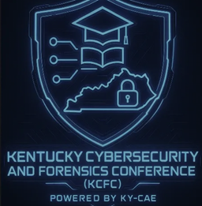
Date: October 30th, 2026
Time: 8 am -4:30 pm
Location: Kentucky State University Harold R. Benson Research and Demonstration Farm. 1525 Mills Lane, Frankfort, KY 40601
Website: www.ky-cfc.com
The Kentucky Cybersecurity and Forensics Conference (KCFC) 2026 cordially invites scholars, industry leaders, practitioners, students, and government representatives to participate in a premier colloquium dedicated to cybersecurity and digital forensics. In an era defined by unprecedented growth in digital data and increasingly sophisticated cyber threats, KCFC 2026 provides a distinguished forum for the exchange of research findings, best practices, and innovative strategies that address the challenges shaping today’s cyber landscape.
KCFC 2026 fosters collaboration among academia, industry, and public-sector partners to promote cybersecurity awareness, advance technical knowledge, and support workforce development. Through scholarly presentations, expert panels, and interactive discussions, participants will engage in critical dialogue on emerging technologies, digital crime, and resilient cyber systems. We invite all stakeholders committed to securing the digital future to join us in this important gathering and contribute to shaping solutions for the evolving digital data era.

