MONDAY NIGHT COUPLES SCRAMBLE LEAGUE
Swing into Fun at Castlewood Golf Course!
Where: Castlewood Golf Course - Forest Lake, MN
When: Monday Evenings - Tee Times Start at 4:00 PM (Hopeful start date of 4/27)
Format: 9-Hole, 2-Person Scramble (Handicapped)
Registration Fee: $135 per team (Includes Prize Pot & End-of-Year Banquet, non-refundable)
Grab your partner and join us for an exciting and relaxed evening of golf! Whether you're seasoned golfers or just out for a fun date night, this weekly league is the perfect way to start your week off right. Enjoy friendly competition, great company, and a chance to meet new people all season long!
Don’t miss out—sign up today! ⛳✨
Player 1: ________________________________________________
Email: __________________________________________________
Phone: _________________________________________________
Player 2: ________________________________________________
Email: __________________________________________________
Phone: _________________________________________________

Email this sign-up to henry@foursomegolf.com or drop it off in the clubhouse anytime! Any questions please send to the above email!

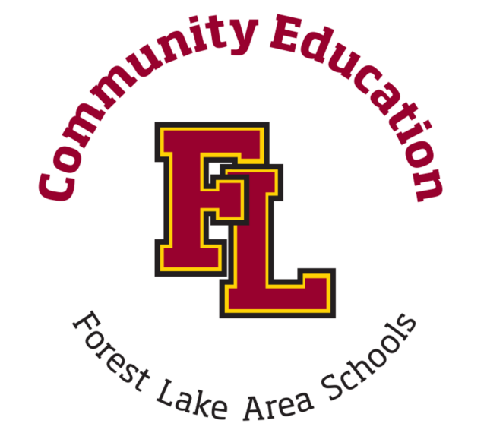
*Registration Fees Can Be Paid in the clubhouse when we open for outdoor golf*

