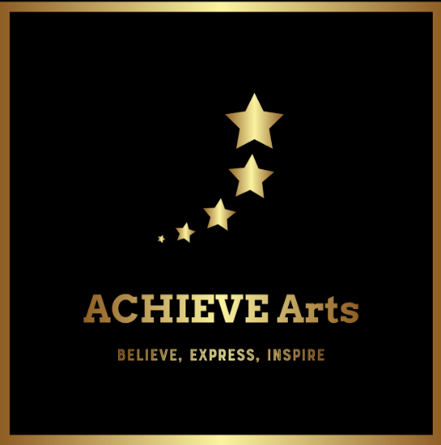
Achieve Arts HQ has been working hard behind the scenes to ensure our students, staff, parents and carers are all safe. Following Public Health,England and the Department of Educations advice here are new modifications we have made to our workshops as always our health and safety is paramount.

Hand washing and hygiene
- All students will be asked to use hand sanitizer before entering the class.
- Hand sanitizer will be available at all times and hand washing will take place at regular intervals throughout the day.
- Surfaces will be cleaned regularly including frequently used areas like door handles, bathrooms, and kitchen utensils.
- All workshop venues will have been deep cleaned before our course starts.

Food and drinks
- Achieve Arts studios are food free zones. Apart from during our Summer Camps where students are required to bring a nut free packed Lunch. They will be reminded not to share food or drink with anyone and will be asked to wash their hands before and after they eat.
- As per our standard practise students are required to bring their own Water bottles to classes. They will be placed on their own designated spot and the children will be able to visit the table when they need a drink.
- During our summer camps all lunch boxes and bottles will be wiped down before lunch.

Medication and first aid
- Any prescribed medication should be given to the Workshop leader who will record and store this safely, as per procedure.
- All Achieve Arts staff have up to date paediatric first aid training and qualifications.
- In line with the new government guidelines, Achieve Arts workshop leaders will wear the necessary PPE when administering any first aid.

Clothing and bags
- Students are only allowed to enter the studio space with a water bottle and their LAMDA folder. Parents and careres will be asked to take any coats or bags home once they have dropped off their child
Whilst we aim to have all our classes run as normally as possible there has to be some changes in the way we do things. We want to ensure the environment we create for our students is as nurturing as possible whilst maintaining their safety. Here are some of the new measure we have implemented during our physical workshops:

Social distancing and student safety during our Workshops
- Registration will take place at the main door of the venue for a socially distanced face-to-face handover without the need for parents to enter the venue. All parents will have to maintain their own social distance measures when handing their child over to a member of staff.
- Registration forms will be electronic, eliminating the need for physical signing at the venue. All registration forms must be filled out VIA our website before students can attend any Achieve Arts workshops.
- Students will be allocated their own “performance spot” to use as their space for ensemble work during the class positioned at the required social distance from others.
- There will be no contact or direct hand-holding activities during workshops or performances.
- When entering or leaving our studios, Achieve Arts staff will ensure that the children are at the required social distance, maintaining their safety and security.
- For the time being there will be no “live” performances at Achieve Arts. All performances will be recorded and sent to students to watch with all the family. Parents are required to sing a disclosure form to ensure their child can take part in these.

Achieve Arts will regularly update our policies in keeping with the latest government advice. So you can relax knowing that we are doing everything in our power to keep our students as safe as we possibly can. If you would like more information please email us at info@achievearts.co.uk.

