FUEL, ACTION & BALANCE
For a strong, healthy body and mind

NUTRITION & ACTIVITY JOURNAL

Date:
Name:
Age:
Weight:
Height:

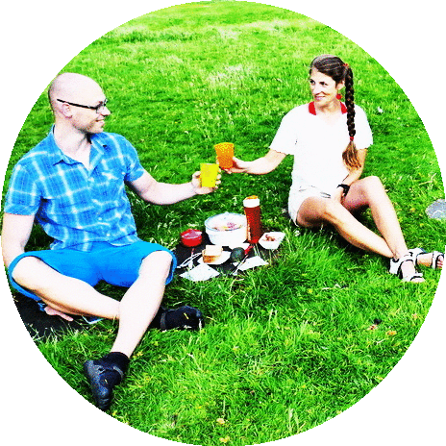

https://fuelactionbalance.com/nutrition

EXAMPLE:

Training or energy consuming activity: | Time |  | Overview of the day & nutrition | Drinks  summary | Supplements or ongoing medical treatment | Comments
Jogging, dancing, fast walking, resistance training, flexibility, pilates, salsa etc. (exercising of any kind ☺)  Please mention any activity which involves a lot of walking (i.e. visiting an exhibition, walking for hours in Ikea, playing with (or running after!) kids).  (time and duration) | 7h00  7h30  8h00  8h15  11h00  12h30  13h30  13h50  17h30  19h00  21h30  23h00 | 8h15  12h30  13h15  17h00  19h00 | Woke up  Breakfast*  Walked to work (approx. 2km)  Office work  Snack*  Lunch* / gym / shopping etc.  Office work  Snack*  Picked-up de kids, played, prepared dinner etc.  Dinner*  TV / put the kids to bed/ reading/ quick stretching etc  Went to bed.  * With as many details about how the food was cooked (grilled, boiled etc), if sauce was added and what kind, if you ate bread and what kind (white, cereal etc), if you had desert (and how many ;) ), the food or ingredients quantities etc.  ** The day you fill in this journal, please keep your nutrition in a… business-as-usual scenario, don’t make any special efforts that day. | 2l water  1 glass of wine  2 coffees with milk/sugar etc.
Training or energy consuming activity: | Time |  | Nutrition | Drinks  summary | Supplements or ongoing medical treatment | Comments
7h00

7h30

8h00

8h30

11h00

12h00

13h30

15h00

17h00

19h00

21h30

23h00

