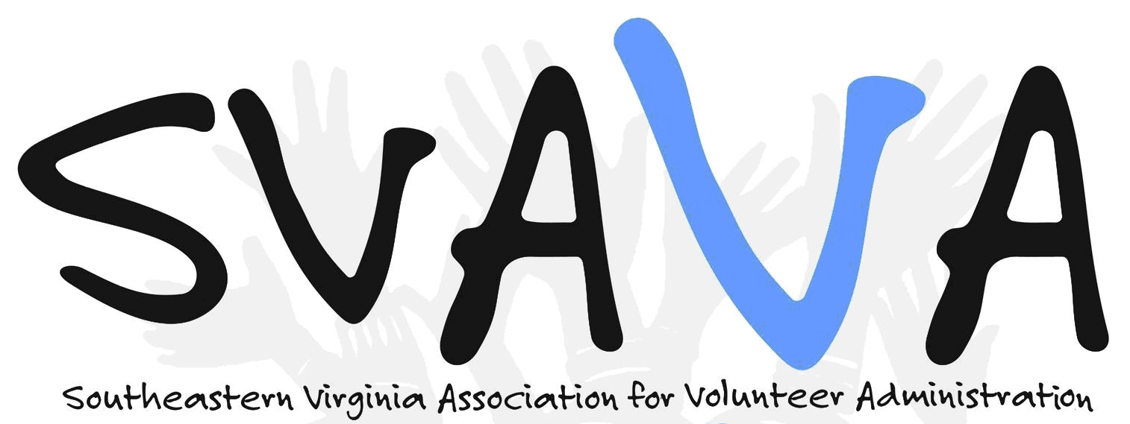

The Southeastern Virginia Volunteer Administration (SVAVA) is a membership organization devoted to providing educational opportunities for, promoting the professionalism of, and strengthening the leadership of volunteer organizations and programs in the Hampton Roads area.

To achieve our goal in offering educational opportunities, the Scholarship Fund is available to assist individuals. This fund is available to be applied to continuing education courses, registration fees, professional materials, and workshops.
Please complete this form if interested in applying for scholarship funds to be applied to continuing education and professional development. Scholarships are distributed based on available funds. The SVAVA Board has the final decision on funding.

As an SVAVA Board Member, you serve a two year term. Each board member is automatically given a (1) $100.00 scholarship to be used in either year of term. To be limited to no more than 3 board members per year. Meaning half of the board will receive a scholarship in the first term, the other half in the second term. Board Members are required to fill out the application form as well.

Guidelines:
• Scholarship applicants must be SVAVA Members in good standing.
• Scholarship funding is to utilize for professional development with priority given to courses, trainings, conferences, etc. related to Volunteer Management.
• Scholarship will be awarded up to $100 and are contingent upon available funds.
• Scholarships will be awarded as a reimbursement.
•Recipients must attend the course or conference within 12 months of scholarship approval.
• Limit 1 scholarship per member per membership year.

Scholarship Recipient Will:
• Complete Information Sheet (on back). Provide and attach an “essay” regarding what you expect to gain from this continuing education and professional development
(personal/professional expectations).
SVAVA Will:
• Grant full or partial scholarships as funds are available.

Southeastern Virginia Association for Volunteer Administration
SoutheasternVA_AVA@yahoo.com
P.O. Box 3274, Norfolk, VA 23514

SCHOLARSHIP APPLICATION
Scholarships available based on available funds.

1. Name: _______________________________

2. Organization: ____________________________

3. Title: _____________________________

4. Supervisor’s Name: ________________________________

5. How long have you been in Volunteer Management: ______________

6. Name of Educational Opportunity: ________________

7. Date of Course or Conference: ___

8. Is your organization able to provide any financial support towards your continuing education and professional development? If yes, please state amount.
_________________________________________________

9. Have you received financial support in the past from your organization and/or SVAVA for continuing education/professional development (yes/no)? If yes, when?

Organization: ___________________ SVAVA: _________________

10. On a separate sheet of paper please highlight why you wish to receive this scholarship (personal/professional expectations) and how you intend to use the scholarship money. If available, attach copy of course or conference information/cost.

Please return this form and any other attachments to:
SVAVA Treasurer
P.O. Box 3274
Norfolk, VA 23514
Or email SoutheasternVA_AVA@yahoo.com

