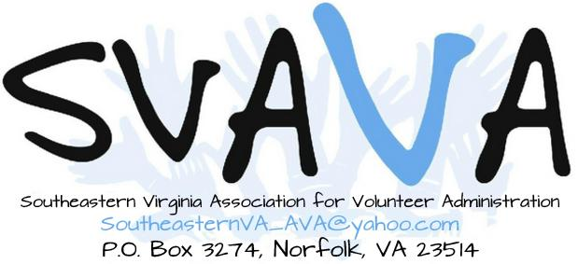

MEMBERSHIP APPLICATION/RENEWAL FORM
(Please print clearly)

Membership Year: 2019

MEMBERSHIP BENEFITS
- Networking opportunities with colleagues in volunteer management
- Discussions of pertinent volunteer resource management topics
- Scholarship program for conferences, classes and other relevant opportunities

DATE __________ Membership* Type (circle one): • Individual • Organizational

NAME ____________________________________________________________________

TITLE _______________________________________________________

ORGANIZATION______________________________________________________________________

ADDRESS ________________________________________________

CITY____________________________________________________, VA ZIP ___________

E-MAIL_____________________________________________

WORK#________________HOME#__________________________

*Membership Type: An individual membership is non-transferable and stays with one individual, regardless of the organization for which they work. An organizational membership is for a designated representative; colleagues are welcome to attend meetings but are not eligible for benefits. In the event the representative leaves the organization or moves to a different position, the membership is transferable to a new designee.

I AM A • NEW SVAVA MEMBER • RENEWING SVAVA MEMBER

Membership runs from January 1st through December 31st of each calendar year. Annual dues are $30.00, payable by December 31 for the coming year. Prospective members who have not previously attended a meeting may attend one meeting per calendar year before being required to submit dues. Any individual working in Virginia who is interested in or serving as an administrator of a volunteer program is eligible for membership.

COMMITTEE INTERESTS (Please circle all that apply)
• Hospitality • Membership • Social Media • Member Resources • Programs

HOW DID YOU HEAR ABOUT SVAVA?_________________________________________________________________

DO YOU KNOW ANYONE WHO WOULD LIKE INFORMATION ABOUT SVAVA?

NAME________________________________________________________TITLE___________________________________

AGENCY_______________________________________________________________________________________________

PHONE_________________________________ E-MAIL________________________________________________________

Return completed Application/Renewal Form with check or money order made out to SVAVA
Mail to: SVAVA, PO Box 3274, Norfolk, VA 23514
For more information on membership, contact Beth Heaton, bheaton@marinersmuseum.org

