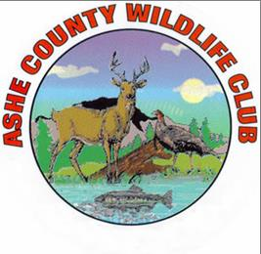
Ashe County Wildlife Club Featured in National Sporting Clays Magazine
Contact: Clint Johnson 336-982-4456

Last August 26 the Ashe County Wildlife Club hosted its first tourney sanctioned by the National Sporting Clays Association (NSCA). Sixty-one shooters from around North Carolina visited the county to shoot clays at the stations scattered around the club. The on-line magazine for NSCA, Clay Target Nation, featured news coverage of the event in its October 2017 issue. The article and photo can be found at: http://www.claytargetnation-digital.com/November2017#&pageSet=8&contentItem=0.
”Our first National Sporting Clays Association registered shoot was a success far above our expectations. We would have thought we had done well with 30 shooters. We drew 61, more than double our expectations. The membership turned out in force to support the event, and the Ashe County Wildlife Club can be very proud of its accomplishment. Guest shooters from out of the area were treated to a great breakfast and lunch, challenging but fun targets worthy of a tournament event, pleasant mountain weather, and the hospitality of Ashe County. What could be better? Many local shooters broke out their quail and grouse and duck guns and got their first taste of competition shotgun shooting,” said Jerry Seaman, who organized the event for the Club.
Sporting Clays is a shotgun sport that emulates bird hunting with clays being thrown from machines set up around the Club’s hilly and wooded terrain about 12 miles east of Jefferson. The Ashe County Wildlife Club will sponsor two NSCA tourneys in 2018, Saturday, August 25, and Saturday, September 29. Club membership is $175 for the first year and $125 each following year. The Club has a club house, a 300-yard rifle range, skeet and sporting clays fields, a 5-Stand and a pyramid trap stand. For more information: www.acwlc.org.

