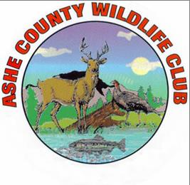
Ashe County Wildlife Club Hosts Introduction To Firearms Safety Day for Ladies on Saturday – May 12 at 11:00 a.m.
For More info: Clint Johnson at 336-982-4456

The Ashe County Wildlife Club will host another Introduction to Firearms Safety Day for Ladies on Saturday, May 12 at 11:00 a.m. at its pistol range at 3220 Big Peak Creek Road, Laurel Springs. The range is about 15 miles east of Jefferson, reached by turning left onto Big Peak Creek Road from N.C. 88 East in front of the Upper Mountain Research Center. There is no charge and no registration list. Ladies should bring their own pistols and ammunition if they have them.
A limited number of pistols will be available to borrow. If a lady knows what type of pistol she would like to borrow, she should bring ammunition for it. For instance, participants without their own guns might buy a box of .38 Special ammunition for a .38 revolver, a box of 9 mm ammo for a 9 mm semi-automatic pistol, or a box of .22 Long Rifle ammo for a .22 revolver or semi-automatic pistol. Hearing and eye protection are mandatory. Some protective glasses and ear plugs will be available for borrow.
“We had 19 ladies come out last fall. Some of them asked us to host another one so we are trying this one in the spring,” said Clint Johnson, publicity chair of the Wildlife Club. “The Club has several women members who are good shooters. In fact, last year our club shooting champion going across all disciplines of pistol, shotgun and rifle was a woman. We encourage women to look at the shooting sports and to join our Club. This day, however, will be all about the basics of how to safely shoot a hand gun. After the basic safety instruction, we will move to the firing line for some individual coaching. We will stay at the range until every lady has been able to shoot as much as she wants. “
The Ashe County Wildlife Club has ranges for pistol, rifle and shotgun and a clubhouse. Nearly every Friday afternoon at 4:00 p.m. starting in May the Club hosts a 5-Stand Friday shoot for shotgunners shooting at flying clays. The shooting calendar for organized events can be found at www.acwlc.org . Membership is $175 for the first year and $125 each year afterwards with the commitment of working eight hours during the year around the club. NRA membership is also required to join the Club.

