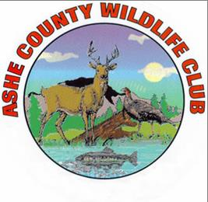
Ashe County Wildlife Club National Sporting Clays Association Registration/Check-in
Date of Shoot _________________

NSCA # ____________________ Conc________ Hunter (Fun) Class_______
Pre-Registered: Yes__________ No___________
ACWLC Club Member: Yes_________ No_________
Name: First___________________ Last____________________
e-mail_______________________ Phone____________________

(Disregard Address ONLY IF PREREGISTERED on ScoringPro.com)
Address________________________________________________
City_________________________ State________ Zip___________

Main Event $75 __________________
Class Option $10__________________
Concurrent Option $10__________________
Targets Only Entry $35 _________________
Addl Lunch $10 # _____ Tot $_____________
Warmups @ $5 # _____ Tot $_____________
Total $________________

Pd ___________________Cash ( ) Check #_____________

