Ashe County Wildlife Club Range Rules
Updated January 2020.
All members and guests must abide by these rules to use our facilities. Members and their guests caught disobeying the following rules will lose their membership with no refund. A review board will determine if the member can be reinstated. Range Safety is not a “gray area.” If you do not follow the rules, you will lose your membership. Members and guests are personally liable for their safety and the safety of others on Club property.

GENERAL RULES FOR USE OF CLUB PROPERTY:
Only active members and their guests are permitted to use the range facilities except during organized shoots or Club activities to which the general public has been invited.
Members must accompany guests while on Club property. Members may not give out the gate codes to non-members.
The Club Member who unlocks any of the Club locks is responsible for also relocking IF the Club member is the only one or last one using the range. DO NOT leave the gates open upon leaving the range if you are the only one left on the range.
New members must be trained in the use of clay throwing equipment in orientation sessions scheduled by the Club.
Club members are responsible for their own safety and the safety of their guests. Club members must ensure that their guests handle their firearms in a safe manner.
No alcohol or mood-altering drugs may be consumed while on Club property.
Hearing and eye protection are strongly recommended.
No hunting is allowed on Club property.
Club ranges are generally open for shooting at 9:00 a.m. Monday through Saturday, and 1:00 p.m. on Sunday. There are exceptions for scheduled Club matches.
Club ranges are used by local law enforcement agencies for practice and qualifying. Please yield to their needs if they are already on the ranges, or come out to use the ranges. We will try to list law enforcement practice dates on the Club calendar.
Clean up spent shell casings, used paper targets, etc. and take them with you when you finish shooting at all ranges. There is no regular garbage service at the ranges.
Return chairs, rests, benches, etc. to where you found them.
FIREARMS SAFETY FOR ALL RANGES:
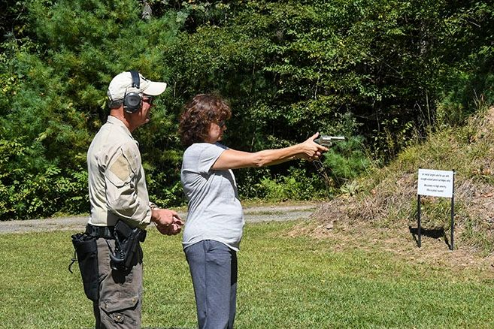
The Club follows the simple acronym: M.A.T. That stands for Muzzle – Action – Trigger. Keep your Muzzle pointed down range or in a safe direction away from all humans, animals or objects. Keep your Action open and clear of any rounds until ready to shoot. Keep your fingers outside of the trigger guard and off the Trigger.
All firearms must be unloaded, magazines removed, actions open, or bolts removed when arriving or leaving the ranges. Handle each firearm as if it is loaded. Do not load or chamber a round until on-station and ready to shoot. Shoot only on ranges with a backstop. Shoot straight towards the backstop.
DO NOT PLACE TARGETS ON THE GROUND! No cans, water bottles, water jugs, etc. may be placed on the ground as targets. The ground at the Club ranges is clay and hard. Bullets hitting the ground have been known to ricochet into the air and above the backstops. This is a zero tolerance policy. All targets must be at least four feet above the ground and mounted in or on a target frame.
Place paper targets only on the target frames at each range. DO NOT put paper targets on the wooden posts at any range. This is a zero tolerance policy as shooting at the wooden posts is damaging to Club property.
“COLD RANGE!” – Use this safety term when you want to ensure that all shooters put down their firearms when someone needs to go down range such as to reset targets. When you hear “COLD RANGE!”, open the action on your firearm and put it down. NO ONE should have their hands on any guns or be handling ammo once “COLD RANGE!” is shouted. If someone is driving by (such as at the Pistol Range), go to “COLD RANGE!” until they have passed.
“HOT RANGE!” – This safety term is shouted once the range is clear of anyone down range and it is safe to shoot.
“CEASE FIRE!” – This is a safety term meaning for EVERYONE to stop shooting. Notify others shooting if you have a live round in the chamber that must be shot or removed.
Treat any misfire with caution. Wait at least a minute before opening the breech in the event there is a “hang fire” (common in black powder muzzle loaders). If the primer fires, but the power does not fire, immediately stop shooting. Once you confirm there is no hang fire, check the barrel for a bullet that may have traveled down the barrel, but not out the muzzle (commonly called a “squib”).
When a new shooter comes onto the range, use good manners and go “COLD RANGE!” as soon as practical so they can set up their targets. ALWAYS CHECK AND DOUBLE CHECK that all shooters have returned to the shooting line before going to “HOT RANGE!”.

RIFLE RANGE RULES
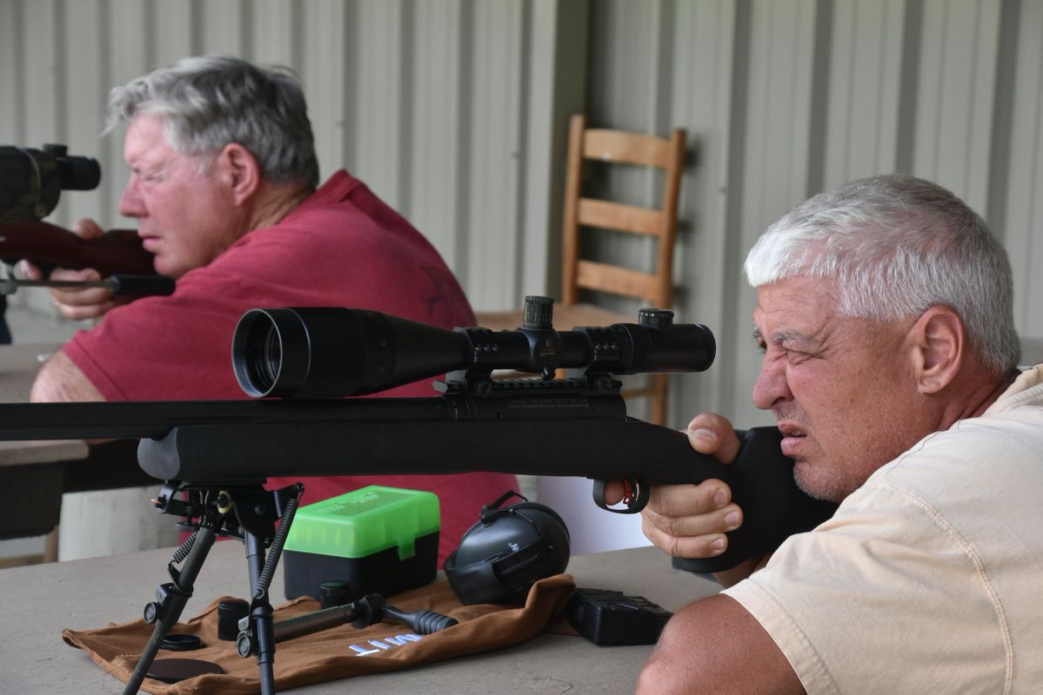
The Club follows the simple acronym: M.A.T. That stands for Muzzle – Action – Trigger. Keep your Muzzle pointed down range or in a safe direction away from all humans, animals or objects. Keep your Action open and clear of any rounds until ready to shoot. Keep your fingers outside of the trigger guard and off the Trigger.
Shoot only at targets placed on the target frames. Make sure your rounds go straight in the direction of the backstop.
DO NOT PLACE ANY TARGETS ON THE GROUND (No cans, bottles, etc.). Bullets hitting the ground can ricochet.
NO FULLY AUTOMATIC WEAPONS ARE ALLOWED ON CLUB GROUNDS (This rule has an exception for Law Enforcement Agencies).
Until the Rimfire Rifle Berm is built (Spring 2020), ALL personal/individual Rimfire Rifle shooting will be conducted at the Pistol Range. The exception to this is when the Club has organized Rimfire Rife Shoots when portable target frames are moved closer to the Rifle Range backstop.
Initial sight-in of hunting rifles is to be conducted at the Pistol Range.
NO PISTOL SHOOTING on the Rifle Range.
Use only Rifle Frames for hanging targets. DO NOT HANG TARGETS ON WOODEN POSTS, PVC POSTS, etc. This is damaging Club property.

SHOTGUN RANGE RULES
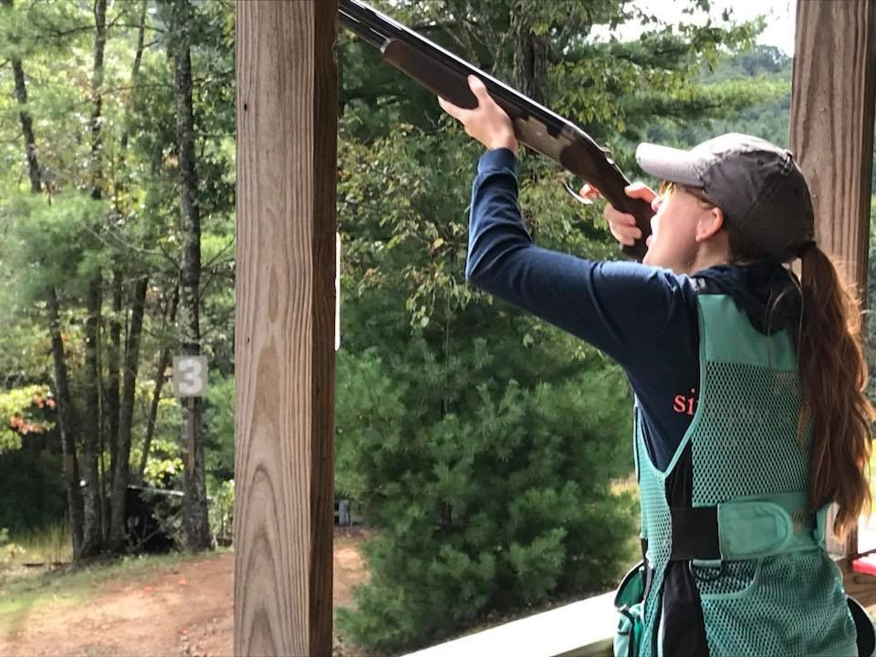
The Club follows the simple acronym: M.A.T. That stands for Muzzle – Action – Trigger. Keep your Muzzle pointed down range or in a safe direction away from all humans, animals or objects. Keep your Action open and clear of any rounds until ready to shoot. Keep your fingers outside of the trigger guard and off the Trigger.
Shotgun actions are to remain open and unloaded until on station. It is permitted to close the empty shotguns when stationed in the shotgun racks at the 5-Stand, Skeet Field, and Pyramid Trap.
If using an automatic shotgun, never load more than two rounds.
Double check your ammo before loading if you own multiple caliber shotguns to avoid confusing 12 and 20 gauges, or 20 and 28 gauges.
Do not use shot larger than 7 ½ used on any of the shotgun ranges.
SKEET – It is suggested that Skeet shooters load only one round for each single and two rounds for doubles. If using an automatic shotgun, never load more than two rounds.
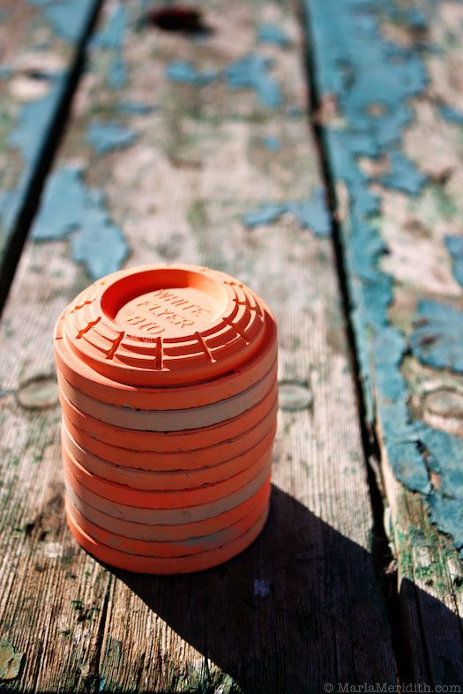
Trap Machine Safety &
Trap Machine Use Rules
New members must attend a trap machine safety and operation demonstration before using the Pyramid Trap machine (the only automated machines that can be used by individual members outside of an organized Club shoot).
Do not walk in front of a shotgun trap as a thrown clay can be dangerous. Do not get close to the throwing arm as it can be dangerous.
At the end of shooting, make sure the trap machine’s throwing arm has been released so there is no stored energy. Power switches should be in the off position at the end of the day. All 5-Stand traps are powered by batteries. The Pyramid Trap is powered by electricity.
5-Stand and Sporting Clays throwers are only open during organized Club Shoots. They are not to be used by individual members.
Pyramid Trap is open to individual members, but new members must complete an orientation course on how to turn on and turn off the thrower. Bring your own NEW, BOXED clays. DO NOT pick up unbroken clays from the field and put them into the electric throwers. Clays from the field often have sand in them that can damage the machines.
When all shooting has ended, clean the traps of clays, remove all shell casings and boxes. There is no garbage collection at the Shotgun Range. If you brought it in with you, take it out with you.
Manual throwers are usually available in front of the Skeet Field. You may use unbroken clays recovered from the field in the manual throwers. Using manual throwers are the best way for new shooters to practice their shotgun skills.
PISTOL RANGE RULES
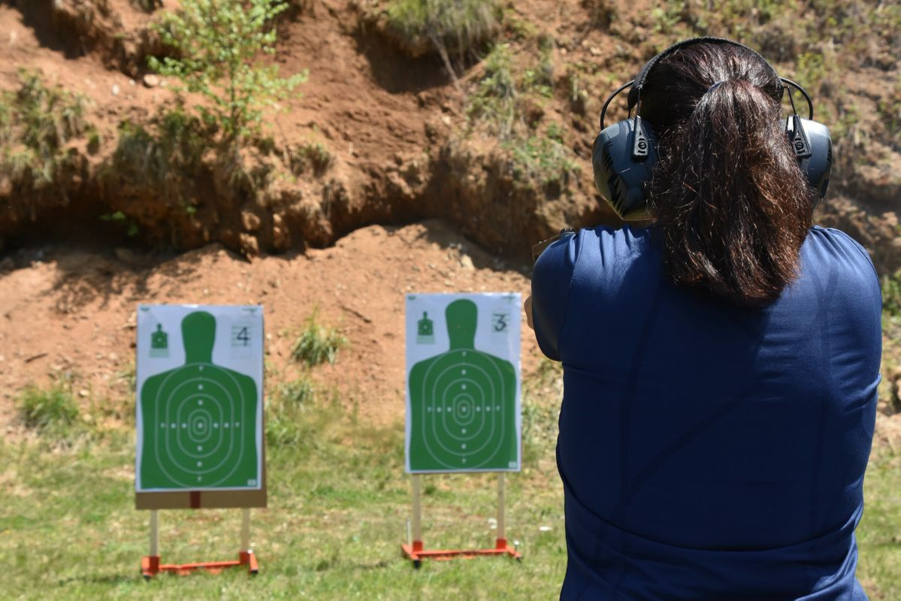

The Club follows the simple acronym: M.A.T. That stands for Muzzle – Action – Trigger. Keep your Muzzle pointed down range or in a safe direction away from all humans, animals or objects. Keep your Action open and clear of any rounds until ready to shoot. Keep your fingers outside of the trigger guard and off the Trigger.
Pistol Knockdown Targets and spinner targets are only for pistol and rimfire calibers. DO NOT FIRE HIGH POWERED RIFLE CALIBERS at the Pistol Knockdown Targets. This is a zero tolerance rule. Anyone caught shooting AR-15s, AK-47s, or any high powered rifle round at the pistol knockdown targets will have their membership revoked.
NO FULLY AUTOMATIC WEAPONS ARE ALLOWED ON CLUB GROUNDS
Rimfire Rifles may be used on the knockdown targets. All rimfire and rifle sight-ins are to be conducted on the Pistol Range.
Be a good neighbor. When new shooters arrive, go “COLD RANGE!” so they may set up their targets. There are 12 target stands that accept cardboard targets so there should be enough space for at least 12 shooters on a common firing line.
When finished shooting, pick up shot brass and remove shot-up targets and shot-up cardboard. There is no garbage collection at any range. If you brought it in, take it out. Return target stands to the storage shed. If the wooden uprights are shot-up, do not put them back in the shed. Take them home and dispose of them.
In the storage shed are two large tarps with large nails that can be used to stake out to collect brass. There are also brass pickers and cans so spent brass can be picked. Take spent brass out with you.
If new shooters arrive and want to establish another shooting line, negotiate on a single shooting line. DO NOT shoot from more than one shooting line. Pistol Knockdown shooters must be on the same line as Target Stand shooters.
IF YOU HAVE ANY RANGE RULES SUGGESTIONS TO IMPROVE THESE RULES, PLEASE CONTACT E.T. WEAVER AT 336-846-3752 or e-mail him at ETWeaver@skybest.com. 