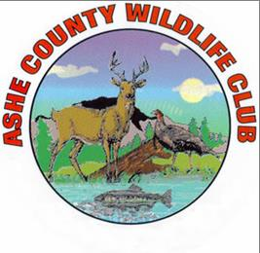
Ashe County Hunters for the Hungry Donate 61 Deer to Food Banks in Ashe County in 2018 Hunting Season
For more info: Bill Burkett 336-977-3888

The Ashe County Wildlife Club, sponsors of the North Carolina Hunters for the Hungry for the past nine years, reports that 61 deer were harvested in the September 2018 through January 1, 2019 hunting season. With each deer yielding 40 to 50 pounds of meat that means that up to 3,050 pounds of meat were donated to three food pantries in the county in 2018. The meat is ground up and packaged in two-pound packets so upwards of 1,525 meals were provided free to the county’s needy through Ashe Really Cares, Ashe Outreach Ministries, and Camp New Hope.
“Hunting season was affected this year with wet weather and that big heavy snow that kept many hunters out of the woods and off of the tree stands for a few days,” said Bill Burkett, coordinator of Hunters for the Hungry for the Ashe County Wildlife Club. “Still, 61 deer are around what we have been averaging for deer donations over the past several years.”
Joe’s Place, a meat processor at 638 Friendship Baptist Church Road in Jefferson, processes the donated deer at a steep discount to the Wildlife Club. The Wildlife Club pays for the processing through its own funds and any additional donations collected from the public and churches. All donations are tax deductible.
“The Club has always enjoyed its association with N.C. Hunters for the Hungry,” said Burkett. “The program provides protein for those who need it; a chance for hunters to extend their hunting season if they’ve already filled their own freezers; and it is a charity where all the benefits stay right in Ashe County. Thanks to all of the hunters who did participate their deer.”
Ashe County Wildlife Club maintains shotgun, rifle, pistol and archery ranges at 3220 Big Peak Creek Road, near Laurel Springs (about 15 miles east of Jefferson, off N.C. 88 East. Membership is $175 for new members and $125 for regular members each year after joining the club. Lifetime memberships are available. For details on the club, visit www.acwlc.org or search on Facebook for Ashe County Wildlife Club. Membership applications can be downloaded from the site, or picked up from Weaver Equipment Company at 102 South Main Street in Jefferson.

