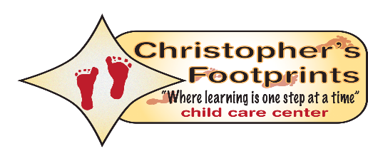  
**Infant 1/ Infant 2**

Our Infant program is designed to ensure your child achieves the essential milestones of their social, emotional, intellectual, and physical development. Experienced and loving staff will help your child develop a sense of trust through both bonding and stimulation; music, and story time, and tummy time to help lay the foundation for their future learning.

**Younger Toddler: Toddler 1/ Toddler 2**

Crawler's Our Toddler 1 classroom encourages child interaction and learning through play as it helps promote thinking, talking, exploration and discovery. Gross motor (physical activities), fine motor (eye-hand coordination) and language development skills are reinforced daily as they are essential tools for our toddlers to evolve and establish a sense of independence.

**Older Toddler: Toddler 3/ Toddler 4**

Our Older Toddler program encourages learning through play as it promotes thinking, talking, exploration and discovery. Gross motor (physical activities), fine motor (eyehand coordination) and language development skills are reinforced daily as they are essential tools for our toddlers to evolve and establish a sense of independence.

**Preschool 1/ Preschool 2/ Preschool 3**

Glider's Our Preschool program provides the basic skill sets necessary for advancement in all areas of child development. Physical and intellectual; name, number and letter recognition, basic shapes, as well as communication and problem solving skills are routine as they build self esteem and promote excellence in language development.

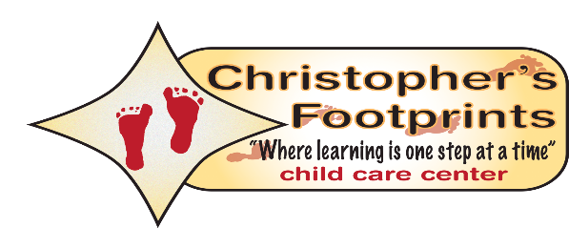

**Pre-Kindergarten 1/ Pre- Kindergarten 2**

"Preparation, Progression, and Preservation." Our Pre-K program prepares your child with the tools; academic and physical as well as social and emotional, necessary for furthering education while providing a smooth transition. Your child will learn all of the material necessary to prepare themselves for Kindergarten. Material such as, writing and recognizing ones name, address and telephone number in addition to letters, numbers, shapes and colors.

**After School/ Summer Camp**

Working on life skills throughout the summer while providing a fun learning environment. We also provide fun outings and learning on various field trips for all school age campers. Different professionals will stop by to work hands on with the students doing art, sports, speeches, reading etc.