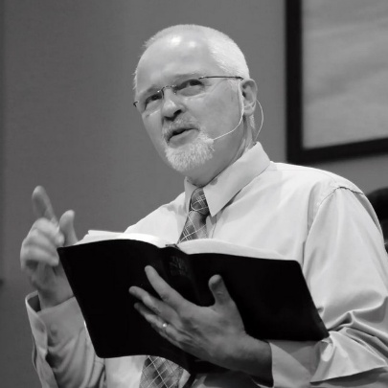
THANK YOU!
As my time of service as your Senior Pastor at Mountain View comes to a close I want to express my deep and sincere appreciation for the opportunity given me to serve among and with you over these past 23+ years. When Janet and I moved here with our three young children I hoped to serve a “long time” – ideally at least until our children were through High School (so that they might have some stability). Such a goal was ambitious in a world where Senior Pastors average about seven years at a church. But, by God’s grace and because of your partnership in ministry, that goal was reached – and passed -- long ago.
Knowing my limitations (which we all have in one form or another) I have always been wary of staying beyond my usefulness as your Senior Pastor. And, while no one has ever communicated to me that they believed I should consider moving on (perhaps because they were too afraid or too kind), our church is at a point where I believe my stepping aside now will be beneficial to Mountain View in the long run.
Please know that in stepping aside as your Senior Pastor I hope to practice what I have been preaching – to remain useful to God somehow, in some way, wherever He has me. I have already been accepted as a substitute teacher at Dayspring Christian Academy here in Greeley – which has the potential to keep me as busy as I might want to be. And, having a desire to continue preaching God’s Word, I have created a website (www.preacheroftheword.com) to introduce myself a bit to those in churches that are looking for or in need of one-time or short-term “pulpit supply”.
It has been and will be my prayer that you who are “Mountain View Church” will demonstrate unity as you go through the coming months with Pastor Al Lewis as your Intentional Interim Senior Pastor. May he sense the same love and support that I have known. May you seek, be sensitive to, and follow God’s leading as Pastor Al helps guide you through the process of taking inventory of our strengths and weaknesses, as he helps guide you through the process of identifying our goals for the future, and as he helps guide you through the process of searching for the next Senior Pastor of Mountain View. Whoever that will be, he will be fortunate to serve here at Mountain View Church with you!
With gratitude for the privilege that Janet & I (and our children) have had of being a part of the Mountain View Church family,
Pastor Bruce

