As a counsellor I am committed to you, my client.
I will provide a safe, supportive, non judgemental space for you.

Each session will last for 50 minutes.
Please be free of non-prescription drugs or alcohol prior to the start of the session. Sessions take place, by agreement, weekly or fortnightly.

I will not counsel in areas I am not qualified to do so.
Should our work move towards such areas I will not just drop you as a client.
The sessions will still be available but will assume a holding style i.e. not go into the matters I am not competent to deal with.

I will always be open, honest and ethical in the sessions with you.
As a member of the British Association of Counsellors and Psychotherapists (BACP) I am bound by their ethical framework at all times.
You can view a copy of this framework simply by searching online - BACP Ethical Framework. Part of the ethical framework is concerned with client confidentiality. I will always preserve your confidentiality unless I have reason to believe that you are a serious risk to the safety of others or yourself, are involved in money laundering, acts of terrorism or people trafficking. Hopefully this can be discussed with you, but not necessarily.

As a BACP counsellor I am required to have regular clinical supervision, when in supervision I may speak about clients or client related issues. In clinical supervision your identity will be kept anonymous.

Under UK General Data Protection Regulations I am required to keep records in a non identifiable form and in a digitally safe way. This I do and records are kept for up to 7 years. You can view these records by asking for them in writing. I will provide them within 1 month.

Periodically we will review our progress and discuss direction and duration of sessions.
Should you not be able to attend sessions I require at least 24 hours notice. Events happen and this is acknowledged.
It is okay to leave a message or to email if you are unable to attend.
Failure to do so might mean that a fee is still due.
I will endeavor to give 24 hours notice should I be unable to attend.

ODAAT Counselling.
Counsellor - Client Contract

Online Counselling

When undertaking counselling online I will need to know the following so that the counselling can be safe and ethical.
Your location in the unlikely event a 999 service is required to attend.
An agreed method of contacting you should the internet connection be broken i.e is it okay to phone? Leave a message? Text you?
In the event that I need to make a duty of care call, on your behalf, I will need the contact details of your GP as well as a friend, partner or family member.

Out Of Session Contact

I will provide counselling during sessions, however, if you need emergency psychological support or are in crisis please call 911 or The Samaritans.
It can be helpful to write down thoughts and feelings between
sessions. These can be useful memory aids for subsequent sessions. If you want
to send them to me between sessions, please do so. However, be aware that I will not reply to these, though I am happy to refer to them when we meet.
I will reply if they are about times and changes of appointments.

Payment

I charge £60 per 50 minute session.
Late arrival will be charged at the agreed full session rate and the session will not extend beyond the agreed time for the session.
Short notice cancellation may attract the full fee.
Payment is expected, in full, 24 hours before the start of the session.
Please pay nationwide bank account -:
S FAYERS
Sort Code 07-09-76
Account number 02002609

Insurance

I am insured as a psychotherapeutic counsellor and also for the purposes of Public Liability.

By reading and signing this contract you agree to the terms and being available at the time and in the mode we agree.

ODAAT Counselling.
Counsellor - Client Contract

Client Signature

Date

GP Contact Details

3rd Party Contact Details

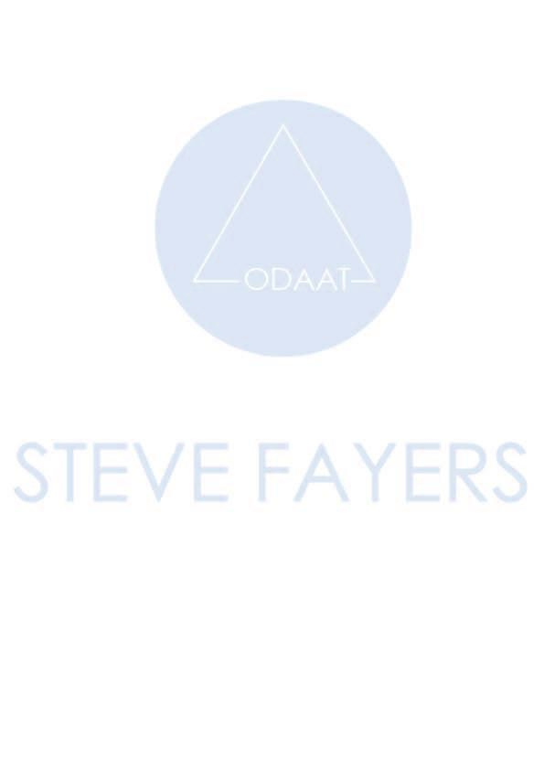
3rd Party Relation To You i.e friend, partner, colleague

