Show Low Days 2024
Chamber Use Only
App. Rcvd: Paid: Booth #(s): Paid Date:

June 7-8, 2024

Frontier Park, 660 N 9th Place Show Low, AZ
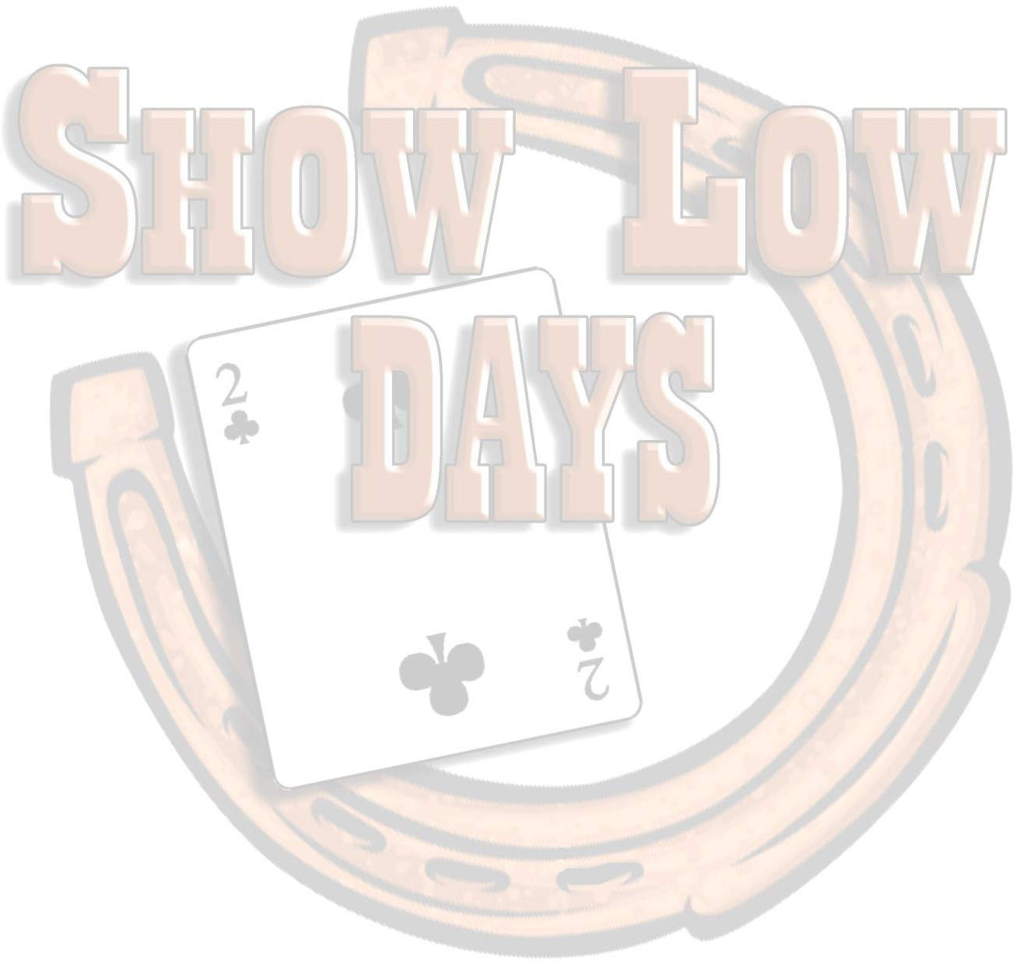
FOOD VENDOR APPLICATION
Company Contact Name E-Mail Address Mailing Address City, State, Zip Product Sold:
Returning Vendor? YES or NO
Website
Phone
Years Attended:
AZ Tax License Number:
Display Type: Tent or Trailer (dimensions and drawing)
Special Needs
Let us know who to make your refund check out to:
COMPANY INFORMATION: Please TYPE or PRINT clearly

REGISTRATION INFORMATION: Vendors are responsible for their own liability insurance and must provide a certificate of insurance with this vendor application.
BOOTH SIZE |  | Price | Amount Due
SINGLE BOOTH SPACE: one 10’x10’ booth.  There is a $50 discount for Show Low Chamber Members |  | $225.00
DOUBLE BOOTH SPACE: one 20’x10’ booth. |  | $350.00
PREMIER BOOTH SPACE: one 30’x10’ booth. |  | $450.00
ELECTRIC OUTLET: one electrical hookup within 50’ of booth (Chamber does not supply cords). Power will be provided during the event hours only. |  | $ 160.00
**Refundable Deposit. Please see CANCELATION AND REFUND for details |  | $100.00 | $100.00
TOTAL

THIS VENDOR APPLICATION WILL NOT BE APPROVED WITHOUT PAYMENT AND A COPY OF YOUR LIABILITY INSURANCE.

CHAMBER CONTACT INFORMATION
Please e-mail or mail the signed application forms and copy of insurance to the Show Low Chamber of Commerce.
81 E. Deuce of Clubs
Show Low, AZ 85901 Contacts: Sunshine Brewer, Executive Director
Phone: (928) 537-2326 Melisa McKinley, Membership Coordinator
DEADLINES AND DATES AT A GLANCE:
May 31, 2024
June 7, 2024
June 8, 2024
Final Day for Vendor Registration
Friday: Saturday:
Vendors Set- Up Hours 8:00 a.m. – 11:30 a.m. Vendors Set -Up Hours 7:00 a.m. – 9:30 a.m.
NO VEHICLES WILL BE ALLOWED ON THE FIELD AFTER 11:30 a.m. on June 7th. (No Exceptions)
FOOD VENDORS MUST BE OPEN FOR BUSINESS AS FOLLOWS:
June 7, 2024 Friday: Vendor Show Hours 12:00 p.m. – 10:00 p.m.
June 8, 2024 Saturday: Vendor Show Hours 10:00 a.m. – 10:00 p.m.
VENDOR BREAKDOWN
June 9, 2024 Sunday: Vendor Show Breakdown 8:00 a.m. – 12:00 p.m.
MUST BE OFF THE FIELD BY 12:00PM IN ORDER TO RECEIVE REFUND
E-Mail: info@showlowchamber.com

PAYMENT INFORMATION
Preferred Method of Payment: Credit or Debit Card. Please call Chamber with card information to complete the transaction. Checks should be made payable to the Show Low Chamber of Commerce and mailed to Show Low Chamber at the office address. Paid invoices will be emailed back to the email listed on application.

CANCELATION AND REFUND
Registrants who provide written notice of cancelation to the Show Low Chamber Office before May 30, 2024 will receive a refund less a $25.00 service charge. No refunds will be provided for cancelations received after May 30, 2024 for any reason.

** A $100 REFUNDABLE deposit is required. Vendors may be and are encouraged to remain open for the entire time that the Show Low Days Event is open to the public. FOOD VENDORS ARE REQUIRED TO BE OPEN DURING THE ENTIRE EVENT. Chamber Staff will verify this at the end of each day. Refunds will be mailed out the

BOOTHS/DISPLAYS
Single booths spaces are 10’x10’ and will be assigned on a first-come, first-serve basis. An electric connection can be available within 50’ of your booth space for an additional $50 if requested and paid for on your Vendor Application. Extension cords will not be provided. Pop-up tents are permitted and highly recommended, sometimes we do get weather. Weights on tents are mandatory for safety purposes. No stakes are permitted on the field.

FOOD VENDOR SPOTS
Single spaces are 10’x10’ and will be assigned on a first-come, first-serve basis. An electric connection can be available within 50’ of your booth space for an additional $160 if requested and paid for on your Vendor Application. Extension cords will not be provided. Only quiet generators are allowed and are encouraged.

SECURITY

Security will be provided throughout the entire event until everything is broken down and removed.

LIABILITY FOR LOSSES

The Show Low Chamber of Commerce and The City of Show Low will not be responsible for losses or damage resulting from any cause connected with transfer, installation, maintenance, storage or removal of exhibits or management of the exposition. The vendor assumes complete responsibility and liability for all injury to any and all persons or property in
any way connected with vendor’s display or caused by vendor, his/her agents, representatives, or employees.

The vendor agrees to protect, indemnify, defend and hold harmless the Show Low Chamber of Commerce and the City of Show Low and their employees and agents against all claims, losses or damage to persons or property, government.
charges, fines, or costs (including reasonable attorney’s fees) arising out of or connected with the use of facilities, including but not limited to installation, removal, maintenance, occupancy or use of the premises or part thereof by vendors, invitee or agent of vendors or any independent contractor hired by vendors, except those claims arising out of the sole gross negligence or willful misconduct of the Show Low Chamber of Commerce.

The Show Low Chamber of Commerce and The City of Show Low reserve the right to deny any application, expel any vendor, change, modify or cancel this event at any time.

PLEASE NOTE

The evening hours get dark inside vendor booths. It is highly recommended that vendors bring lighting for their booths. No open flames or camp propane lights with a flame are permitted.

Overnight parking is not permitted in the Frontier Park, Per City Ordinance.

No dogs or pets except service dogs.

By signing, the Vendor agrees to all terms and conditions set forth herein this VENDOR APPLICATION

and 2023 General Vendor Information

SIGNATURE of Responsible Party Print Name & Title Date

