Become a Foster Grandparent or Senior Companion!
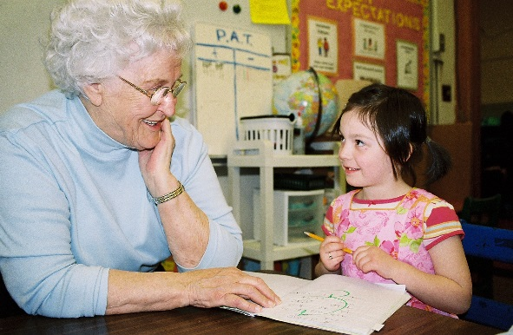
The Opportunity Alliance has meaningful volunteer opportunities available for adults 55 and older in Southern Maine. Foster Grandparents are placed in schools and child development centers to support school readiness and academic achievement of children. Senior Companions make independence a reality for isolated elders by visiting clients in their homes and providing transportation assistance for doctor’s appointments and/or grocery shopping.

Volunteers who commit to a minimum of 15 hours/week and meet generous income guidelines, receive a tax-free stipend, mileage and meal reimbursement. All volunteers receive ongoing training, recognition, and supervision.

We are also accepting referrals for individuals interested in having a Senior Companion provide socialization and local transportation.

To learn more about becoming a volunteer or client, please call 207-773-0202 or toll-free at 1-800-698-4959.

