Road work to be completed in the Spring of 2020

The Town of Porter will accept sealed bids for work to be done on the roads listed below until 3:00 pm on December 6, 2019 at the TOWN OFFICE, located at the Porter Town Hall, 71 Main Street, Maine 04068. Bid documents shall be in clearly marked sealed envelopes titled Road Work to be completed in the Spring of 2020 – all bids will be opened in the Selectmen’s MEETING ROOM at 9:30 AM on December 9, 2019, and a contract will be awarded on December 18, 2019 at 3:00PM.

Scope of Work:

Chapel Street: Remove existing bituminous pavement and existing boulders from road surface for approximately 2165’, and return to gravel 18’ wide as per the “typical cross section” drawing. See appendix A for more information

Pine Street: Remove existing bituminous pavement and existing boulders from road surface for approximately 1825’, and return to gravel 18’ wide as per the “typical cross section” drawing. See appendix B for more information

Colcord Pond Road: Remove existing bituminous pavement and existing boulders from road surface for 3630’, and return to gravel 18’ wide as per the “typical cross section” drawing. See appendix C for more information. Two large white pine trees are marked, and will need to be removed.

Colcord Pond Road - Hill: Beginning at a point designated by the Selectman of Porter. This portion of Colcord Pond Road is approximately 1600’ long and 17’ wide with 14’ of pavement. Three trees have will need to be removed, two red oak trees and one yellow birch which are marked with pink ribbon. BMP’s will need to be used on the hill. See “typical roadway section” drawing. See appendix D for more information.

Insurance:

The contractor must be able to provide proof of liability insurance in the amount of $1,000,000.00, EIN number or social security number, and a copy of certificate of workers compensation if you have employees working with you, or a predetermination certificate from the State. Proof of insurance for all vehicles used must also be provided, and all vehicles must be properly registered. This must be done before any work can begin if you are awarded the contract.
Disclaimer

The Town of Porter reserves the right to reject any or all Bids, to waive any technical or legal deficiencies, and to accept any Bid that it may deem to be in the best interests of the Town of Porter, to negotiate the contract Price with any Bidder, and to omit any item or items deemed advisable for the interest of the Town of Porter.

MANDATORY PRE-BID CONFERENCE
A pre bid conference will be held at 8AM on November 18, 2019, starting at the Porter Town Hall, to present and review elements of the project. All prospective bidders must attend.
Bids are due in the Porter Town Office by 3PM on December 6, 2019

BIDDER INFORMATION:

NAME: _________________________________________________

DBA/ ___________________________________________________

ADDRESS: ______________________________________________

TEL: __________________________________________________

Email: ______________________________________________

I CURRENTLY HAVE: (CIRCLE ALL THAT APPLY)
- GENERAL LIABILITY INSURANCE
- AUTO INSURANCE
- WORKERS COMP INSURANCE OR CERTIFICATE FROM WC BOARD.

I, ___________________________________, DO HEREBY PLACE THE FOLLOWING BIDS:

Chapel Street: _______________________________

Pine Street: _________________________________

Colcord Pond Road: __________________________

Colcord Pond Road – Hill: ______________________

Total Bid Amount: ________________________

REFERENCES:

________________________________________________________________
________________________________________________________________

Appendix A

Chapel Street: Remove existing bituminous pavement and existing boulders from road surface for approximately 2165’, and return to gravel 18’ wide as per the “typical cross section” drawing. Start and stop points are marked on the road.

Best management practices must be used, and all driveways are to be matched or blended into the road. Bidder must be willing to cooperate with the town in a professional manner.

Bid for Chapel Street: ___________________________________

Bidder Company: _____________________________________

Bidder signature: _____________________________________

Date: _______________________

Typical cross section – no asphalt

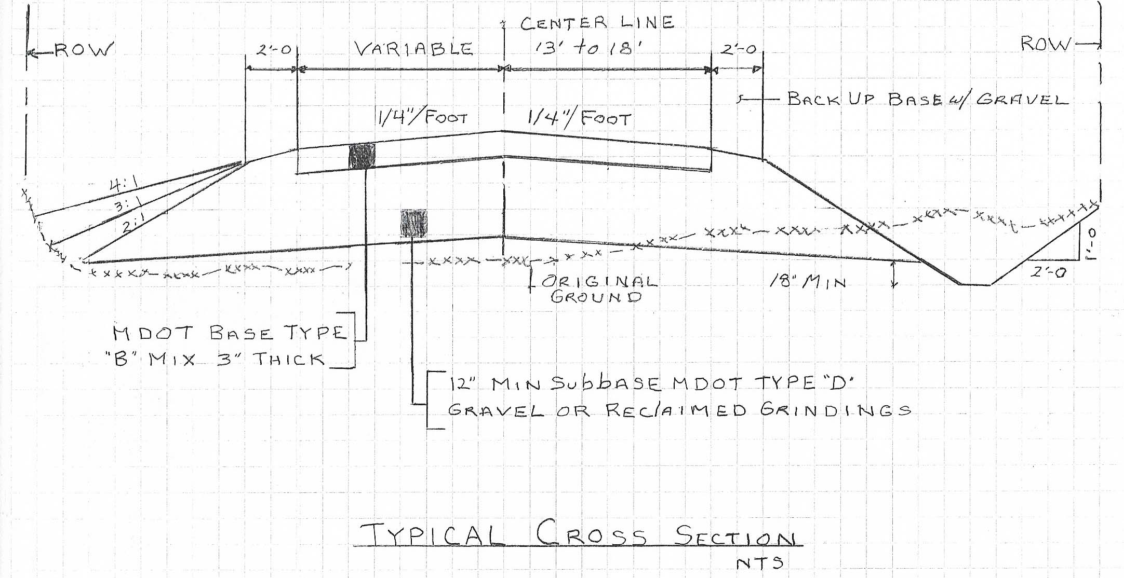

Appendix B

Pine Street: Remove existing bituminous pavement and existing boulders from road surface for approximately 1825’, and return to gravel 18’ wide as per the “typical cross section” drawing. Start and stop points are marked on the road.

Best management practices must be used, and all driveways are to be matched or blended into the road. Bidder must be willing to cooperate with the town in a professional manner.

Bid for Pine Street: ___________________________________

Bidder Company: _____________________________________

Bidder signature: _____________________________________

Date: _______________________

Typical cross section – no asphalt

Appendix C

Colcord Pond Road: Remove existing bituminous pavement and existing boulders from road surface for 3630’, and return to gravel 18’ wide as per the “typical cross section” drawing. Two large white pine trees are marked, and will need to be removed. Start and stop points are marked on the road.

Best management practices must be used, and all driveways are to be matched or blended into the road. Bidder must be willing to cooperate with the town in a professional manner.

Bid for Colcord Pond Road: ___________________________________

Bidder Company: _____________________________________

Bidder signature: _____________________________________

Date: _______________________

Typical cross section – no asphalt

Appendix D

Colcord Pond Road - Hill: Beginning at a point designated by the Selectman of Porter. This portion of Colcord Pond Road is approximately 1600’ long and 17’ wide with 14’ of pavement. Three trees have will need to be removed, two red oak trees and one yellow birch which are marked with pink ribbon. BMP’s will need to be used on the hill. See “typical roadway section” drawing. Start and stop points are marked on the road.

Best management practices must be used, and all driveways are to be matched or blended into the road. Bidder must be willing to cooperate with the town in a professional manner.

Bid for Colcord Pond Road - Hill: ___________________________________

Bidder Company: _____________________________________

Bidder signature: _____________________________________

Date: _______________________

Typical cross section – with asphalt

