FCC CONSUMER CONNECTIONS

Affordable
Connectivity Program
The Affordable Connectivity Program is an FCC program that helps connect families and households struggling to afford internet service.
The benefit provides:
- Up to $30/month discount for internet service;
- Up to $75/month discount for households on qualifying Tribal lands; and
- A one-time discount of up to $100 for a laptop, desktop computer, or tablet purchased through a participating provider.
See if You Qualify and Apply
Call: 877-384-2575
Visit: ACPBenefit.org
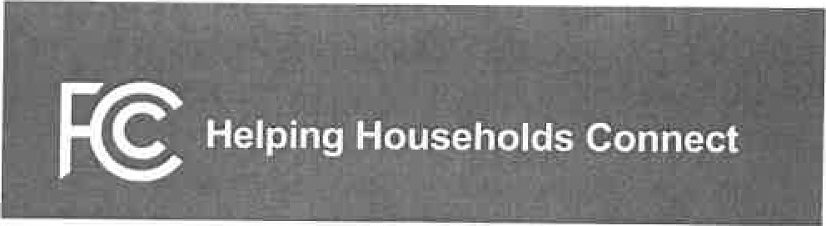
FCC I CONSUMER CONNECTIONS

Affordable
Connectivity Program
Are You Eligible?
A household is eligible if a member meets at least one of the criteria below:
- Has an income that is at or below 200% of the Federal Poverty Guidelines;
- Participates in certain assistance programs, such as SNAP, Medicaid, Federal Public
Housing Assistance, SSI, WIC, or Lifeline;
- Participates in Tribal specific programs, such as Bureau of Indian Affairs General Assistance, Tribal TANF, or Food Distribution
- Program on Indian Reservations;
Is approved to receive benefits under the free and reduced-price school lunch program or the school breakfast program, including through the USDA Community Eligibility Provision;
- Received a Federal Pell Grant during the current award year, or
- Meets the eligibility criteria for a participating broadband provider's existing low-income program.
Two-Steps to Enroll
- Go to ACPBenefit.org to submit an application or print out a mail-in application; and
- Contact your preferred participating provider to select an eligible plan and have the discount applied to your bill.
Some providers may have an alternative application that they will ask you to complete.
Eligible households must both apply for the program and contact a participating provider to select a service plan.
The Affordable Connectivity Program is an FCC program that helps connect families and households struggling to afford internet service.
The Affordable Connectivity Program provides:
Up to $30/month discount for broadband service;
Up to $75/month discount for households on qualifying Tribal lands; and
A one-time discount of up to $100 fora laptop, desktop computer, or tablet purchased through a participating provider if the household contributes more than $10 but less than $50 toward the purchase price.
The Affordable Connectivity Program is limited to one monthly service discount and one device discount per household.
Who is Eligible?
A household is eligible if a member of the household meets at least one of the criteria below:
Has an income that is at or below 200% of the Federal Poverty Guidelines;
  - Participates in certain assistance programs, such as SNAP, Medicaid, Federal Public Housing Assistance, SSI, WIC, or Lifeline;
  - Participates in one of several Tribal specific programs, such as Bureau of Indian Affairs General Assistance, Tribal Head Start (only households meeting the relevant income qualifying standard), Tribal TANF, or Food Distribution Program on Indian Reservations;
  - Is approved to receive benefits under the free and reduced-price school lunch program or the school breakfast program, including through the USDA Community Eligibility Provision; Received a Federal Pell Grant during the current award year; or
  - Meets the eligibility criteria fora participating broadband provider's existing low-income program.
Check out www.fcc.gov/ACP for a Consumer FAQ and other program resources.
Two-Steps to Enroll
- Go to ACPBenefit.orq to submit an application or print out a mail-in application; and
- Contact your preferred participating provider to select a plan and have the discount applied to your bill.
Some providers may have an alternative application that they will ask you to complete.
Eligible households must both apply for the program and contact a participating provider to select a service plan.
Call 877-384-2575
or find more information about the Affordable Connectivity Program at fcc.gov/ACP

