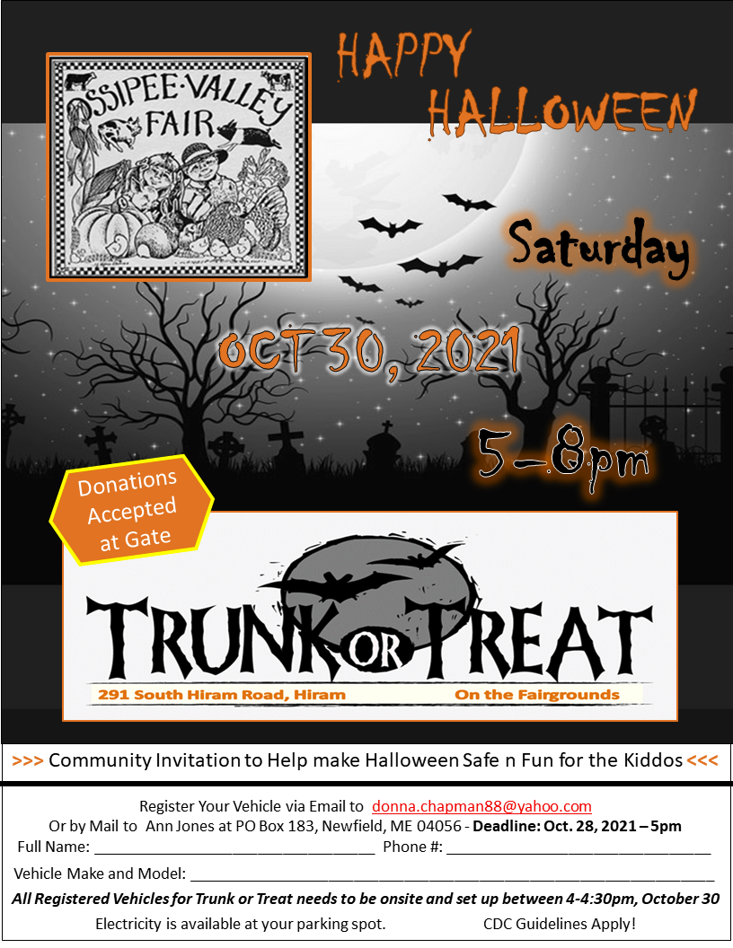

**2021 Trunk or Treat   
Vehicle Registration Form   
Saturday October 30, 2021   
Set up 4pm   
Ossipee Valley Fairgrounds**   
  
Please return this form via email to; donna.chapman88@yahoo.com   
By mail to Ann Jones P.O. Box 183 Newfield, Maine 04056   
Deadline to Register is 5:00 Thursday October 28th 2021.   
Please plan on a large crowd! Expected to be larger than last year   
about 450 attendees. Candy donations are greatly appreciated.   
  
Full Name & License Plate   
____________________________________________

Phone Number ___________

Vehical Make, Model, Color  
______________________________________________  
  
Electricity Needed YES_____ NO______