Introducing a Queen to your Colony
There are many methods for introducing a queen to you colony. Choose and use the one you feel most comfortable with. This is only a suggestion of one of the most conservative methods of introduction.
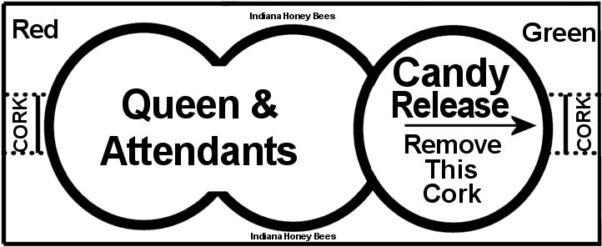
Most of our “3 hole Queen Cages” are marked green on one end and red on the other. Green is for a “candy release” which takes 1-3 days once you remove the tiny cork. It allows for the colony to become familiar with her, yet keeps her in a somewhat protected state in the event they do not accept her. The red end is for “direct release” which is not recommended. First, you must inspect the hive to make sure no other queen(s) are in the hive. The “queen” can present herself in many forms. A colony can accept queen cells, a virgin queen that might be present or out on a mating flight, your queen that was elusive, or even a laying worker as their “queen”. If this occurs, they will not accept the queen you are trying to introduce. Always look for the presence of single eggs neatly placed in the center of the bottom of comb. This means you probably have a queen already. She may be fine and you don’t need a new queen, or you may be choosing to replace her for a variety of reasons. If there are many eggs randomly deposited within each cell, and it is in many cells of the comb, you most likely have a drone laying worker, aka laying worker. You will not be able to introduce a queen without dealing with your laying workers first or they will kill your new queen. So you ask “How will I know if they accept her?” Open the hive and place the queen cage on top of the frames, above the brood chamber. WATCH HOW THEY RESPOND. If they are calm and curious, crawling all over the cage poking around, then it is likely they will accept her. If you can wipe the bees off with your finger with no resistance and they casually crawl back on the cage, you are probably ok to move to the candy release step. Remove the green cork and wedge the cage between two frames with the screen facing up and check on her in about 3-4 days. You may have to remove a frame to fit the cage between the frames. A queenless colony is generally buzzy and loud, so if they become quiet as you introduce the new queen it is good. Be concerned if they ignore her or stick to the screen of the cage like Velcro and are trying to sting her. That means you have a problem to resolve and can NOT leave her with the colony at this time. Once you have fully inspected the hive and it is clear of any prior queen, virgin queens, queen cells(and cups), and laying workers, then you can move on to the next step. If you are requeening your hive, the colony will be more accepting of a new queen when it has been queenless for 1-5 days. It will make introduction of a new queen much easier. Whether you chose to requeen because the old queen has poor genetic, failing, or they chose to supersede her, you MUST remove or destroy all queen cells they might try to make. If you see a cell that is open on the end with a “hatch cover”, you may (most likely) have a virgin running around. She will kill your new mated queen. You must be vigilant in removing or destroying the cells for the first two weeks when you introduce a new queen. Here is why. Scenario: You choose to requeen a poor laying queen. You remove her. They chose a 3-4 day old larva to draw a queen cell and make a new queen. That cell emerges at day 12 (Day 16 of its life) and you have a virgin queen running around. So, the day you introduce your new queen, destroy any queen cells they have made. When you check on her 3-4 day after you have pulled the candy release cork, remove or destroy any new queen cells they have made. Inspect again in 4 days to be sure your new queen is laying eggs and destroy any queen cells you may have missed. Do NOT leave your queen in direct sunlight. Plan ahead and install the Queen as quickly as you can. It is your responsibility to properly care for and introduce your queen. If you find that you can’t install a queen immediately, offer the attendants water and your own honey at least 4 times a day. A tiny drop will suffice to keep them hydrated and healthy for several days. The Queen is packaged with attendant bees to assist her in eating and cleaning herself.

This may be reproduce & distributed in exact form with credits 2019©Jerry Gordon, IndianaHoneyBees.com

Problem Solving: ……………When it appears they don’t want to accept a new Queen.
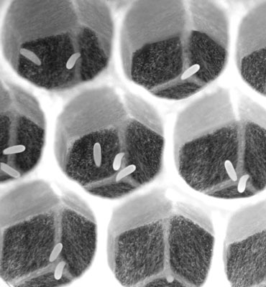
Laying Worker: If you don’t see a queen but see eggs, and it looks like the image, you have a laying worker or possibly a very young queen, but most often it is a laying worker if you cannot find a queen. A laying worker will only lay haploid eggs(drones), which are easily recognized as larger cells and when capped, are rounded like a bullet. Laying workers can be too short bodied to reach the bottom of the cell and often lay multiple eggs off center and on the walls of the wax comb cell as you see in the picture. This situation usually occurs when a hive has been neglected and has been queenless for a long time. It is very difficult to correct and often times means dumping the colony because it consumes so many resources to try to correct. A Queenright hive may have some laying workers in it, however the other worker bees recognize by pheromones that is not eggs their Queen has laid and they remove almost all of them before they develop.

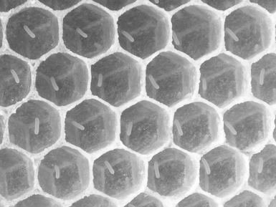
Queenright Eggs: You may choose to replace a Queen for different reasons, for example, she has become a poor layer and is failing, or it is fall and you want a new young queen to overwinter your colony, she may have gone missing, injured, or they want to supersede her for reasons we aren’t sure about. This is simply an example of what a normal Queen’s eggs look like. It is important that you see eggs like this every time you inspect you colony. This will be the first signs of trouble within a hive. If you catch it early enough, you can easily correct things and avert disaster. A Queen will lay one egg per cell, but occasionally, it may not stick and that cell is skipped, but the cell next to it may have 2 eggs. There is no reason for alarm.
Recognizing Queen cells
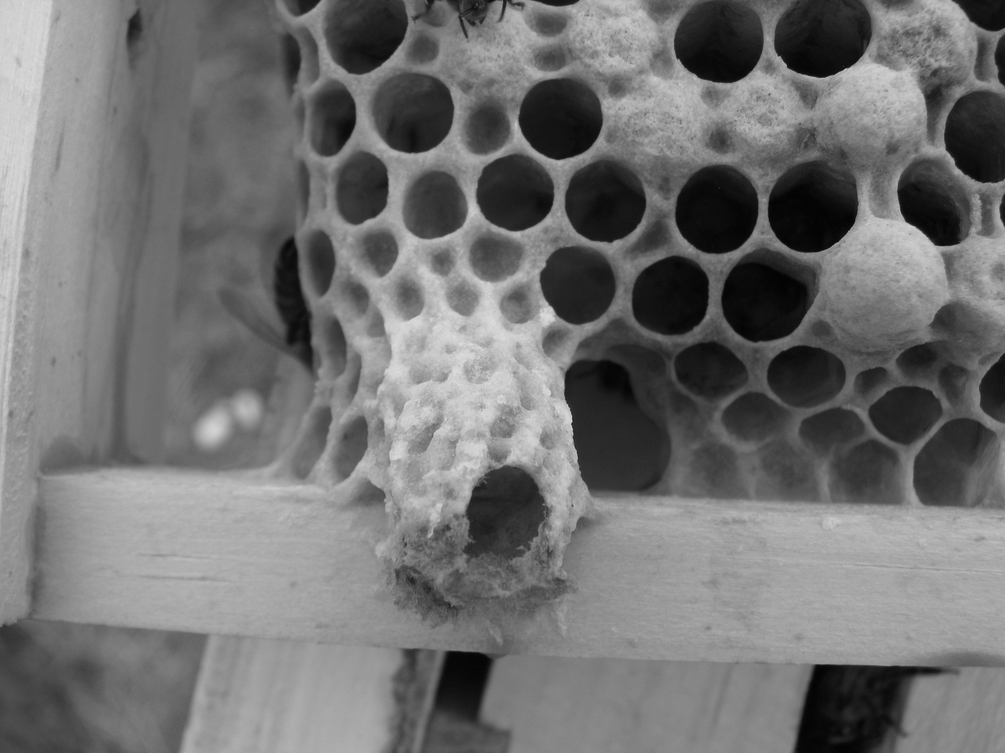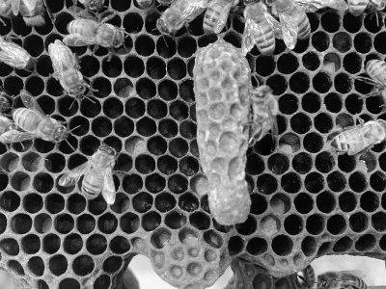
All of the queen cells must be removed or destroyed prior to introducing of the queen and any subsequent cells they may try to make. Generally, a queen cell looks like a peanut. They can be anywhere on the comb and may have shapes that tend to be disguised or blend in. It is best to brush or shake the frame to clear it of bees so you can inspect for queen cells. You must remove or destroy 100% of them. Missing just one will cost the life of your new queen.
This may be reproduce & distributed in exact form with credits 2019©Jerry Gordon, IndianaHoneyBees.com

