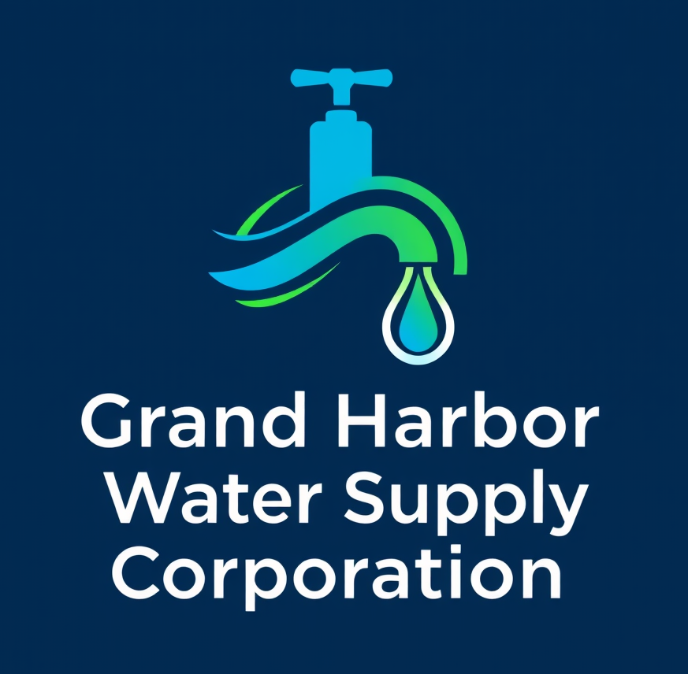
PO Box 128
Chico TX 76431
Phone (972) 603-5951
Email: info@ghwsc.com

From: Grand Harbor Water Supply Corporation

Re: New Water Tap Application

Dear [Recipient’s Name],

Enclosed with this cover letter, you will find a Service Application and Agreement sent via email. Please complete the necessary pages and email them back to us at info@GHWSC.com.

Additionally, please mail a check for $3,000.00 payable to GHWSC, PO Box 128,
Chico, TX 76431, which covers the total cost of your new meter installation.

You can expect your new meter to be installed within two to three weeks after we receive your application and payment. Please note that factors such as inclement weather, machinery needs, labor scheduling, and the location of the meter can affect the installation timeline. We appreciate your patience as we handle all meter installations on a first-come, first-served basis.

If you have any questions, feel free to contact our field operations supervisor, Bart Kirby, at 972.603.5951.

Respectfully,

Rob Dean
President GHWSC

FUTURE BILLING ADDRESS:
CURRENT BILLNG ADDRESS:
PREVOUS OWNER:

Grand Harbor Water Supply Corporation
PO Box 128
Chico, Texas 76431
CORPORATION USE ONLY
.
APPLICATION
AND AGREEMENT
DATE
Please Print:
APPLICANT'S NAME
CO-APPLICANTS NAME
Work{ ) _
PHONE i'-IUMBER - Home ( j _
PHONE NUMBER - Home
PROOF OF OWNERSHIP PROVIDED BY
DRIVER'S LICENSE NUMBER OF APPLICANT
DATE APPROVED:

SERVICE CLASSIFICATION:

COST: WORK ORDER NUMBER:

METER NUMBER: READING NUMBER: FINAL READING:

ACCOUNT NUMBER:

SERVICE INSPECTION DATE:

LEGAL DESCRIPTION OF PROPERTY {Include name of road. subdivision with lot and block number)
PREVIOUS OWNER'S NAME AND ADDRESS of Transferring Membership)
HOUSEHOLD SIZE
ACREAGE
LIVESTOCK & NUMBER
NUMBER IN FAMILY
SPECIAL SERVICE NEEDS OF APPLICANT
NOTE: FORM MUST BE COMPLETED BY APPLICANT AND A MAP OF SERVICE
LOCATION REQUEST MUST BE ATTACHED.
AGREEMENT made of ______________________ 20_____, between Grand
Harbor Water Supply Corporation, a corporation organized under the laws of the State of Texas
(hereinafter
Witnesseth:
The Corporation shall sell and deliver water service to the Applicant and the Applicant shall purchase, receive, and/or reserve service from the Corporation in accordance with the bylaws and tariff of the Corporation as amended from time to time by the Board of Directors of the Corporation. Upon compliance with said policies, including payment of a Membership Fee, the Applicant qualifies for Membership as a new applicant or continued Membership as a transferee and thereby may hereinafter be called a Member - The Member shall have all rights duties and responsibilities of membership under the Corporation's articles and by-laws and, by the act of making application for service and membership agrees to abide by and be bound by all terns, conditions and provisions of the same without exception, waiver, reservation or exclusion
The Member Shall pay the Corporation for service hereunder as determined by the Corporation5 tariff and upon the terms and conditions set font' therein, a copy of which has been provided as an information packet, for which Member acknowledges receipt hereof by execution of this agreement. A copy of this agreement shall be executed before service may be provided to the Applicant.
The Member shall pay the Impact Fee prescribed in the Corporation's tariff if the same has not been previously paid on the Member's property by a previous owner of the lot. If the Impact Fee is payable, it shall be paid at the time of closing on the sale of the lot. The Member shall have the option of financing the Impact Fee with the purchase of the property.

and
(hereinafter called the Applicant and/or Member),

corporation)
the
called

The Member acknowledges that the subdivision deed restrictions create a standby fee, which may change from time to time for the maintenance of the installed water system that has been assigned to the Corporation. The Member agrees to pay this standby fee annually, he/she maintains a membership and does not take active water utility service. Failure to pay the standby fee shall constitute a service delinquency to the Corporation, which shall be grounds for refusal to serve if water service is requested at a future date.
The Board of Directors shall have the authority to discontinue service and cancel the Membership of any Member not complying with any policy or not paying any Corporation fees or charges as required by the Corporation's published rates, fees and conditions of service. At any time service is discontinued, terminated or suspended, the Corporation shall not re-establish service unless it has a current, signed copy of this agreement.
If this agreement is completed for the purpose, of assigning utility service as a part of a rural domestic water system loan project contemplated with the Rural Development, an Applicant shall pay
- an indication of interest fee in lieu of a membership Fee for purposes of determining
a.
The number of taps to be considered in the design and
b.
The number of potential ratepayers considered in determining the financial feasibility of constructing
1) a new water system or
2} expanding the facilities of an existing water system.
The Applicant hereby agrees to obtain, utilize, and/or reserve service as soon as it is available. Applicant, upon qualification for service under the terms of the Corporation's policies, shall further qualify as a Member and the Indication of Interest Fee shall then be converted by the Corporation to a Membership Fee. Applicant further agrees to pay, upon becoming a Member, the monthly charges for such service as prescribed in the Corporation's tariff. Any breach of this agreement shall give cause for the Corporation to liquidate, as damages, the fees previously paid as an indication of interest. in addition to any Indication of Interest Fees forfeited, the Corporation may assess a lump sum of
$300.00 as liquidated damages to defray any losses incurred by the Corporation If delivery of service to said location is deemed infeasible by the Corporation as a part of this project, the Applicant shall be denied Membership in the Corporation and the Indication of Interest Fee, less expenses, shall be refunded. The Applicant may re-apply for service at a later date, under the terms and conditions of the Corporation's policies. For the purposes of this agreement, an Indication of Interest Fee shall be of an amount equal to the Corporation's Membership Fees.
All water shall be metered by meters to be famished and installed by the Corporation. The meter is for the sole use of the Member or customer and is to provide service to only one (1) dwelling or one (1) business. Extension of pipe(s) or hoses to transfer utility service from one property to another, to share, resell, or submeter water to any other persons, dwellings, businesses, or property, etc., is prohibited. Customer shall not connect, or allow any other person or party to connect, onto any water lines or hoses on his premises. Except in cases where the customer has a with Corporation for reserve or auxiliary service, no other water ser./ice will be used by the Customer on the same installation in conjunction with Corporation's service, either by means of a cross-over valve or any other connection.

The Corporation shall have the right to locate a water service meter and the pipe necessary to connect the meter on the Member's property at a point to be chosen by the Corporation, and shall have access to its property and equipment located upon Members premises at ail reasonable and necessary times for any purpose connected with or in the furtherance of its business operations, and upon discontinuance of service the Corporation shall have the right to remove any of its equipment from the Members property- The Member shall install at their own expense any necessary service lines from the Corporation's facilities and equipment to the point of use, including any customer service isolation valves, backflow prevention devices, clean-outs, and other equipment as may be specified by the Corporation. The Corporation shall also have access to the Members property, for the purpose of inspecting for possible cross-connections and other undesirable plumbing practices.
The Corporation is responsible for protecting the drinking water supply from contamination or pollution that could result from improper plumbing practices. This service agreement serves as notice to each customer of the plumbing restrictions that are in place to provide this protection. The
Corporation shall enforce these restrictions to ensure the public health and welfare. The following undesirable plumbing practices are prohibited by state regulations:
a.
No direct connection between the public drinking water supply and a potential source of contamination is permitted. Potential sources of contamination shall be isolated from the public water system by an air gap or an appropriate backflow prevention assembly in accordance with state plumbing regulations. Additionally, all pressure relief valves and thermal expansion devices must be in compliance with state plumbing codes.
b.
No Cross-Connection between the public drinking water supply and a private water system is permitted. These potential threats to the public drinking water supply shall be eliminated at the service connection by the proper installation of an air gap or a reduced pressure­ zone backflow prevention assembly and a service agreement must exist for annual inspection and testing by a certified backflow prevention device tester.
No connection, which allows condensing, cooling or industrial process water to be returned
to the public drinking water supply, is permitted.
c.
No pipe or pipe fitting which contains more than 8.0 % lead may be used for the installation or repair of plumbing on or after July 1988, at any connection that provides water for human consumption.
d.
e.
No solder or flux that contains more than 0.2 % lead may be used for the installation or repair of plumbing on or after July 1, 1988, at any connection that provides water for human consumption.
f.
No plumbing fixture is installed which is not in compliance with a state-approved plumbing code,
The Corporation shall maintain a copy of this agreement as Fong as the Member and/or premises are connected to the public water system. The Member shall allow his property to be inspected for possible cross-connections and other undesirable plumbing practices. These inspections shall be conducted by the Corporation or its designated agent prior to initiating service and

periodically thereafter. The inspections shall be conducted during the Corporation's normal business hours.
The Corporation shall notify the Member in writing of any cross-connections or other undesirable plumbing practices that have been identified during the initial or subsequent inspection. The Member shall immediately correct any undesirable plumbing practice on their premises. The Member shall, at his expense, properly install, test, and maintain any backflow prevention device required by the Corporation. Copies of ail testing and maintenance records shall be provided to the Corporation as required. Failure to comply with the terms of this service agreement shall cause the Corporation to either terminate service or properly install, test, and maintain an appropriate backflow prevention device at the service connection. Any expenses associated with the enforcement of this agreement shall be billed to the Member.
In the event the total water supply is insufficient to meet all of the Members, or in the event there is a shortage of water, the Corporation may initiate the Emergency Rationing Program as specified in the Corporation's Tariff. By execution of this agreement, the Applicant hereby shall comply with the terms of said program.
Customer shall be Viable for any damage or injury to Corporation-owned property or personnel shown to be caused by the customer his invitees, his agents, his employees, or others under his control. By accepting service under this agreement, customer agrees to take no action to create a health hazard or otherwise endanger, injure, or threaten Corporation's plant, its personnel, or its customers. Failure to comply this provision shall be grounds to terminate customer's service without notice-
Public water utilities are required to deliver water to the customers side of the meter or service connection that meets the portability and pressure standards of the Texas Commission on Environmental Quality ("TCEQ'). Corporation will not accept liability for any injury or damage to individuals or to their properties occurring on the customer's side of the meter when the water delivered meets these state standards. Corporation makes no representations or warranties (expressed or implied) that customer's appliances will not be damaged by disruption of or fluctuations in water service whatever the cause. Corporation will not accept liability for injuries or damages to persons or property due to disruption of water service caused by: (1) acts of God or other natural causes outside of the Corporation's control, (2) acts of third parties not subject to the Corporation's control. (3) electrical power outages, or (4) termination of water service pursuant to Corporation's tariff, TCEQ rules or statutes- By execution hereof, the Applicant shall hold the Corporation harmless from any and all claims for damages caused by service interruptions due to waterline breaks by Corporation or like contractors, tampering by other Member/users of the Corporation, normal failures of the system, or other events beyond the Corporation's control.
Corporation is not required by law and does not provide fire prevention or firefighting services. Corporation therefore does not accept liability for fire-related injuries or damages to persons or property caused or aggravated by the availability (or lack thereof) of water or water pressure (or lack thereof) during fire emergencies. Corporation may (but is not required to) contract with individual customers/applicants to provide water service capacities to their properties in excess of the TCEQ's domestic water system regulations so that such water volumes and pressures may be used by the customer/applicant or local fire department (at their sole election and responsibility) for firefighting purposes. Such additional water service capacities shall be provided only in response to and according

and regulations fo the Corporation. The Customer will bring out his service line to his property line at a
to design criteria and/or plans prepared by the customer/applicant's registered professional engineer. Notwithstanding any understanding or intent of such customer/applicant for the use of such excess water service capacity, Corporation does not profess, state, warrant, guarantee, or imply that such additional water service capacity is, or shall ever be, adequate or sufficient for firefighting. Corporation neither possesses nor claims to possess knowledge or expertise in firefighting or the requirements of firefighting. No statement or action of Corporation shall ever be implied or meant to suggest that any facilities of Corporation comply with any state or local fire code.
Corporation has adopted the Uniform Plumbing Code. All customer-owned plumbing, service extensions and/or new facilities shall comply with that code and all standards established by the TCEQ. Where arise, the more stringent standard must be followed. The piping and other equipment on the premises furnished by the Customer will be maintained by the Customer at all times in conformity with the requirements of the applicable regulatory authorities and with the service rules
point designated by the Corporation. No water service smaller than S/811 will be connected. The Customer shall install and maintain a cut-off valve on the Customer side of the meter and within three
(3) feet of the meter. If the Customer desires water at a lower pressure than that which is delivered at the meter and such delivery pressure does not exceed any TCEQ rule or order pressure standard, the Customer will install, at the Customers expense, the equipment necessary for such reduction in pressure. It shall be the Customers responsibility to maintain such equipment in good repair and working order.
It is agreed and understood that any and all meters, water lines and other equipment furnished by Corporation (excepting the Customers individual service One from the point of connection to the Customers point of ultimate use) is and shall remain the sole property of Corporation and nothing contained herein shall be construed to reflect a sale or transfer of any such meters, lines or equipment to any customer. Alf tap charges shall be for the privilege of connecting to said water lines and for installation, not purchase, of said meters and lines.
No application, agreement or contract for service may be assigned or transferred without the written consent of Corporation.
It is possible that Member and Corporation will enter into an additional contract(s) pertaining to water service at this location. Any such contract shall be in addition to this Application. Nothing therein will negate any provision of this Application.
The Member shall grant to the Corporation, now or in the future, any easements of right-of­ way for the purpose of installing, maintaining, and operating such pipelines, meters, valves, and any other equipment which may be deemed necessary by the Corporation to extend or improve service for existing or future Members, on such forms as are required by the Corporation.
By execution hereof, the Applicant shall guarantee payment of all other rates, fees, and charges due on any account for which said Applicant owns a Membership Certificate. Said guarantee shall pledge any and all Membership Fees against any balance due the Corporation. Liquidation of said Membership Fees shall give rise to discontinuance of service under the terms and conditions of the Corporation's tariff.
By execution hereof, the Applicant agrees that non-compliance with the terms of this agreement

by said Applicant shall constitute denial or discontinuance of service until such time as the violation is corrected to the satisfaction of the Corporation. Any misrepresentation of the facts by the Applicant on any of the pages of this agreement shaft result in discontinuance of service pursuant to the terms and conditions of the Corporation's tariff.
Witnessed Signature:
Applicant Member Signature:
Approved and Accepted:
Date Approved:

