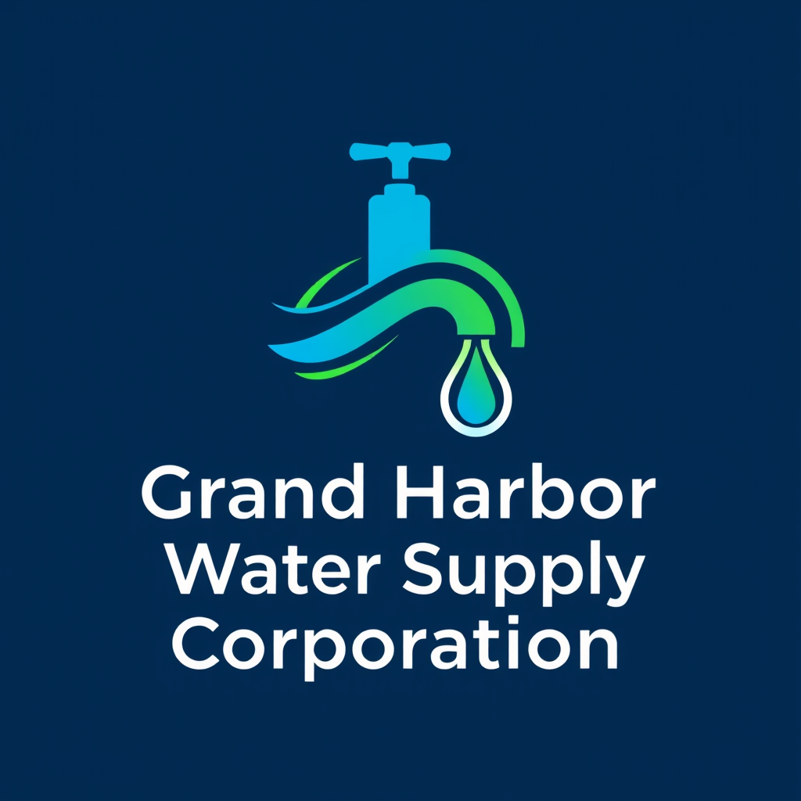

PUBLIC NOTICE
Disinfection Byproducts (DBPs) Monitoring Results
TTHM and HAA5 Maximum Contaminant Level Violations
This notice is being provided to customers of Grand Harbor Water Supply Corporation (WSC) in accordance with Texas Commission on Environmental Quality (TCEQ) public notification requirements.

System Information
Public Water System Name: Grand Harbor WSC
PWS ID: TX2490070
County: Wise County, Texas
Time Period of Violations: Third Quarter 2025

NOTICE 1: Total Trihalomethanes (TTHM) MCL Violation
WHAT HAPPENED?
TCEQ has determined that Grand Harbor WSC exceeded the maximum contaminant level (MCL) for total trihalomethanes (TTHMs).
The MCL for TTHMs is 0.080 mg/L. Based on Locational Running Annual Average (LRAA) compliance sampling, the TTHM level at monitoring site DBP2-01 during the third quarter of 2025 was 0.10290 mg/L.
WHAT ARE TTHMs AND WHAT ARE THE HEALTH EFFECTS?
Trihalomethanes are formed when chlorine used for disinfection reacts with naturally occurring organic matter in water.
Long-term consumption of water with TTHMs above the MCL may increase the risk of liver, kidney, or central nervous system problems and cancer.
DO I NEED TO TAKE ACTION?
You do not need to use an alternative water supply. If you have health concerns, consult your healthcare provider.

NOTICE 2: Total Haloacetic Acids (HAA5) MCL Violation
WHAT HAPPENED?
TCEQ has determined that Grand Harbor WSC exceeded the maximum contaminant level (MCL) for total haloacetic acids (HAA5).
The MCL for HAA5 is 0.060 mg/L. Based on Locational Running Annual Average (LRAA) compliance sampling, the HAA5 level at monitoring site DBP2-01 during the fourth quarter of 2025 was 0.123 mg/L.
WHAT ARE HAA5 AND WHAT ARE THE HEALTH EFFECTS?
Haloacetic acids are formed when disinfectants react with organic matter in water.
Long-term exposure to HAA5 above the MCL may increase the risk of cancer.
DO I NEED TO TAKE ACTION?
You do not need to use an alternative water supply. If you have health concerns, consult your healthcare provider.

Corrective Actions Being Taken
• Reviewing and optimizing disinfection practices
• Evaluating treatment and operational changes to reduce organic precursors
• Increasing monitoring and data review
• Working with technical experts and regulatory agencies on long-term treatment solutions

Please Share This Information
Please share this notice with all people who drink this water, especially those who may not have received it directly (for example, people in apartments, nursing homes, schools, and businesses).
For questions, contact:
info@GHWSC.com
Grand Harbor WSC
Phone: (214) 810-5250 ‬
Posted at www.ghwsc.com delivered via email/mail‬
Delivered on: 2/7/2026

