Consent and Decision Making

This document provides information about your rights to make decisions about your life.
Decision making is all about what you want.
You have the right to be respected and treated like other people

When you can make decisions
You have control over your life. We are here to support you to make decisions. You can make decisions about:
• daily activities
• food and drink
• money
• household tasks
• hygiene (such as showering and brushing teeth)
• what help you receive from us
• medical visits and treatments
• taking medicine
• sharing your personal information.

We will give you the time you need to make those decisions.

Consent
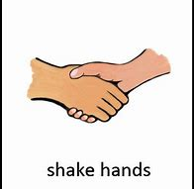
When you agree that something should take place, you are giving consent.

Before giving consent you have to understand:
• what will be happening
• what you will have to do
• how the activity or treatment will make you feel better
• what might go wrong.

You can make the decision all by yourself if you feel comfortable.

You can ask questions if you are unsure or want more information at any time.

