**About this document**

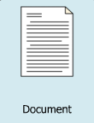

This document tells you about our privacy and confidentiality policy.

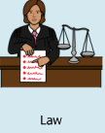

The privacy and confidentiality policy says how we do what the law says we must do to protect your privacy.



Privacy means that any person has the right to have their personal information to not be told or shown to anyone.

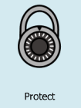

Confidentiality means that there is a duty to keep your personal information private and protected.

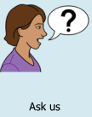

If you would like to know more information or you have a question, please ask our staff.

**Your privacy**

Personal information is anything that is about you. This could be:

• your name

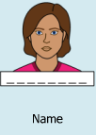

• where you live

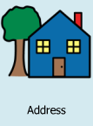

• your date of birth



• your job or day activities

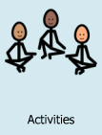

• information about your disability.

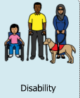

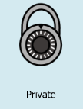

We will keep your information private.



This means we will not tell people your personal information unless we have to.

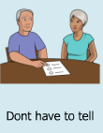

You do not have to give us your personal information.



If you choose not to give us personal information we may not be able to give you services you need.

**Why do we keep your personal information?**

We ask for your personal information for different reasons:



• it helps us to provide the right services and supports



• we can help you with complaints



• we can give you details about our activities

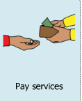

• we can get staff and pay them for their work.

**What personal information do we keep?**

The personal information we keep might include:



• your name



• your date of birth

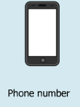

• your phone number

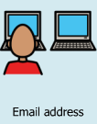

• your email address



• information about your disability.

**Sometimes your personal information is sensitive information.**

Sensitive information is normally private and can include:



• your cultural background



• your religious beliefs

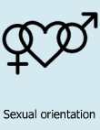

• you sexual orientation

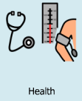

• information about your health.

We also keep personal information on:

• other service providers you receive services from



• your family or carers

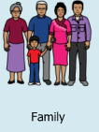

• our staff.





We will not tell anyone about your personal information unless we have to.



The NDIS Commission might need the information to keep you safe.

**How do we use your personal information?**



We will use your personal information to help us provide the best services and supports.

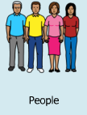

We might need to tell other people about you because they give you the supports you need.



You need to give consent for us to tell other people your personal information. Consent means you say ‘yes’

We might give other people your information when you have not given consent if:

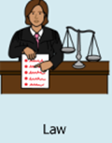

• the laws say we must or



• it will keep you safe.



You can ask us any time about the personal information we keep about you.

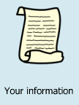

You can request a copy of your personal records.

**How do we keep your personal information safe?**

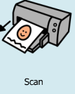

We scan paper records onto our computer.



We keep your personal information stored on computers protected with a password.



Only staff who provide supports and services to you can see your personal information.



We destroy your personal information when we no longer need it.

**What happens if someone has accessed your personal information without your consent?**

When someone has accessed your personal information without our permission and without your consent, this is called a data breach.

If a data breach happens:

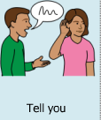

• we will tell you what happened



• we will take action to make sure you will not be harmed

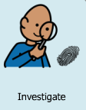

• we will find out why it happened

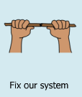

• we will improve the way we handle your personal information



• we may have to report this to the NDIS or government



• this will not affect the services we provide you.