**JCRTA**

**Trips and Tours**

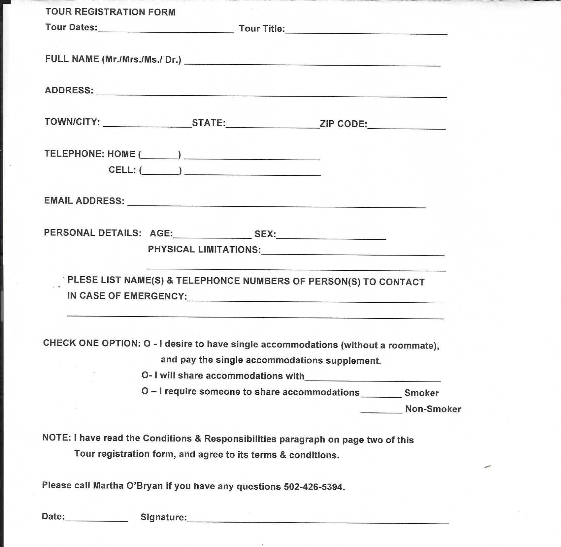

Tour Registration form (page 2)

**Conditions & Responsibility**

This tour is operated by Diamond Tours, Ins. 13100 Westlinks Terrace, Suite 1, Fort Myers, FL 33913. JCRTA acts merely as agent for the client in acquiring airfare, cruise itinerary, transportation, hotel, accommodations, sightseeing, and other privileges, or services as described. I have read the forgoing and agree to be bound by the terms and conditions thereof. I have read the cancellation/revision policy and agree to the terms provided.

Therefore, JCRTA shall not be responsible for any loss, accident, injury, delay, defect, omission, or irregularity which may occur or be occasioned, whether by reason of any act, negligence, or default of any company or person engaged in or responsible for carrying out any of the arrangements, or otherwise in connection therewith. By forwarding of deposit, or any payments, the participant certifies that he/she does not have any disability that would create a hazard for him/herself or other participants and accepts the terms contained in this Release of Liability, Assumption of Risk and Binding Arbitration Agreement.

**Payment Terms:**

Deposit of $75 USD per person is due at the time of registration. The balance of the tour cost is $____________ Due ___________________.

**Cancellations/Refunds:**

Cancellations must be submitted in writing. Reimbursements for all individual cancellations will be made and honored up to two weeks prior to departure (provided the total remains at 40 paid participants).

Therefore, obtaining trip cancellation insurance is recommended! Trip insurance must be purchased **within 14 days of deposit to cover pre-existing conditions**. Travel Confident Protection Plan purchasing update. Travel Confident Protection Plan can no longer be purchased by check. The Travel Confident Protection Plan is on a separate flyer. EASY ONLINE SIGNUP to purchase the Travel Confident Protection Plan at:

www.TravelConfident.com

Mail completed registration form and check written out to JCRTA to:

JCRTA

C/O Martha O’Bryan

11309 Coolhouse Court

Louisville, KY 40223

Please call Martha O’Bryan, if you have any questions 502-426-5394.