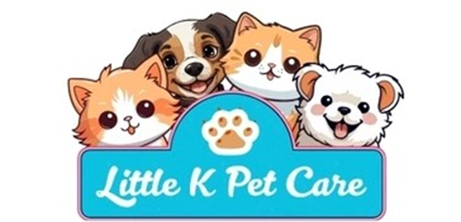

Doggy Day Care Agreement
Service Provider: Little K Pet Care
Address: 25 Vicarage Road CM2 9BP
Phone: 07884424453
Email: Littlekpetcare@outlook.com

Client: _________________________________________
Address: ________________________________________
Phone: ____________________________________
Email: ____________________________________

Dog(s) Covered by This Agreement:
- Name: ____________________ Breed: _______________ Age: _______
- Name: ____________________ Breed: _______________ Age: _______

Services Provided
The Service Provider agrees to provide doggy day care services, including:
- Supervised care throughout the agreed hours
- Access to safe indoor and outdoor areas
- Socialisation with other suitable dogs (if appropriate)
- Rest periods and enrichment activities
- Feeding (if required)
- Administration of medication (if agreed in advance)
Days of attendance: __________________________________________
Drop-off time: ____________________
Collection time: ____________________

Behaviour and Temperament
The Client confirms that their dog(s):
Are friendly and safe around people and other dogs
Have no history of aggression unless disclosed
Are not destructive or excessively vocal
Are toilet trained (unless puppy arrangements are agreed)

Behavioural notes or concerns:
The Service Provider reserves the right to separate or refuse care for any dog that poses a risk to safety or welfare.

Health and Vaccinations
The Client confirms that their dog(s):
Are fully vaccinated and up to date
Have regular flea and worm treatment
Are microchipped and wear an ID tag
Are in good general health
Medical conditions or allergies: _________________________________________________________________________________________________________________________________________________________________________________________________________
Dogs showing signs of illness (e.g., vomiting, diarrhoea, coughing) may be refused entry for the safety of others.
Socialisation and Play
The Client understands that:
Dogs may play together under supervision
Minor scratches or play-related bumps can occur
Dogs will be with other dogs so must be friendly and well-tempered with other dogs.
If the Client prefers their dog not to socialise, they must inform the Service Provider.
Drop-Off and Collection
Dogs must arrive on a lead
The Client must collect their dog at the agreed time
Late collection may incur additional charges
Only authorised individuals may collect the dog
Authorised collectors: ______________________________________________________________________________________________________________________________________
Belongings
The Client may provide items such as food, toys, or bedding.
The Service Provider is not responsible for loss or damage to personal items.
Items: ______________________________________________________________________________________________________________________________________
Liability
The Service Provider will take all reasonable care but cannot be held liable for:
Injury, illness, or death of the dog unless due to negligence
Damage caused by the dog to property or third parties
Loss or damage to personal belongings
The Client is responsible for ensuring adequate pet insurance.
We have professional insurance cover for you peace of mind.

Cancellations and Termination
Client cancellations require at least 5 hours’ notice
The Service Provider may cancel due to illness, emergencies, or unsafe behaviour
Either party may terminate this Agreement with 5 days’ written notice
Consent and Signatures
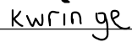
Client Signature: ___________________________ Date: ___________
Service Provider Signature: Date: ___________

