9th Annual Sip ‘n’ Snip Festival
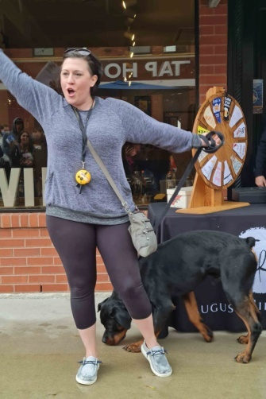
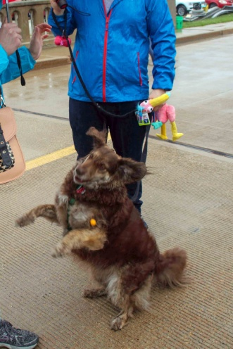
Saturday, June 11, 2022
11AM to 4PM
Mill Street, Utica

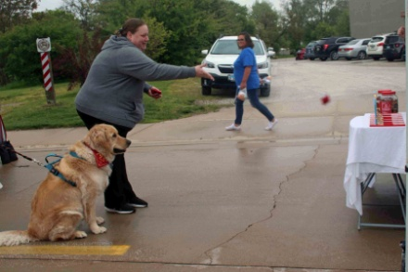
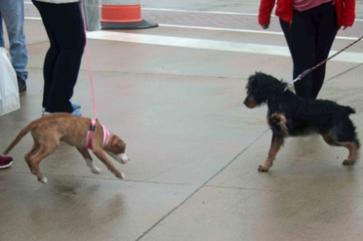
August Hill Winery will announce winners of our annual Best Friend Pet Photo Contest which will be on August Hill wine labels. All profit from this pet photo contest will go to Safe House Animal Rescue (cat rescue), and 2nd Hand Ranch & Recue (wild life rehabbers) for their public spay/neuter programs.
Bring your dog(s) to enjoy games, treats, fun in the sun.
Vendors, Live music, Wheel of chance, fine dining at local Utica restaurants, games, raffles, wine tasting, and much, much more.

Sponsored by No Animal Left Behind, 2339 N 2879th Rd., Marseilles, IL 61341
Nalb09@yahoo.com or 815-252-7484
And August Hill Winery

