[](https://www.cre8r.agency/)

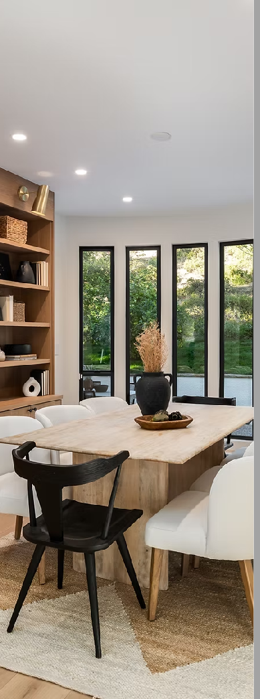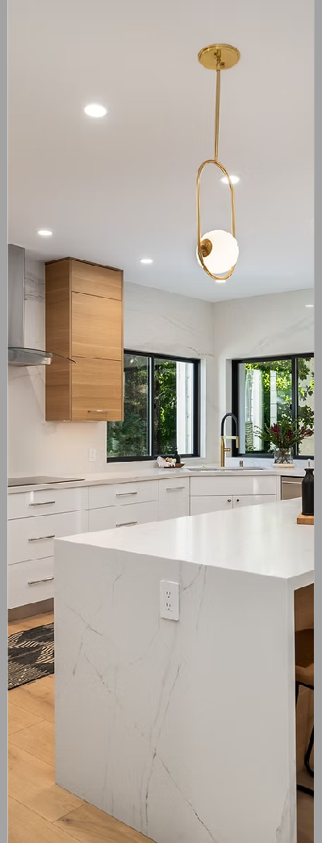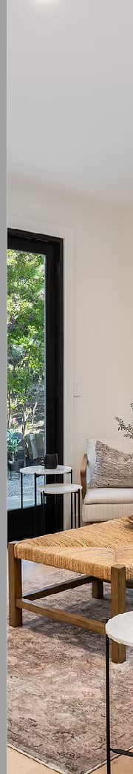

2/24/25, 1:57 PM

CRE8R | How To Prepare For A Residential Shoot

P R E P A R I N G

F O R A S H O O T

Whether it's your first time working with a professional photographer or a seasoned pro, getting ready for a shoot can be exciting and

overwhelming.

But don't worry, we're here to help! This guide has tips and tricks to ensure your space looks its best and the shoot

goes smoothly.

G E N E R A L

P R E P A R A T I O N

T I P S

**Clean and Declutter:**

1. Start thoroughly cleaning dust surfaces, vacuum carpets, and mop floors.
2. Remove clutter and unnecessary items from view to create a neat, spacious appearance.
3. Remember, less is often more in photography.

**Personal Items:** Temporarily remove personal items like family photos, mail, and personal documents. This helps in creating a neutral space that appeals to a broader audience.

https://[www.cre8r.agency/residentialpreparation](http://www.cre8r.agency/residentialpreparation)

1/8

2/24/25, 1:57 PM

CRE8R | How To Prepare For A Residential Shoot

**Lighting:** Make sure all light fixtures are working and have bulbs of the same temperature (cool or

warm light). Natural light works best, so open curtains and blinds to let in as much daylight as possible.

**Neutral Decor:** Consider adjusting your decor to be more neutral. Bold or unusual decorations

might distract from the space itself. Aim for a look that's welcoming and broad in appeal.

**Furniture Placement:** Arrange your furniture to showcase the space effectively. This might mean

repositioning chairs, tables, or other elements to create a more open and inviting layout.

**Touch Up:** Look for small details that need attention. This could be a fresh coat of paint on a scuffed

wall, tightening a loose doorknob, or replacing a burned-out light bulb.

**Odors:** Neutralize any strong smells that can affect the mood during the photoshoot. Consider light,

neutral air fresheners or simply airing out the space.

**Outdoor Areas:** If your property has outdoor spaces like gardens, patios, or balconies, ensure they are tidy and inviting. Trim any overgrown plants, sweep the paths, and arrange outdoor furniture

neatly.

R O O M - B Y - R O O M

P R E P A R A T I O N

Preparation is everything. The better you're able to prep, the better the photos,

videos, and all other visuals will be.

**Living Room:**

**Arrange Furniture:** Create a welcoming and open space by arranging furniture for easy movement and visual balance. Remove any excess or oversized pieces that might make the

room look cramped.

**Decor:** Add simple, stylish decor like throw

pillows or a vase with fresh flowers for a touch of color and life.

**Electronics:** Hideaway cables and remotes, and

ensure the TV and other screens are turned off.

https://[www.cre8r.agency/residentialpreparation](http://www.cre8r.agency/residentialpreparation)

2/8

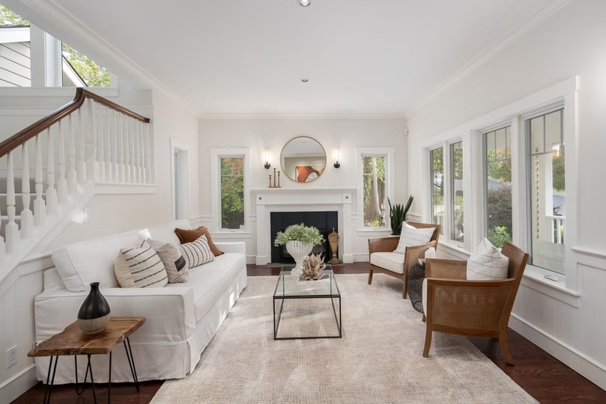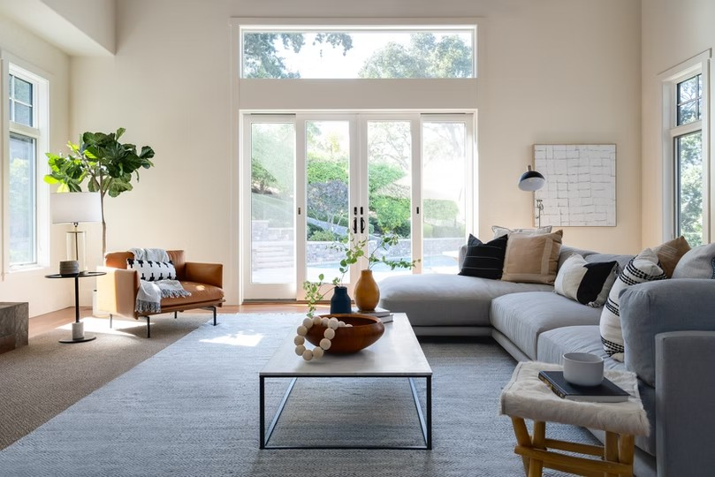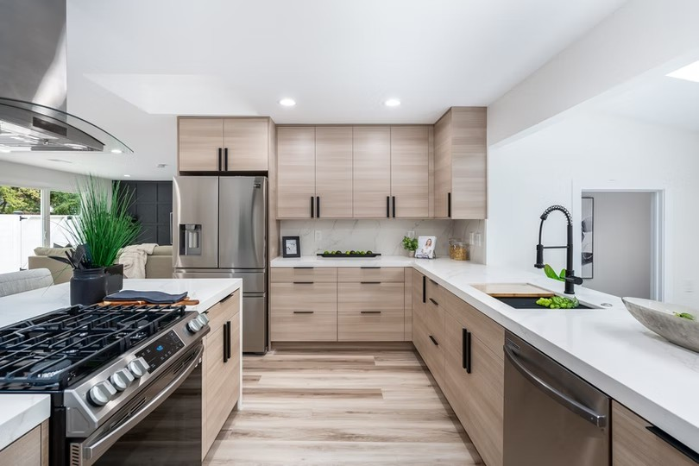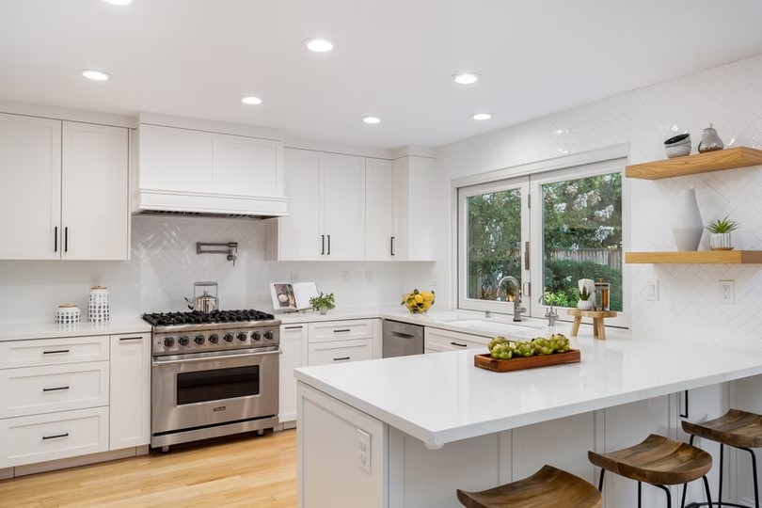

2/24/25, 1:57 PM

CRE8R | How To Prepare For A Residential Shoot

**Kitchen:**

**Declutter Countertops:** Clear countertops of all but essential items. A fruit bowl or a coffee machine can stay, but put away dishes, cutting

boards, and cleaning supplies.

**Highlight Appliances:** If you have high-end

appliances, ensure they're clean and prominently displayed.

**Refresh the Space:** Consider placing a plant or a small herb garden on the windowsill to add

freshness.

**Bedrooms:**

**Beds:** Make sure beds are neatly made with

coordinated bedding. Fluff and arrange pillows for a plush, inviting look.

https://[www.cre8r.agency/residentialpreparation](http://www.cre8r.agency/residentialpreparation)

3/8

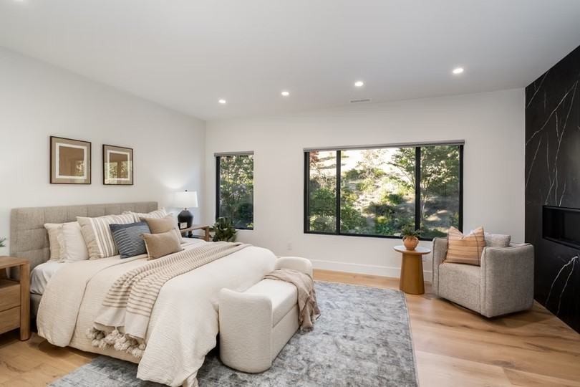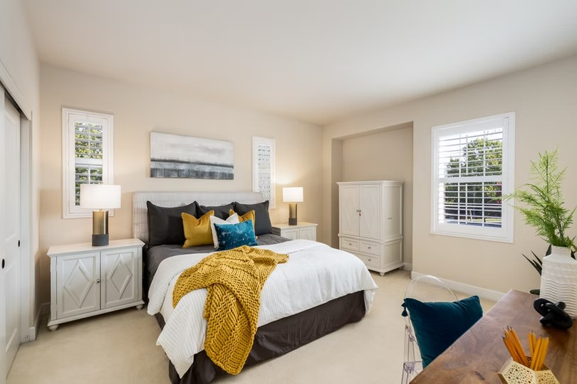

2/24/25, 1:57 PM

CRE8R | How To Prepare For A Residential Shoot

**Closet Doors:** Close closet doors unless the

closet is a crucial and neatly organized feature.

**Personal Items:** Clear nightstands and dressers of individual items. A simple lamp or a book can

remain for a homely touch.

**Bathrooms:**

**Clean Thoroughly:** Ensure the toilet is spotlessly clean, with mirrors, faucets, and surfaces shining.

**Towels:** Hang fresh, neatly folded towels for a

spa-like ambiance.

**Toiletries:** Remove everyday items like

toothbrushes, shampoos, and soaps. Opt for minimal, decorative items if needed.

https://[www.cre8r.agency/residentialpreparation](http://www.cre8r.agency/residentialpreparation)

4/8

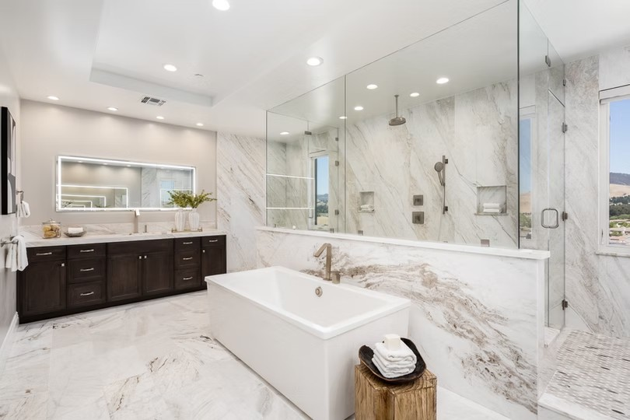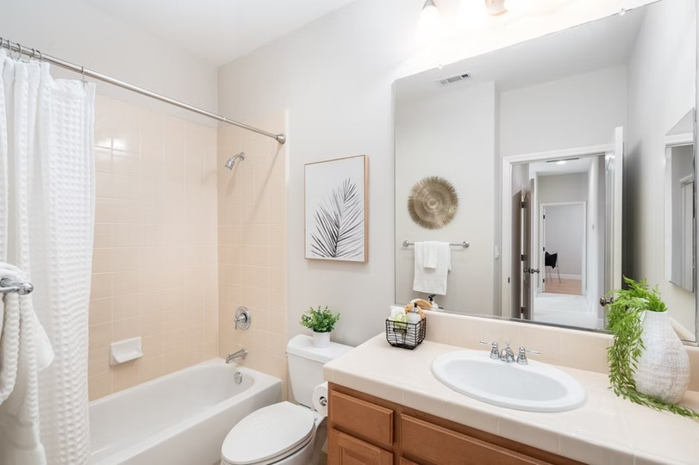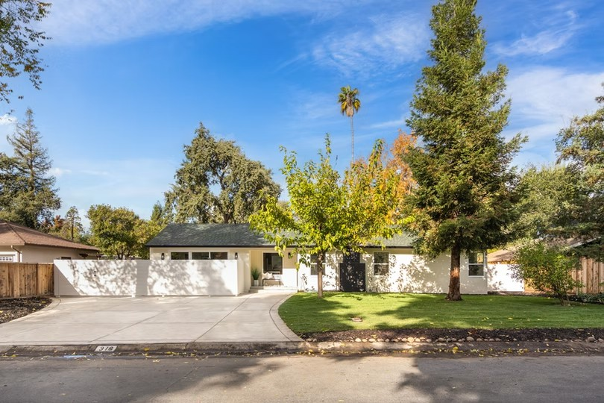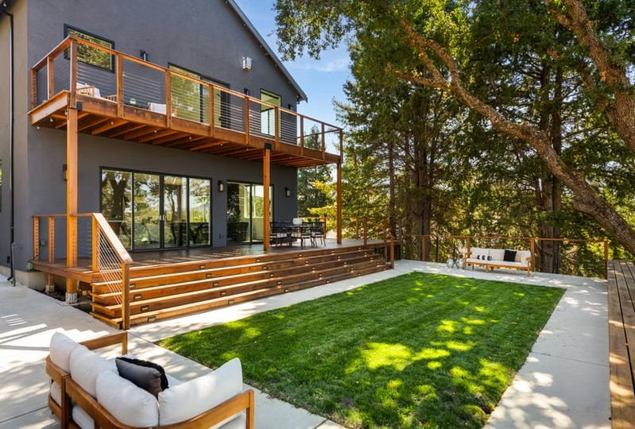

2/24/25, 1:57 PM

CRE8R | How To Prepare For A Residential Shoot

**Exteriors:**

**Curb Appeal:** First impressions matter. Tidy up the yard, trim bushes, and clean the walkways.

**Outdoor Furniture:** Arrange patio or deck

furniture neatly. Add cushions or decor for a cozy, inviting outdoor space.

**Lighting:** Check outdoor lights to ensure they

function, as they may be used for twilight photos.

**Twilight/Sunset Photos:**

**Driveway:** Move cars away from the front of the house so they don’t block the exterior view.

https://[www.cre8r.agency/residentialpreparation](http://www.cre8r.agency/residentialpreparation)

5/8

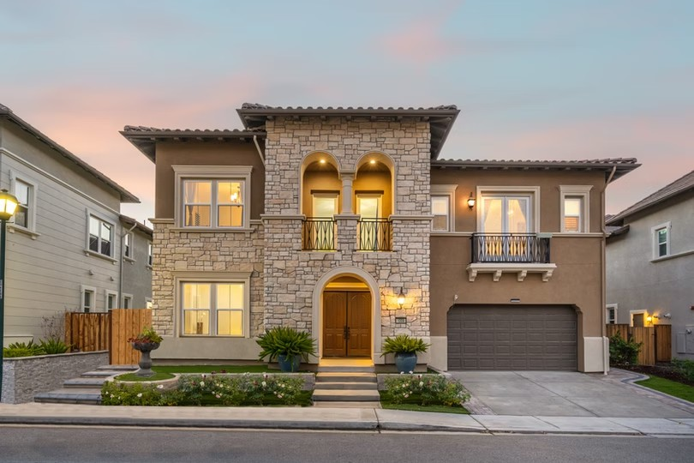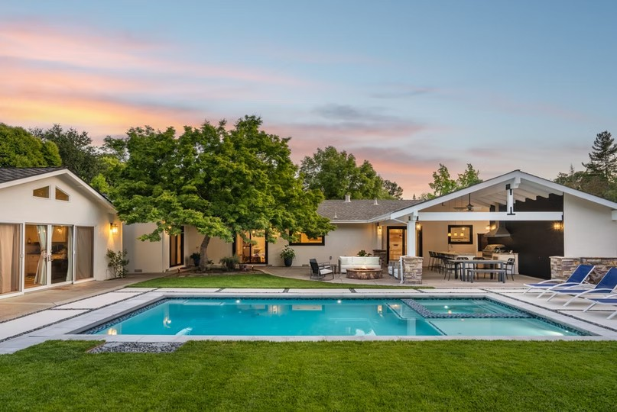

2/24/25, 1:57 PM

CRE8R | How To Prepare For A Residential Shoot

**Shutters & Blinds:** Open the vanes to let interior lights shine through for a warm, inviting look.

**Lighting:** Turn on all interior and exterior lights to

showcase every space clearly.

**Staging & Styling:** Arrange furniture and accessories to best highlight the property. We

can make minor rearrangements if needed.

**Backyard Access:** Unlock any side gates to

provide easy access for photos and viewing.

**Clutter Removal:** Clear away large or unappealing items before the shoot. While some objects can be edited out, it’s best to have the

space picture-perfect beforehand.

FAQs

Q1: How long does a typical photoshoot take?

Q2: Should I be present during the photoshoot?

A: The duration of a photoshoot can vary depending on the size and type of the property. On average, a photoshoot for homes between 500-3000 sqft of Interior

space lasts 30 minutes to 1.5 hours.

A: Nope, but you're welcome to hang out. We ensure to work efficiently whether the

homeowner or agent is on-site.

https://[www.cre8r.agency/residentialpreparation](http://www.cre8r.agency/residentialpreparation)

6/8

2/24/25, 1:57 PM

Q3: Can you shoot a property in any weather?

CRE8R | How To Prepare For A Residential Shoot

Q4: How should I prepare my property for night or twilight

photos?

A: We prefer to shoot in good weather to ensure the best quality of photos, especially for exteriors. However, we can adapt and

shoot in most weather conditions.

A: Ensure all interior and exterior lights are working for night or twilight photos. Set a warm and welcoming mood with soft

lighting indoors.

Q5: Do you provide staging or decoration services?

Q6: How soon can I expect to receive the photos after the

photoshoot?

A: We focus on photography and video, but we can advise on basic styling. For professional staging services, we recommend our partner, [**upStage Home**](http://www.designedbyupstage.com/)

[**Staging**](http://www.designedbyupstage.com/).

A: Turnaround time is typically the next day. However, this can vary depending on the

project's scope.

Q7: Are there any additional costs for photo editing?

Q8: What should I do with my pets during the photoshoot?

A: Nope, editing is included in our fees. We will remove and clean up basic objects and items. Additional time and costs are needed if many object removals or photo

manipulations are necessary.

A: We recommend keeping pets in a secure area or outside the property during the shoot to avoid disruptions and keep the

space clean.

R E A D Y

T O

B O O K

A

S H O O T ?

Click the button below to go to our online booking form or contact us if your shoot requires some special touches to create a visual package that stands out from the rest.

[SCHEDULE YOUR SHOOT](https://order.cre8r.agency/booking/new)

https://[www.cre8r.agency/residentialpreparation](http://www.cre8r.agency/residentialpreparation)

7/8

[](https://www.cre8r.agency/)

2/24/25, 1:57 PM

CRE8R | How To Prepare For A Residential Shoot

© 2023 CRE8R Marketing and

Creative Agency, LLC

https://[www.cre8r.agency/residentialpreparation](http://www.cre8r.agency/residentialpreparation)

8/8