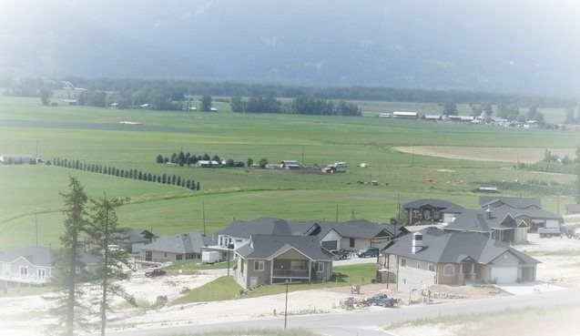
Hidden Valley View Homes

Quality Townhomes Located in Hawk View Estates

Creston, BC

250-402-9217

The Hillside (per unit)

- 1109 sq ft Finished Main Area
- 847 sq ft Fully Finished Basement
- 2 Bedrooms, 2 Baths on the Main
- 483 sq ft Double Car Garage
- Sale price $399,900 per unit (GST Included)

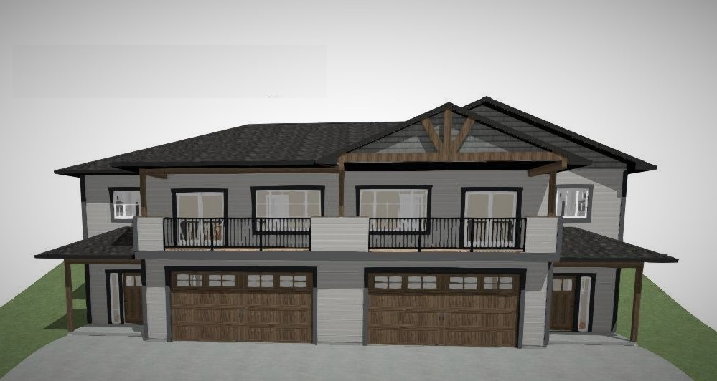

Main Floor
1109 sq ft
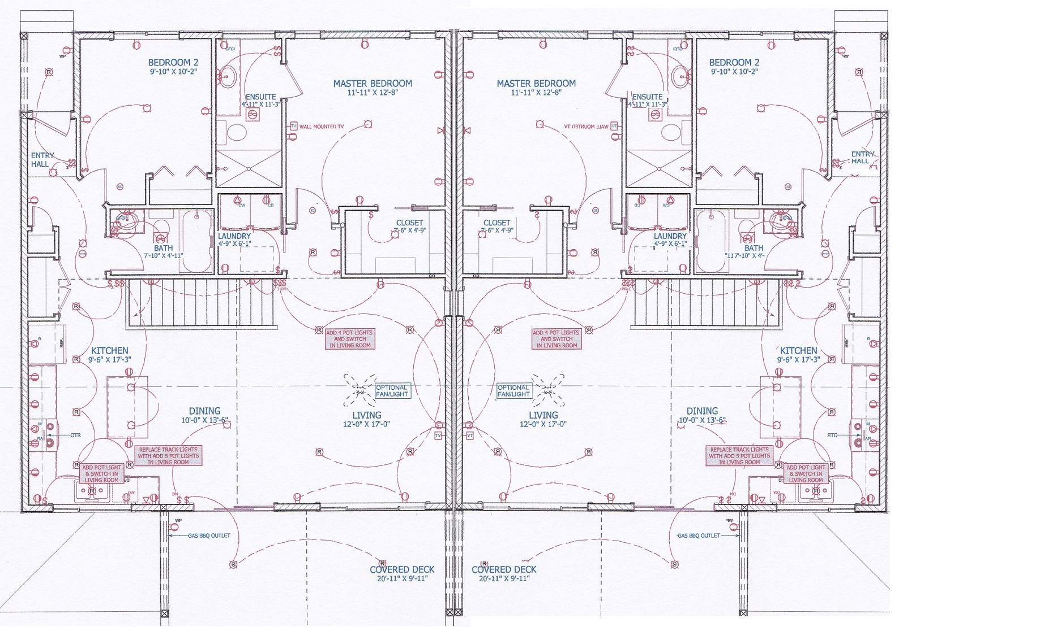

Walk out Basement
847 sq ft
(Fully finished)

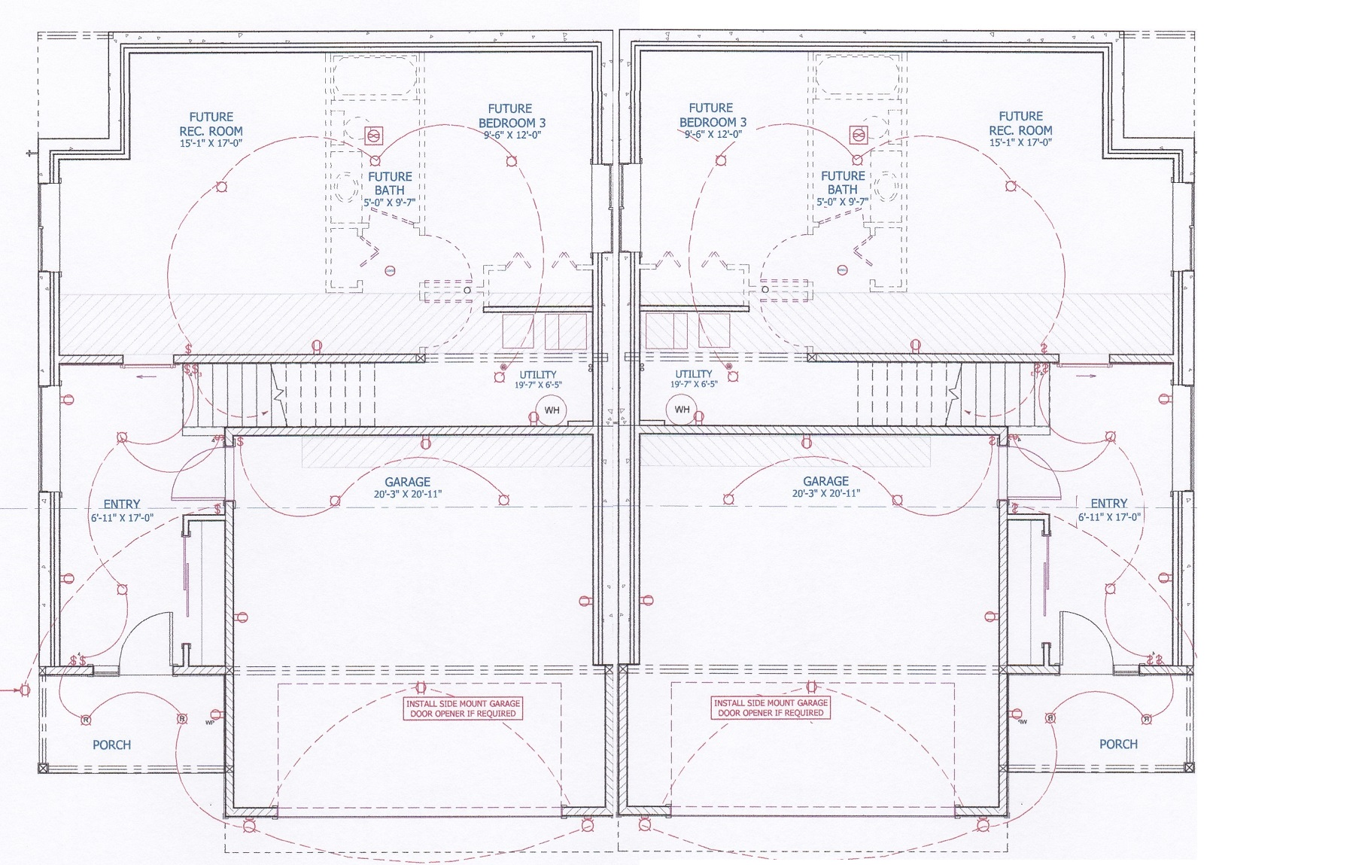

Standard Features

Exterior

- Hardie Board siding
- Shingle Roofs
- Waterproof Vinyl Decking
- ICF Foundation plus Common Wall between the Units

Interior

- 9 ft ceilings – Main and Basement
- Water proof laminate flooring
- Ceramic tile flooring in the master and main baths
- Solid wood Knotty Alder interior doors

Kitchen

- Full appliance package
- Custom Shaker Style Cabinetry
- Tile Backsplash
- Granite Countertops
- Double Silgranite Sink
- Moen Faucets

Bath and Ensuite

- Custom Vanity
- Granite Vanity Tops
- Ceramic Tile shower with Glass door in Ensuite
- One-piece Tub/Shower in Main
- Moen Faucets

Energy Efficiency

- High Efficiency Gas Furnace
- Gas Fireplace
- Central Air Conditioning
- New Code Standard Windows and Exterior Doors
- Recessed LED lighting

All of our homes come with a “2/5/10” WARRANTY
By law, builders must provide a third party warranty covering the following:
2-Year Materials & Labour Warranty
First 12 months—coverage for any defect in materials and labour
First 15 months—coverage for any defects in materials and labour in the common property of a multi-unit building
First 24 months—coverage for any defect in materials and labour supplied for the electrical, plumbing, heating, ventilation and air conditioning delivery and distribution systems. In addition, coverage for any defect in materials and labour supplied for the exterior cladding, windows and doors that may lead to detachment or material damage to the new home.
5-Year Building Envelope Warranty
10-Year Structural Defects Warranty

