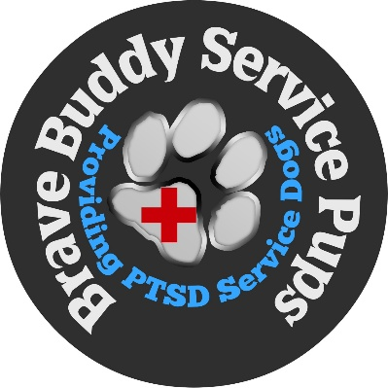
BBSP INC./ BRAVE BUDDY SERVICE PUPS
Serving Veterans and First Responders
779 Glenhurst Rd
Willowick, Ohio 44095
Phone: (216) 242-7007
Email: bbspdogs@aol.com - Website: www.bbspdogs.com

Therapy Dog Program
Handler & Dog Application
Thank you for your interest in volunteering with the Hopkins Hounds Therapy Dog Program. Please complete all sections of this application.

Section 1: Applicant Information
First Name: ____________________________
Last Name: ____________________________
Date of Birth: ____________________________
Email Address: ____________________________
Phone Number: ____________________________
Street Address: ____________________________
City: ____________________________
State: ____________________________
ZIP Code: ____________________________

Section 2: Emergency Contact
Emergency Contact Name: ____________________________
Relationship: ____________________________
Phone Number: ____________________________

Section 3: Employment & Background
Employment Status
☐ Employed
☐ Self-Employed
☐ Retired
☐ Student
☐ Unemployed
Languages Spoken

Have you previously volunteered?
☐ Yes
☐ No
If yes, list organizations:

Section 4: How Did You Hear About Us?
☐ Newspaper
☐ Social Media
☐ Friend/Family
☐ Airport Event
☐ Therapy Dog Demonstration
☐ Other: ____________________________

Section 5: Dog Information
Dog Name: ____________________________
Breed: ____________________________
Age: ____________________________
Weight: ____________________________
Sex
☐ Male
☐ Female
Spayed/Neutered
☐ Yes
☐ No

Section 6: Ownership & History
Are you the dog’s owner?
☐ Yes
☐ No
How long have you owned this dog?

Where did you obtain your dog?
☐ Breeder
☐ Shelter
☐ Rescue
☐ Other: ____________________________
Age of dog when acquired

Section 7: Training & Certifications
Has your dog received any of the following?
☐ AKC Therapy Dog Recognition
☐ AKC Canine Good Citizen (CGC)
☐ Formal Obedience Training
☐ Therapy Dog Certification
If yes, please describe:

List therapy dog programs you currently participate in:

Section 8: Behavior & Temperament Screening
Please answer honestly.
Does your dog respond reliably to basic commands?
☐ Sit
☐ Stay
☐ Down
☐ Leave It
☐ Come
Is your dog housebroken?
☐ Yes
☐ No
How does your dog respond to:
Loud noises

Large crowds

Children approaching quickly

Wheelchairs or walkers

Sudden movements

Section 9: Personality & Behavior
Positive traits of your dog

Any behavioral concerns

Section 10: Safety Screening
Has your dog ever:
Been asked to leave a public facility?
☐ Yes ☐ No
Shown aggression toward a person?
☐ Yes ☐ No
Shown aggression toward another dog?
☐ Yes ☐ No
Bitten a person or animal?
☐ Yes ☐ No
If yes, explain:

Section 11: Veterinary Information
Veterinary Clinic Name

Veterinarian Name

Veterinarian Phone

Date of Last Veterinary Exam

Section 12: Vaccinations
Please provide current vaccination dates.
Rabies ____________________________
DHPP ____________________________
Bordetella ____________________________
Please attach:
☐ Veterinary health record
☐ Rabies certificate

Section 13: Medical Information
Does your dog have any medical conditions?
☐ Yes
☐ No
If yes, explain:

Is your dog taking any medication?
☐ Yes
☐ No
If yes, list medications:

Section 14: Volunteer Availability
Please indicate your typical availability.
☐ Sunday
☐ Monday Morning
☐ Monday Afternoon
☐ Tuesday Morning
☐ Tuesday Afternoon
☐ Wednesday
☐ Thursday Morning
☐ Thursday Afternoon
☐ Friday
☐ Saturday

Section 15: Airport Environment Readiness
Airport therapy dogs must be comfortable around:
- Large crowds
- Loud announcements
- Rolling luggage
- Elevators and escalators
- Wheelchairs and mobility devices
Describe how your dog handles busy environments:

Section 16: Liability Agreement
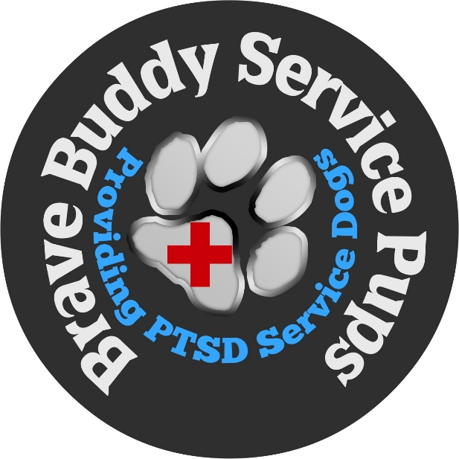
I certify that the information provided in this application is accurate. I understand that participation in the Hopkins Hounds Therapy Dog Program is voluntary and subject to evaluation and approval.
I agree to follow all program rules and airport safety guidelines.
Applicant Name: ____________________________
Signature: ____________________________
Date: ____________________________
Attach the following certificates to your application:
Rabies certificate, current veterinary health records, and earned therapy dog titles

