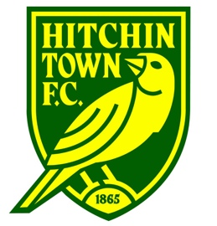
Managers/Coaches - Use the below form to outline your team affiliation for the 2021-22
season. Please note:
- One person per team needs to have a FA Level 1 qualification as a minimum
- Team Affiliation Forms are to be returned to our Club Secretary, Geoff Pollard, via his email: secretary@hitchintownyouthfc.com

AGE GROUP & TEAM NAME | UNDER: | NAME:
LEAGUE REQUIRED
RCL / MHL
Herts County Cup Entry Y/ N
(Competitive teams only)
MANAGER NAME
TEL/MOBILE
E-MAIL ADDRESS
FAN NUMBER & DATE OF BIRTH
COACH 1 NAME
TEL/MOBILE
E-MAIL ADDRESS
FAN NUMBER & DATE OF BIRTH
COACH 2 / ASSISTANT NAME
TEL/MOBILE
E-MAIL ADDRESS
FAN NUMBER & DATE OF BIRTH
ADMIN/FIXTURE SECRETARY
TEL/MOBILE
E-MAIL ADDRESS
FAN NUMBER & DATE OF BIRTH

NEW PERSONNEL DETAILS
Please note: All new Managers / Coaches must have up to date DBS / FA Safeguarding as a minimum).

ROLE WITHIN TEAM
FULL NAME
TEL/MOBILE
E-MAIL ADDRESS
FAN NUMBER & DATE OF BIRTH

PLAYER REGISTRATION FEES 2021-22

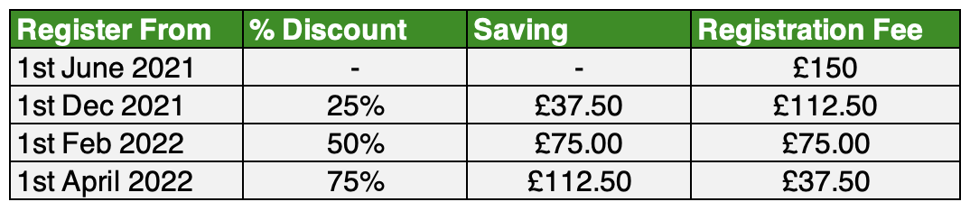

Please note:
- Full annual registration fee needs to be paid (1st half) £75.00 by 30/06/21, and (2nd half) £75.00 by 30/09/21
- All player forms to be in by 30/06/21 with 1st half payments
- New players as and when (see above table for registration fee discounts)
- Team Managers are responsible for collecting all registration forms and will transfer to the Registration Secretary – Adam Nethersole (adam.nethersole@hitchintownyouthfc.com)
- Team Mangers are responsible for collecting all registration payments (1st and 2nd halves) and transferring to the club’s bank account as advised by our Finance Manager – Ade Olabode (ade.olabode@hitchintownyouthfc.com).

