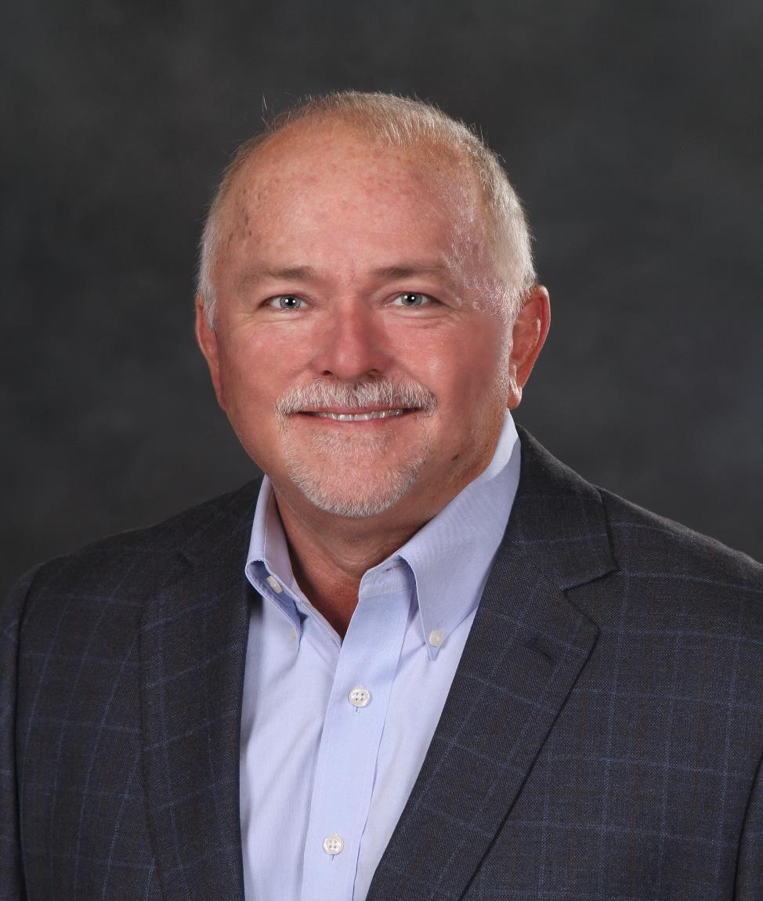
“Send us your rookie, and we’ll send you back,
A WARRIOR!”

The most powerful, results generating, and transformational, Producer training in the country.

“I have attended many courses over the years, your camp has had the most profound and positive effect on my entire career of any of them. Thank you” Sarah Prince, Burbank, CA

“Accelerated Producer Intensive” – overview

- Background:

Agency principals have little time and energy to train and mentor newer producers. The common strategy is to “hope” that the producer will “work as hard, and be as good as they were”, which rarely works out.

In Phil’s first agency, his young Producers were experts at qualifying buyers and building books rapidly. In 2001, the agency was sold, and in 2007 Phil left a CEO position in Canada. Several agency principals no longer competing with Phil’s team, asked Phil to train THEIR young people. Three months later the API was launched.

Today, many Producers have experienced one of the strongest educational experiences of their careers, and credit what they learned as largely responsible for their success today.

They became ethical, service driven, professional, competent, and successful Warriors!

Read on for “Who This is For”, and “What You Will Learn”

- Who is this for: “the NEW, the NEARLY NEW, NEED to RENEW”

There are three types of participants that benefit the most:

- New producers needing strong fundamentals to build their books and careers, as solid and as fast as possible. They learn to attract, targeted buyers, and then qualify them to assure success.

- CSR and “account executives”, that need a fundamental base from which to sell, at several levels in transitioning to the production role. Already insurance professionals and need support in becoming a more powerful Account Executive responsible for rounding accounts and closing renewals.

- Experienced producers from 3-20 years, who find themselves “stuck” in growing their books to a higher level. Producers find themselves in this position with books developing revenue of $300,000 to $600,000 and stop. Causes ranging from lost vision of what they truly want or how they got there in the first place, and therefore dulled commitment. Renewed commitment to a plan of action.
(This group provides the highest praise of all three groups!)

“Being a seasoned Producer, I had no idea how this class would benefit me. The number of light bulbs that went off in this 3 day course could light up the Golden Gate Bridge!”
Jake Lombardo, San Jose, CA

- What you will learn:

- Day One: Marketing

- Why you committed to this industry. Actual goal setting that includes your behavior, that sets the stage for the rest of your career.

- Marketing:
- Understanding personal marketing, “What marketing doesn’t do, sales has to make up for”.
- 12-15 second “elevator speech”.
- Understanding the insurance buyer, why they buy from us, and managing “5 levels of interest”.
- 11 Personal marketing tactics that cost virtually nothing including Associations, telemarketing, email marketing, and the best training on the use of the phone anywhere.
- “Permission Marketing”, the power of understanding the levels of permission to achieve with buyers to “earn the right” to sell to them in the first place; and why rejection happens.

- Day Two: Sales Training

- “Typing the buyer”; styles and behaviors
- “Qualifying the buyer”; the most powerful segment of the course. Allows even the youngest producer the power to stick up for themselves in a competitive situation.
- Making the calls. Take away fear of calling forever.
- “Relationship selling”; marketing and selling using the knowledge of how relationships develop, and how you can use this to expand your success.
- Managing your statistics; Key Performance Indicators and what behaviors will need to be measured to manage yourself.
- Setting your sales goals; right down to daily measurement.

- Putting it together:
- Personal marketing and sales plan.
- A chosen target market (industry, number of employees, average commission per account, and most importantly “who they are”)
- Commit to two marketing tactics they will employ immediately.
- Key Performance Indicators to measure behavior.
- Delegation skills necessary to allow them to leverage themselves.
- Then to learn to grow their book into the 7-figure arena and still have a life.

Prepare you for the 30 days of mentoring I provide to every participant to assure that you are executing your plan.
"The best impact this had for me was conquering of my fear. This will help me overcome anything that stands in my way of being a successful insurance agent. Having my sales plan and goals to reach them will work great for me."
Nathan Borecki, Simi Valley, CA

Going Forward:

Every participant will be personally coached and mentored by Phil for 30 days, ensuring they put their plans of action into practice immediately. In our experience, this does the trick.

Important: Every registration contains a 100% Money Back Guarantee provided to anyone attending. If for ANY reason, after Day 1, the participant is not satisfied they need not return for day 2 and they will be immediately refunded their full tuition.

From Phil, and the entire team, we thank you.

Good Hunting!

Phil Beakes

