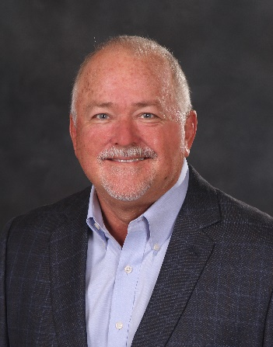

**Successful Producers and Effective Sales Managers are NOT born…..**

**they are created!**

**Are you ready double your sales and increase your profit by hiring and managing Producers?**

**Your time is NOW!!**

Phil Beakes

**“Sales Leadership Summit”**

**2 Day Workshop**

100% Money Back Guarantee!

**Who is it for?**

Frustrated **Agency Principals** and **Sales Managers**; have tried to hire Producers to take advantage of the agency’s knowledge, experience, and infrastructure, and do it profitably. You hire repeatedly, trying to find that superstar who will *“sell like I did when I was their age”.* you end up losing money, endless friction in the organization, waiting for the revenue to come in, and eventually fall back and punt.

**See if one of these examples is YOUR experience:**

1. There is the **“experienced Producer”**; a “legend in their own resume”, with a book of business guaranteed to move into your shop, and of course pay a salary to come over. About half of the book shows up after 12 months and a major hassle with the prior agent. The experienced Producer is either “above” doing any personal marketing because they “only work on referral”, and no new business comes in… then they leave.
2. There is the **family member** who receives an opportunity, and maybe even join you as a potential owner one day. They “hit the ground *walking*”, and you cannot find a way to motivate them to sell with the same urgency you did building the agency. You are faced with “hoping” they come around, or you are faced with a terrible decision of having them leave.
3. You decide to get some **“new blood”** in the company and grab some recent college grads, or young people in other industries needing experience, because they have energy and frankly they are CHEAPER to acquire (you think). You plan to train them the business and have them take off and grow a book from scratch. You either start them on BOPs, and they never graduate to larger accounts, or perhaps treat them like a potted plant in the corner, expecting water and sunlight to make them grow with minimal oversight and mentoring on your part. Either way, the training and managing was more involved than you thought to make it into a win.
4. There are many more scenarios! **(Enter YOUR’S here!)**

**Time to break the pattern, and PROFIT with Producers!! What you will learn:**

**Day One**

* Know EXACTLY what you want and why you are doing all this!
* Alternative growth strategies.
* Predictable stages of your growth and what to expect.
* Producer Recruiting; standards, strategies, priority action, skills.
* Contracts and agreements.
* Pre-testing.
* Marketing for candidates. Producer training.
* Mentoring Vs. Coaching
* Accountability and delegation -Handing it Off

**Day Two**

* Managing Producers; motivation, expectations, being the “ROKQ”
* Key Performance Indicators
* Attracting candidates
* Agency marketing tactics and training
* Great Sales Meetings
* Training the Trainer (sales)
* Action Plans and your accountability

**Going Forward:**

Every participant will be coached and mentored by me personally enabling them to put their plan of action into practice, and help to navigate getting everything started and moving. In my experience, this does the trick.

Further coaching will be available, and negotiated on a case by case basis depending on the need to assure success.

**Important:** Every registration contains a **100% Money Back Guarantee** provided to anyone attending. If for ANY reason, after Day 1, the participant is not satisfied they do not need to return for day 2 and they will be immediately refunded their full tuition.



The camp is HIGHLY INTERACTIVE, and is in every way a WORKSHOP. The atmosphere is high energy and intense. Participants will be exhausted by the end of the day, but highly energized. This intensity does not leave you as I personally make sure you put the training into action in the ensuing 30 days.

From Phil, and the entire team, we thank you.

Good Hunting!

Phil Beakes