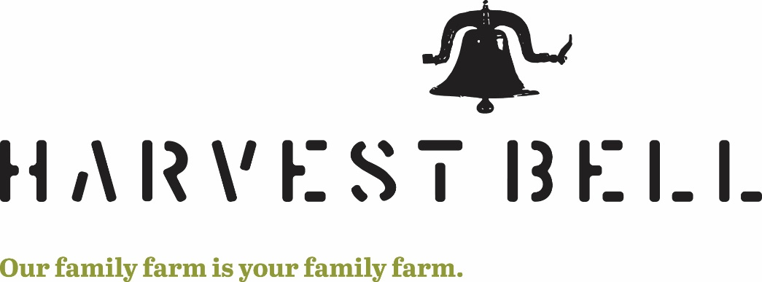

**PORK**

Bacon (thin, thick, ends & jowl) $10

Sausage Links (hot Italian, sweet Italian, brats, breakfast) $8

Sausage Bulk (hot Italian, sweet Italian, chorizo) $7

Sausage Patties (breakfast) $8

Ground Pork $7

Hot Dogs $10/pack

Ribs $7

Chops $8

Roast (bone-in/boneless) $7

Smoked Ham $10

Smoked Ham Hocks $3

Shanks $3

Neck Bones $3

Liver, Heart, Tongue $3

**TURKEY**

Whole $5

Breast $10

Thighs $5

Drumsticks $3

Wings $3

Ground Turkey $9

Sausage Links (brats, kielbasa, maple) $9

*Meat Listing (all prices per pound unless marked differently)

*Availability of products subject to change

**Contact Information:**

[harvestbellfarm@gmail.com](mailto:harvestbellfarm@gmail.com)

(440) 564-7070