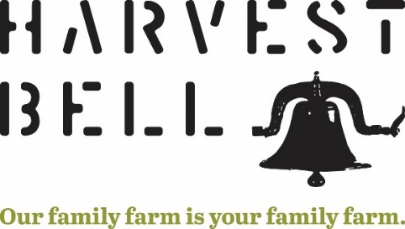

11278 Bell Road. Newbury, Ohio 44065

440.564.7070 | [Mentzer@harvestbellfarm.com](mailto:Mentzer@harvestbellfarm.com)

**Your Information**

Name: _______________________________________________________________________

Address: _____________________________________________________________________

Phone: _______________________________________________________________________

Email: _______________________________________________________________________

**CSA Egg Share Options** (Please check the box next to the membership option you are signing up for.)

___ 1 dozen eggs/week ($5/week)

___ 2 dozen eggs/week ($10/week)

**Payment** for egg shares must be received every two months (cash or check). Please make checks payable to Harvest Bell Farm, LLC.

Please note: Chickens lay eggs in cyclical fashion due to cold/warm weather and shorter/longer day length. There may be weeks during the winter months that you will not receive eggs on the exact scheduled delivery day. No worries, you will get your egg share, we will work with the chickens as they provide us with their bounty.

**Egg Pick-Up**

Since we are only doing an egg CSA at this time, we will be offering two pick-up times during the week, one at the farm and the other at the Geauga Fresh Farmer’s Market. Please select which option you want to pick up your eggs.

___ Tuesday 4:00 – 7:00 PM Harvest Bell 11278 Bell Rd. Newbury 44065

___ Saturday 9:00 – 12:00 PM Farmer’s Market, corner of Rt. 306 & Bell Rd.

**CSA Member Agreement**

I would like to become a member of Harvest Bell Farm’s Community Supported Agriculture (CSA) program. I agree to cooperate with the other members in my CSA community and follow the CSA guidelines to make this an enjoyable experience for all. I am committed to my farm for the season and agree to share in the bounty and risks with my farmers and my fellow CSA members. I understand that it is my responsibility to know when and where to pick up my shares, and I agree to pick up my shares on time on delivery day.

By signing your name and the date below you acknowledge that you have read and agree to the above terms and conditions.

Signature: ____________________________________________________________________

Date: _________________________