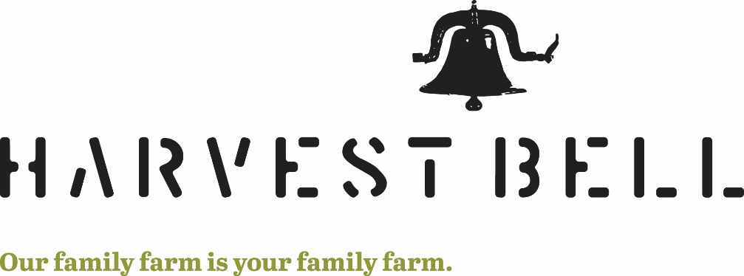

Turkey Order Form (Thanksgiving & Holiday reservations)
At Harvest Bell, we raise our poultry in a humane, stress free environment. Our poultry has a constant supply of fresh water and enjoy the freedom of being outside in the sunshine and eating up nature’s offerings. In addition to nature’s offerings, our poultry has a steady supply of fresh NON-GMO feed and we don't use animal by-products, antibiotics or other non-natural feed additives. Raising healthy happy poultry is only a part of bringing a healthy meal to the dinner table. Fresh frozen turkeys will be available for farm pick up the week prior to each holiday. We will let you know an exact day and time as soon as we know. Please fill out the requested information below and pay a deposit of $25.00 per turkey. Orders and deposit are due upon completion & delivery of form. Drop off at Harvest Bell or mail to 11278 Bell Rd. Newbury, OH 44065. Make checks payable to Harvest Bell Farm.
- Turkey Breast (1/2 & whole) $10/lb. range in 3-8 lb.
- Whole Turkey $5/lb. with giblets range in 14-30 lb.
  - We do our very best to get you a turkey in the size you have requested, give us a 3-5 lb. range when requesting the weight.
Full Breast/1/2 Breast/Whole Turkey (circle one) # of Turkeys_______
Approximate weight of turkey: ________lbs. (we will do our best to get you as close to the size that you want, there are no guarantees)
Name: _____________________________________________________
Phone Number: ______________________________________________
Email Address: _______________________________________________ Deposit paid ($25 per turkey) _____________ Date: ________________

