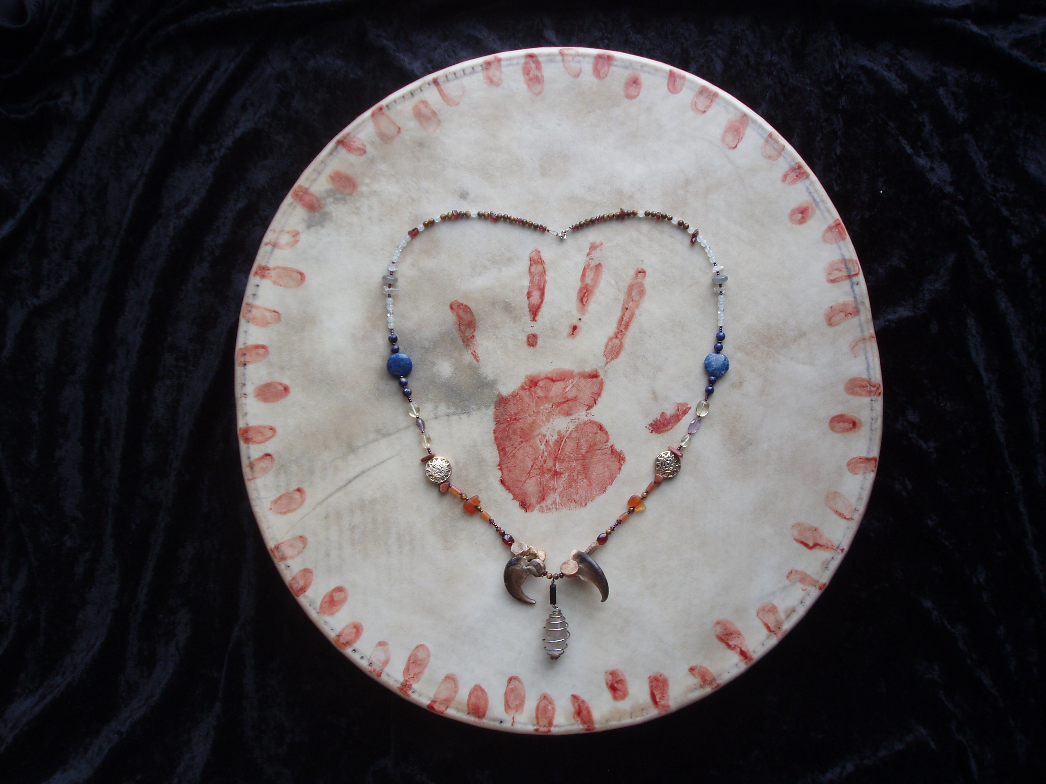  - Tending the Wild Soul  a woman’s shamanic retreat  November 8-10, 2019 - Boulder Hot Springs, MT  Join Shaun Phoenix, shamanic practitioner and psychotherapist, in creating the most ancient of powerful and sacred forms – a circle of conscious and intentional women. Using the wisdom and practices of shamanism, we will dis-cover our own authentic wild nature … that part of us which is fed and restored by the natural world … that part of us which sustains and heals our world. No shamanic experience necessary. Limited to 11 participants.  Shaun Phoenix, LCPC, has been both a licensed counselor and a shamanic healing practitioner for almost 30 years, and has received advanced training from the Foundation for Shamanic Studies. She is currently accepting new clients for both her shamanic and psychotherapy practices. She also offers instruction and mentoring in shamanic journeying for personal empowerment and self-care. A musician, artist and writer, her life’s work has focused on empowering women’s authentic voices and honoring women’s truths. | November 8-10, 2019  ____  sacred play  ____  sacred art  ____  sacred music making  ____  Brought to you by  Many Hands  Light Work  (“Like” us on Facebook!)  For more information,  please contact  Shaun Phoenix, LCPC, at:  safepassagecounseling.com  shaunloves2drum@gmail.com  (406) 580-0562

