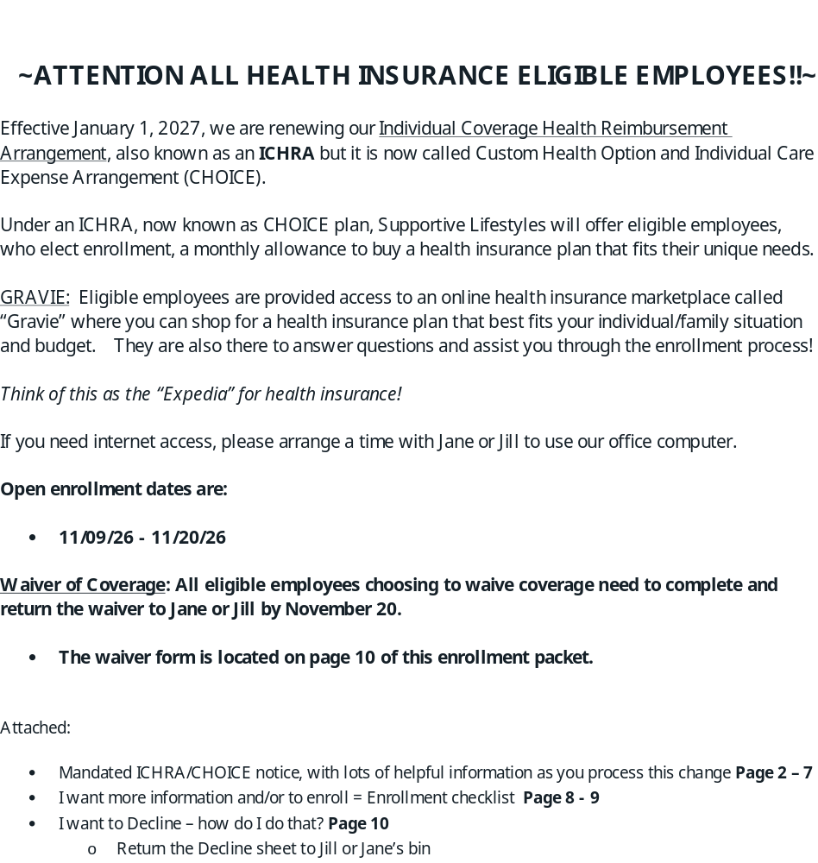

October 13, 2026

Individual Coverage HRA Notice
USE THIS NOTICE WHEN APPLYING FOR INDIVIDUAL HEALTH INSURANCE COVERAGE

Dear Supportive Lifestyles Inc. employee,

You are getting this notice because your employer is offering you an individual coverage health reimbursement arrangement (HRA). Please read this notice before you decide whether to accept the HRA. In some circumstances, your decision could affect your eligibility for the premium tax credit. Accepting the individual coverage HRA and improperly claiming the premium tax credit could result in tax liability.

This notice also has important information that the Exchange (known in many states as the “Health Insurance Marketplace”) will need to determine if you are eligible for advance payments of the premium tax credit. An Exchange operates in each
state to help individuals and families shop for and enroll in individual health insurance coverage.

You may also need this notice to verify that you are eligible for a special enrollment period to enroll in individual health insurance coverage outside of the annual open enrollment period in the individual market.

The Basics

What should I do with this notice?

Read this notice to help you decide if you want to accept the HRA.

Also, keep this notice for your records. You’ll need to refer to it if you decide to accept the HRA and enroll in individual health insurance coverage, or if you turn down the HRA and claim the premium tax credit on your federal income tax return.

What’s an individual coverage HRA?

An individual coverage HRA is an arrangement under which your employer reimburses you for your medical care expenses (and sometimes your family members’ medical care expenses), up to a certain dollar amount for the plan year. If you enroll in an individual coverage HRA, you must also be enrolled in individual health insurance coverage or Medicare Part A (Hospital Insurance) and B (Medical Insurance) or Medicare Part C (Medicare Advantage) (collectively referred to in this notice as Medicare) for each month you are covered by the HRA. If your family members are covered by the HRA, they must also be enrolled in individual health insurance coverage or Medicare for each month they are covered by the HRA.

The individual coverage HRA you are being offered is employer-sponsored health coverage. This is important to know if you apply for health insurance coverage on the Exchange.

Note: There are different kinds of HRAs. The HRA that’s being referred to throughout this notice, and that your employer is offering you, is an individual coverage HRA. It is not a qualified small employer health reimbursement arrangement (QSEHRA) or any other type of HRA.

What are the basic terms of the individual coverage HRA that my employer is offering?

        - Please see the contribution chart below to see dollars available for 2027. Multiply the monthly amount by 12 and this will be your annual amount.

Note that the self-only HRA amount available for the plan year, which is the amount you should tell the Exchange is available to you. If you apply for individual health insurance coverage through the Exchange, this is the amount the Exchange will use to figure out if your HRA is considered affordable. The maximum dollar amount is prorated to reflect only those months you (or your dependent) are covered under the HRA.

Age | Monthly EE Only Amount | Monthly EE + Spouse Amount | Monthly EE + Child Amount | Monthly EE + Family Amount
< 25 | $334.80 | $334.80 | $334.80 | $334.80
25-29 | $334.80 | $334.80 | $334.80 | $334.80
30-34 | $378.00 | $378.00 | $378.00 | $378.00
35-39 | $410.40 | $410.40 | $410.40 | $410.40
40-44 | $432.00 | $432.00 | $432.00 | $432.00
45-49 | $507.60 | $507.60 | $507.60 | $507.60
50-54 | $615.60 | $615.60 | $615.60 | $615.60
55-59 | $831.60 | $831.60 | $831.60 | $831.60
60-64 | $1,004.40 | $1,004.40 | $1,004.40 | $1,004.40
65+ | $1,004.40 | $1,004.40 | $1,004.40 | $1,004.40

        - Your family members are eligible for the HRA.

        - In general, your HRA coverage will start January 1, 2027. However, if you become eligible for the HRA less than 90 days before the beginning of the plan year or during the plan year, your HRA coverage will start the first day of the month following timely enrollment.

        - The HRA plan year begins on January 1, 2027, and ends on December 31, 2027.

        - Amounts newly made available under the HRA will be made available on January 1, 2027.

Note: You will need this information if you apply for health insurance coverage through the Exchange.

Can I opt out of the individual coverage HRA?

Yes. You can opt out of the HRA for yourself (and your family members, if applicable). In order to opt out of the HRA, do not submit an enrollment form during open enrollment.

Upon termination of employment, the HRA is forfeited.

If I accept the individual coverage HRA do I need to be enrolled in other health coverage too?

Yes. You (and your family members, if applicable) must be enrolled in individual health insurance coverage or Medicare for each month you (or your family members) are covered by the HRA. You may not enroll in short-term, limited-duration insurance or only in excepted benefits coverage (such as insurance that only provides benefits for dental and vision care) to meet this requirement.

Getting Individual Health Insurance Coverage

How can I get individual health insurance coverage?

If you already have individual health insurance coverage, you do not need to change that coverage to meet the HRA’s health coverage requirement.

If you don’t already have individual health insurance coverage, you can enroll in coverage through the Exchange or outside of the Exchange – for example, directly from an insurance company.

Note: People in most states use HealthCare.gov to enroll in coverage through the Exchange, but some states have their own Exchange. To learn more about the Exchange in your state, visit https://www.healthcare.gov/marketplace-in-your-
state/.

If you are enrolled in Medicare Part A and B or Medicare Part C, your enrollment in Medicare will meet the HRA’s health coverage requirement. For information on how to enroll in Medicare, visit www.medicare.gov/sign-up-change-plans.

When can I enroll in individual health insurance coverage?

Generally, anyone can enroll in or change their individual health insurance coverage during the individual market’s annual open enrollment period from November 1 through December 15. (Some state Exchanges may provide additional time to enroll.) If your individual coverage HRA starts on January 1, you (and your family members, if applicable), generally should enroll in individual health insurance coverage during open enrollment.

In certain circumstances, such as when your individual coverage HRA starts on a date other than January 1 or if you are newly hired during the HRA plan year, you (and your family members, if applicable) can enroll in individual health insurance coverage outside of open enrollment using a special enrollment period.

If you qualify for a special enrollment period, make sure you enroll on time:

- If you are newly eligible for HRA coverage that would start at the beginning of the HRA plan year, you generally need to enroll in individual health insurance coverage within the 60 days before the first day of the HRA plan year.
- If the HRA was not required to provide this notice 90 days before the beginning of the plan year, or you are newly eligible for HRA coverage that would start mid-plan year (for example, because you are a new employee), you may enroll in individual health insurance coverage up to 60 days before the first day that your HRA can start or up to 60 days after this date. Enroll in individual health insurance coverage as soon as possible to get the most out of your individual coverage HRA.

Note: If you enroll in individual health insurance coverage through this special enrollment period, you may need to submit a copy of this notice to the Exchange or the insurance company to prove that you qualify to enroll outside of the open enrollment period. For more information on special enrollment periods, visit HealthCare.gov or the website for the Exchange in your state.

Do I need to get new individual health insurance coverage each year if I want to enroll in my individual coverage HRA each year?

Yes. Individual health insurance coverage is typically sold for a 12-month period that is the same as the calendar year and ends on December 31. If your HRA starts on January 1, you will either need to get new individual health insurance coverage or re-enroll in your individual health insurance coverage. If your HRA has a plan year that starts on a day other than January 1, because your individual health insurance coverage will stay in effect until December 31, you do not need to get new individual health insurance coverage or re-enroll until the next open enrollment period.

If you are enrolled in Medicare, your Medicare coverage generally will remain in place year to year.

Do I need to substantiate my (and my family member’s) enrollment in individual health insurance coverage or Medicare to the individual coverage HRA?

Yes. You must substantiate that you (and your family members, if applicable) will be enrolled in individual health insurance coverage or Medicare for the period you will be covered by the HRA. Gravie Administrative Services LLC will request the substantiation documentation from you.

Also, each time you seek reimbursement of a medical care expense from the HRA, you must substantiate that you had (or have) (or the family member whose medical care expense you are seeking reimbursement for, if applicable had (or has)) individual health insurance coverage or Medicare for the month during which the expense was incurred.

To qualify for the HRA allowance, you must enroll in the HRA and provide Gravie with proof of coverage, either through an ACA-compliant health plan or Medicare if you are over age 65. This is handled through our Easy Enroll or Self-Enroll process, respectively. Attestation is automated for the majority of our members, however, since Gravie does not coordinate Medicare plans we will send attestation emails to Medicare members to confirm their coverage. These Medicare members will need to work directly with our Gravie Care team to set up their coverage.

What happens if I am (or one of my family members is) no longer enrolled in individual health insurance coverage or Medicare?

If you (or a family member, if applicable) are no longer enrolled in individual health insurance coverage or Medicare, the HRA won’t reimburse you for medical care expenses that were incurred during a month when you (or your family member, as applicable) did not have individual health insurance coverage or Medicare. This means that you may not seek reimbursement for medical care expenses incurred when you (or your family member, if applicable) did not have individual health insurance coverage or Medicare.

Note: You must report to the HRA if your (or your family member’s) individual health insurance coverage or Medicare has been terminated retroactively and the effective date of the termination.

Information About the Premium Tax Credit

What is the premium tax credit?

The premium tax credit is a tax credit that helps eligible individuals and their families pay their premiums for health insurance coverage purchased through the Exchange. The premium tax credit is not available for health insurance coverage purchased outside of the Exchange.

Factors that affect premium tax credit eligibility include enrollment in Exchange coverage, eligibility for other types of coverage, and household income.

When you enroll in health insurance coverage through the Exchange, the Exchange will ask you about any coverage offered to you by your employer, including through an HRA. Your ability to claim the premium tax credit may be limited if your employer offers you coverage, including an HRA.

The Exchange also will determine whether you are eligible for advance payments of the premium tax credit, which are amounts paid directly to your insurance company to lower the cost of your premiums. For more information about the premium tax credit, including advance payments of the premium tax credit and premium tax credit eligibility requirements, see irs.gov/aca.

If I accept the individual coverage HRA, can I claim the premium tax credit for my Exchange coverage?

No. You may not claim the premium tax credit for your Exchange coverage for any month you are covered by the HRA. Also, you may not claim the premium tax credit for the Exchange coverage of any family members for any month they are covered by the HRA.

If I opt out of the individual coverage HRA, can I claim the premium tax credit for my Exchange coverage?

It depends.

- If you opt out of the HRA and the HRA is considered unaffordable you may claim the premium tax credit for yourself and any family members enrolled in Exchange coverage if you are otherwise eligible.
- If you opt out of the HRA and the HRA is considered affordable, you may not claim the premium tax credit for yourself or any family members.

If you are a former employee, the offer of an HRA will not prevent you from claiming the premium tax credit (if you are otherwise eligible for it), regardless of whether the HRA is considered affordable and as long as you don’t accept the HRA.

How do I know if the individual coverage HRA I’ve been offered is considered affordable?

The Exchange website will provide information on how to determine affordability for your individual coverage HRA. To find your state’s Exchange, visit: https://www.healthcare.gov/marketplace-in-your-state/.

Do I need to provide any of the information in this notice to the Exchange?

Yes. Be sure to have this notice with you when you apply for coverage on the Exchange. If you’re applying for advance payments of the premium tax credit, you’ll need to provide information from the answer to “What are the basic terms of the

individual coverage HRA my employer is offering?” on page 2. You will also need to tell the Exchange whether you are a current employee or former employee.

If I’m enrolled in Medicare, am I eligible for the premium tax credit?

No. If you have Medicare, you aren’t eligible for the premium tax credit for any Exchange coverage you may have.

Other Information You Should Know

Who can I contact if I have questions about the individual coverage HRA?

Gravie Administrative Services LLC 10 NE 2nd St, Suite 300
Minneapolis, MN 55413
800-501-2920

Is the individual health insurance coverage I pay for with my individual coverage HRA subject to ERISA?

The individual health insurance coverage that is paid for with amounts from your individual coverage HRA, if any, is not subject to the rules and consumer protections of the Employee Retirement Income Security Act (ERISA). You should contact your state insurance department for more information regarding your rights and responsibilities if you purchase individual health insurance coverage.

Legal notices and documents
You can access the following at https://www.gravie.com/2027sbcsupportivelifestylesinc/ or request free paper copies by calling Gravie Care at 800.501.2920:
- Release of Information
- Privacy Notice
- CHIP Notice
- ICHRA Summary of Benefits and Coverage

Need help?
Gravie Care® is here for you. Call us at 800.501.2920 or send us a secure message 24/7 at member.gravie.com/contact.

Learn about your benefit before you enroll.
Visit gravie.com/enroll to:

- Understand how ICHRA works
- Learn your responsibilities as a member
- Read answers to frequently asked questions
- Get tips for shopping and comparing plans

