The Bible Classroom Freedom Fellowship SOURCEBOOK
Welcome to The Bible Classroom Freedom Fellowship – On the Road with Jesus!
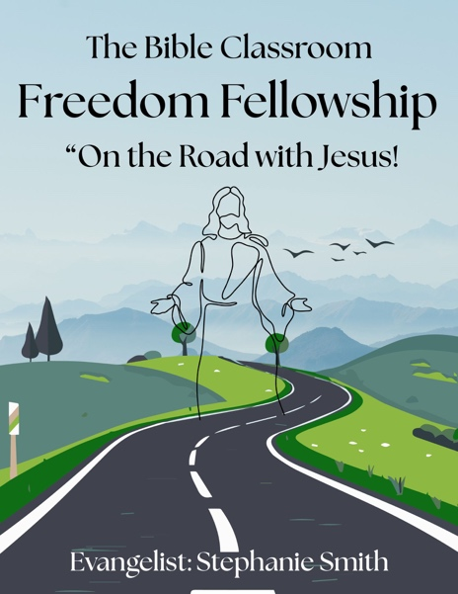
Who we are: We are a traveling fellowship dedicated to sharing the love, power, and truth of Jesus Christ wherever the Holy Spirit leads us. We believe in the WHOLE Bible—from Genesis to Revelation—and we preach the gospel boldly, lovingly, and without compromise.
This sourcebook is your guide and companion for what we believe, how we serve, and how you can discover where you are on your walk with Jesus. Whether you’re sitting by a creek, standing in a backyard, gathered at a picnic table in the park, or visiting us at a local community center, we welcome you.

Evangelist, Bible Teacher, Christian Author & Publisher: Stephanie Smith
www.TheBibleClassroom.com
www.StephanieSmithMinistries.org

OUR MISSION
Our mission is simple:
- To go out into the world and make disciples (Matthew 28:19-20)
- To meet people where they are—spiritually, emotionally, and physically
- To share the Good News of Jesus Christ through the Word, worship, prayer, and love
- To walk with people in grace as they grow in their faith journey
We’re not waiting for people to come to church—we bring church to the people.
WHERE WE MEET
(It will be posted on our Website, Facebook & TikTok)
You may find us:
- At the park under a picnic shelter
- Beside a quiet stream with open Bibles
- On a folding chair in someone’s backyard
- In a small-town community center
- By the riverside, lifting our hands in worship
- At local creeks, lakes, and any open space where people are hungry for Jesus
Jesus walked the dusty roads, stopped at wells, and taught from boats. We’re just following His lead!

Who Is Stephanie Smith?
Hey there, I’m Stephanie Smith—just a Jesus-loving, truth-talking, scripture-teaching, praise-worshiping woman of God! I'm the founder of The Bible Classroom Freedom Fellowship – On the Road with Jesus, and I’m honored to walk this journey of faith alongside you.
For years, I tried to do life my own way… but Jesus stepped in, rescued me, and set my feet on solid ground. I’ve been delivered from darkness, healed from past hurts, and called to boldly teach the Word of God with joy, passion, and purpose. I’m not perfect, but I’m His, and that’s more than enough.
I’m a wife, a mother, a grandma “Gam Gam”, and a Bible teacher with a silly side, a loud laugh, and a heart that beats for Jesus and His people. I’ve been through the wilderness, but I’ve also seen and felt the Goodness of God and now, I want to help others get there too.
This ministry isn't about titles or buildings—it’s about PEOPLE. It's about showing up with the Word, a willing heart, and a portable chair if needed! We gather in parks, by creeks, in living rooms, backyards and anywhere people are hungry for truth. That’s what Freedom Fellowship is all about—meeting you right where you are and walking with you as you grow in faith.
So if you’re wondering if God can use you—He can. If you’re wondering if He still speaks—He does. And if you're wondering if you're alone, you're not. I’m here, and more importantly, Jesus is right here too.
Let’s walk this road of faith together.
With love,
Stephanie Smith
Bible Teacher • Evangelist • Christian Author & Publisher

WHAT WE BELIEVE
- The Bible is the inspired, living, and infallible Word of God.
- Salvation is a gift through faith in Jesus Christ.
- The Holy Spirit empowers believers for boldness, purpose, and victory.
- Deliverance and healing are for today.
- Fellowship, worship, and prayer are essential for spiritual growth.
- We are all called to grow in grace and go in love.

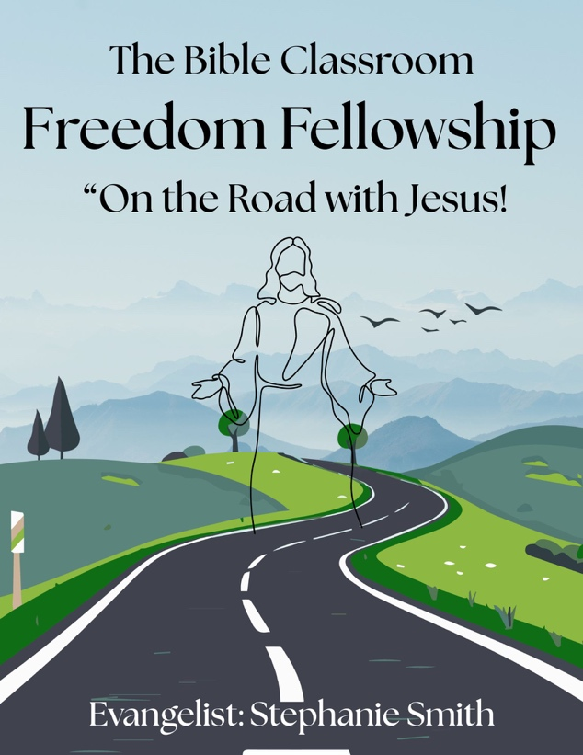

DISCOVERY SECTION: WHERE ARE YOU IN YOUR WALK WITH JESUS?
(Fill in the blanks and reflect honestly. There are no wrong answers—just a starting point.)
- I believe Jesus is the Son of God: Yes / No / I’m not sure
- I’ve accepted Jesus as my Lord and Savior: Yes / No / I want to
- I was baptized in water: Yes / No / Not yet
- I pray: Daily / Occasionally / Rarely
- I read the Bible: Often / Sometimes / Not yet
- I feel close to God when: ____________________________________________________________________________________________________________
- I struggle in my faith when: ____________________________________________________________________________________________________________
- I want to grow in my walk with Jesus by: __________________________________________________________________________________________________________________________________________________________________
- I’ve been walking with Jesus for: Less than a year / 1-5 years / Over 5 years

- I would describe my spiritual walk as: __________________________________________________________________________________________________________________________________________________________________

NEW BELIEVER?
If you’re just getting started, welcome!
Use this page to track your growth.
Date I gave my heart to Jesus: _________________________
Who led me to Christ: __________________________________

My favorite scripture right now: ________________________________________________________________________________________________________________________________________________________________________

My next step is: ________________________________________________________________________________________________________________
Some next steps might be:
- Water baptism
- Learning how to pray
- Reading the Gospel of John
- Attending regular Bible fellowship

10 Powerful Scriptures We Want to Share with You.

Why These Scriptures Matter
The Word of God is our foundation, our compass, and our lifeline. These 10 scriptures were prayerfully chosen because they reflect the heartbeat of The Bible Classroom Freedom Fellowship—to go out, to love big, to meet people where they are, and to boldly share the truth of Jesus Christ.
Each verse speaks to a part of our mission: the call to make disciples, the power of the Holy Spirit, the message of salvation through Jesus, and the importance of gathering together in faith. Whether you’re a new believer, a seeker, or someone reigniting your walk with God, these scriptures will strengthen your journey.
They remind us that:
- Jesus is the Way
- The Holy Spirit empowers us
- We are never alone
- God’s Word lights our path (Psalm 119:105)
- New life is possible through Christ
Keep these verses close. Write them on your heart. Speak them out loud. Let them shape your faith, fuel your prayers, and give you direction. The Bible isn’t just a book—it’s the living voice of God, and these scriptures are powerful tools to help you walk in freedom and truth every day.

1. Matthew 28:19-20 (NKJV)
“Go therefore and make disciples of all the nations, baptizing them in the name of the Father and of the Son and of the Holy Spirit,
teaching them to observe all things that I have commanded you; and lo, I am with you always, even to the end of the age.” Amen.
💬 This is our call to GO—and what Freedom Fellowship is all about.

2. Romans 10:13-14 (NKJV)
“For ‘whoever calls on the name of the Lord shall be saved.’
How then shall they call on Him in whom they have not believed? And how shall they believe in Him of whom they have not heard?”
💬 We’re here to make sure they HEAR about Jesus!

3. John 14:6 (NKJV)
“Jesus said to him, ‘I am the way, the truth, and the life. No one comes to the Father except through Me.’”
💬 This makes it clear—Jesus is the only way, and our message points to Him.

4. Acts 1:8 (NKJV)
“But you shall receive power when the Holy Spirit has come upon you; and you shall be witnesses to Me in Jerusalem, and in all Judea and Samaria, and to the end of the earth.”
💬 Our mission is fueled by Holy Spirit POWER!

5. Isaiah 61:1 (NKJV)
“The Spirit of the Lord God is upon Me,
Because the Lord has anointed Me
To preach good tidings to the poor;
He has sent Me to heal the brokenhearted,
To proclaim liberty to the captives,
And the opening of the prison to those who are bound…”
💬 This is Jesus’ mission—and now ours, too.

6. Psalm 119:105 (NKJV)
“Your word is a lamp to my feet and a light to my path.”
💬 Wherever we go—parks, rivers, backyards—His Word lights the way.

7. 2 Corinthians 5:17 (NKJV)
“Therefore, if anyone is in Christ, he is a new creation; old things have passed away; behold, all things have become new.”
💬 Perfect for new believers discovering new life in Jesus!

8. Hebrews 10:25 (NKJV)
“Not forsaking the assembling of ourselves together, as is the manner of some, but exhorting one another, and so much the more as you see the Day approaching.”
💬 Even if we’re meeting outdoors or under trees—fellowship matters!

9. Philippians 4:13 (NKJV)
“I can do all things through Christ who strengthens me.”
💬 This is for those on the journey—especially when life feels hard.

10. Luke 19:10 (NKJV)
“For the Son of Man has come to seek and to save that which was lost.”
💬 Jesus seeks the lost. So do we.

FREEDOM FELLOWSHIP CREED
Our Declaration of Faith and Freedom
We, the members and followers of The Bible Classroom Freedom Fellowship – “On the Road with Jesus”, boldly declare our faith and identity in Christ. This is our creed—a spoken reminder of who we are, what we believe, and how we walk.

✨ I BELIEVE…
- That the Holy Bible is the inspired, living, and eternal Word of God—cover to cover, Genesis to Revelation.
- That Jesus Christ is the Son of God, born of a virgin, crucified for our sins, risen on the third day, and coming back again in glory!
- That through faith in Jesus, I am saved, forgiven, and made new.
- That the Holy Spirit dwells in me, empowers me, leads me, and comforts me.
- That I have been called to go and make disciples, sharing God’s truth with boldness and love.
- That I am no longer bound by fear, shame, or sin—I have freedom in Christ!

✨ I CONFESS…
- That I will walk in love, live by faith, and speak the truth with compassion.
- That I will meet people where they are, just like Jesus did.
- That I am not perfect, but I am redeemed, chosen, and called.
- That wherever I go—whether a creek, a park, a backyard, or a living room—I carry the presence of God with me.
- That I will read the Word, pray with power, and trust God in every season.

✨ I COMMIT…
- To be a living example of God’s grace and mercy.
- To gather with believers in unity and strength, no matter the location.
- To worship in spirit and truth, even if it’s under a tree or beside a lake.
- To help others discover freedom through Jesus—not religion, but real relationship.
- To stay rooted in the Word and walk the road of faith daily, hand-in-hand with my Savior.
This is my creed.
This is my faith.
This is my Freedom Fellowship Family.
And I will never walk alone again.
In Jesus’ mighty name—Amen!

WHO IS JESUS?
The One Who Changes Everything
Jesus is not just a name in a history book. He is the Son of God, the Savior of the world, and our soon-coming King. He walked the earth over 2,000 years ago, but His love, His power, and His truth are alive today—and they can change your life forever.

💖 Jesus Is the Son of God
He was sent from Heaven, born of a virgin, and lived a sinless life. He is fully God and fully man.
“And the Word became flesh and dwelt among us…” – John 1:14 (NKJV)

✝️ Jesus Is the Savior of the World
He died on the cross to take away the sins of the world—your sins and mine. He rose from the dead on the third day, conquering death and offering us eternal life!
“For God so loved the world that He gave His only begotten Son…” – John 3:16 (NKJV)
“I am the resurrection and the life.” – John 11:25 (NKJV)

🔥 Jesus Is the Way, the Truth, and the Life
He is not one of many ways—He is the way. No one comes to the Father except through Him.
“Jesus said to him, ‘I am the way, the truth, and the life.’” – John 14:6 (NKJV)

💡 Jesus Is the Light in the Darkness
When life feels dark, Jesus is the light that brings hope, healing, and freedom.
“I am the light of the world. He who follows Me shall not walk in darkness.” – John 8:12 (NKJV)

🕊️ Jesus Sends the Holy Spirit
After Jesus ascended into Heaven, He sent the Holy Spirit to live in believers, guide them, empower them, and comfort them.
“But the Helper, the Holy Spirit, whom the Father will send in My name, He will teach you all things.” – John 14:26 (NKJV)

👑 Jesus Is Coming Back Again
He’s not finished—Jesus is returning one day to make all things new. We live ready, in faith, and full of purpose!
“Behold, He is coming with clouds, and every eye will see Him…” – Revelation 1:7 (NKJV)

❤️ What Does Jesus Mean to Me?
(Fill this part out for your own heart.)
- I believe Jesus is: ____________________________________________
- Jesus saved me from: _________________________________________
- Since I met Jesus, my life has: _______________________________________________________________
- Today, I want to thank Jesus for: _______________________________________________________________
No matter who you are, what you've done, or where you’ve been—Jesus loves you. He gave His life for you, and He wants a relationship with you, not just religion.

A PLACE FOR NOTES, TESTIMONIES & PRAYERS
Use these pages to journal your journey with Jesus.
What has God shown you lately?
________________________________________________________________________________________________________
Write your prayer requests.
____________________________________________________________________________________________________________________________________________________________

Praise Reports:
____________________________________________________________________________________________________________________________________________________________

Document your victories with Jesus.

✨ QUIZ: Who Is Jesus?
Circle the correct answer or fill in the blank.

1. Jesus is the ______ of God.
a) Angel
b) Son
c) Servant
d) Prophet only

2. Jesus came to earth to:
a) Rule as a king on a throne
b) Start a religion
c) Save us from our sins
d) Prove He was smarter than everyone

3. What happened on the third day after Jesus died?
a) He stayed in the tomb
b) His body was stolen
c) He rose from the dead
d) No one knows

4. Finish this scripture:
“I am the way, the truth, and the ______.”
a) Victory
b) Life
c) Answer
d) Love

5. True or False: Jesus sends the Holy Spirit to help believers.
___ True ___ False

6. According to John 3:16, God gave His only begotten Son so that whoever believes in Him would not perish but have __________.
a) A second chance
b) Eternal life
c) Riches
d) Earthly rewards

7. Jesus said, “I am the ______ of the world.”
a) Hope
b) Light
c) King
d) Peace

8. Is Jesus coming back again one day?
a) Yes
b) No
c) Only if we’re good enough
d) It’s a mystery

BONUS: What does Jesus mean to YOU?
(Write your answer below.)

Answer Key:
- b 2) c 3) c 4) b 5) True 6) b 7) b 8) a

Dear Christ Follower and Friend,
Wherever you are in life—God sees you, loves you, and wants to walk this road with you. That’s what The Bible Classroom Freedom Fellowship is all about. We meet you where you are, in love and truth, and we walk beside you as Jesus transforms your life.
You’re not alone. Let’s grow together in God’s grace and truth.
With Christ love, Stephanie Smith – Bible Teacher & Evangelist

FOLLOW US & STAY UPDATED
Join us on TikTok @TBCFreedomFellowship & @bibleclassroom — Don’t miss out on where we’ll be next for a LIVE in-person Bible Study!
https://thebibleclassroom.com/freedom-fellowship
The Freedom Fellowship SOURCEBOOK is just the beginning… stay tuned for more events, and live updates on our travels.
steph@stephaniesmithministries.org
The Bible Classroom Ph# 828-823-0362 (text or leave message)
The Bible Classroom
Po Box 412
Dillard, GA 30537
