ANIMAL TEETH
Most animals don’t get cavities because their diets aren’t high in sugar. They also chew on more hard or rough materials than we do, such as bone or tree bark, which help to keep their teeth clean. Animals out in the wild do not eat sugar! However, domesticated animals can develop cavities if they eat a lot of sugar. Sugar is the main reason humans and domesticated animals develop cavities. So, limit your treats and sweets for your dog, cat and yourself to help keep teeth clean and healthy.

Snail (the most teeth at the same time in their lifetime)
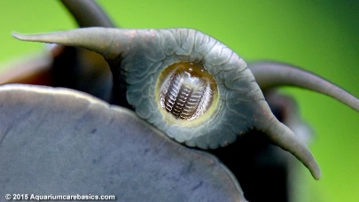
A regular snail has between 14,000 – 25,600 teeth. This is the highest number of teeth in any mouth at a single time. The teeth of a specific aquatic snail, known as the limpet, are harder than titanium! Unlike our teeth, snail teeth grow on their tongue. These many teeth are used for scraping or cutting up their food. Their teeth are referred to as “radula”, they are microscopic in size, but they are all there. Unfortunately for the snail, this doesn’t speed up their ability to eat. It can still take them up to 2 days to eat a small piece of lettuce.

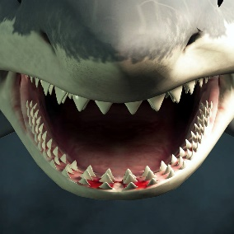
Shark (the most teeth throughout their lifetime)
Like snails, sharks have a lot of teeth. Some sharks can have up to 50,000 teeth in their lifetime. Their teeth grow in rows and fall out all the time. As the front teeth fall out, the back ones move forward and a new one grows. Sharks constantly lose their teeth. They usually lose at least one tooth per week—that’s why you can find so many shark teeth on the beach.
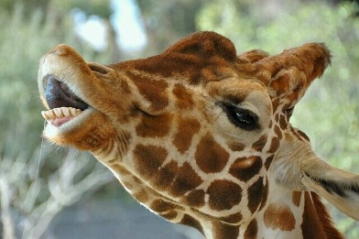
Giraffe (no front teeth)
Giraffes have 32 teeth just like humans however they do not have any front teeth. They use their tongues to grab twigs and leaves and then pull them to their teeth for chewing. The upper lip of a giraffe provides protection against thorns when grabbing food.

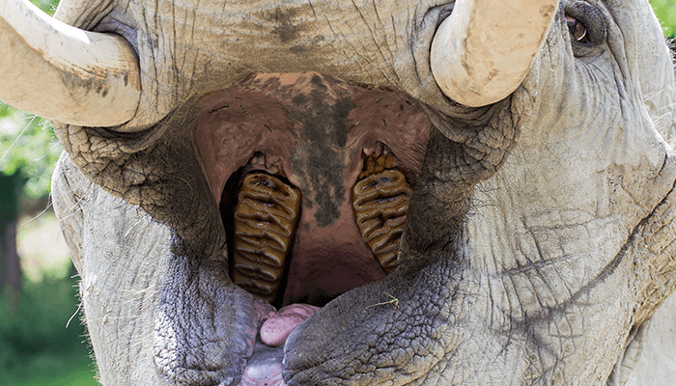
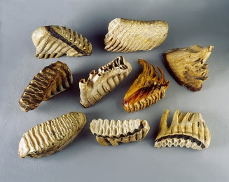
Elephant (tusks are the longest teeth in the world)
Elephants have four sets of teeth in their lifetime. Their tusks are also actually teeth and are the longest teeth in the world.

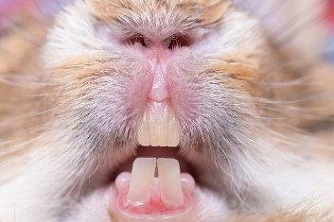
Rabbit, squirrel and rodent (never stop growing)
Rabbits (28 teeth), squirrels (21 teeth), and rodents (rats - 8 teeth) (mice - 16 teeth) have teeth that never stop growing. They have to chew on tough foods like nuts, leaves, and bark to wear down their teeth and keep them from growing too long.

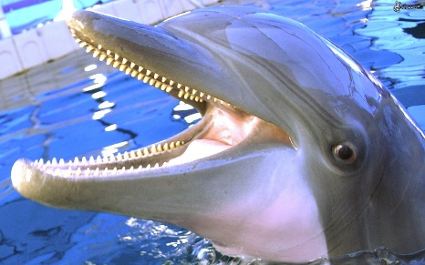
Long-snouted Spinner Dolphin (rings inside teeth tell age like the rings of trees)
Although they are one of the smaller species of dolphins, long- snouted spinner dolphins usually have up to 252 long, sharp teeth that resemble spears hidden in their long, slim snouts. This makes it easy to snap up plenty of squid and fish when they get hungry. You can tell a dolphin’s age by its teeth. Just like trees, dolphin’s teeth have rings inside them that tell how old they are.

Horse
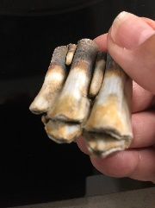
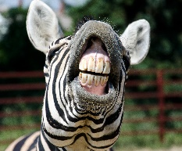
A horse’s teeth take up more space in their head then their brain. Horses can have receding gums just like humans. In fact, that’s where the popular saying “long in the tooth,” meaning old, comes from. As horses age, their gums recede and expose more of their teeth, making it look like they’re teeth are actually growing.
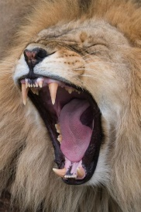
Lion

Lions have 30 teeth at adulthood. Lions don’t chew before they swallow, their back teeth work like
a pair of scissors to cut up the meat in chunks.

Chimpanzee
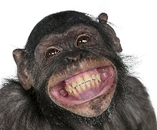
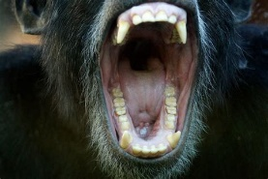
Chimpanzees have 32 teeth which are very similar to those of Humans. They help them to not just grind up plant matter but their longer canines also help to bite into meat.

Bat-eared Fox
Found in South Africa, the bat-eared fox is best known for his huge bat-shaped ears, which usually measure more than 5 in. long. However, there is something else that sets them apart from other species of foxes. They can have up to 50 small teeth, most of which are usually molars. However, their teeth aren’t that terribly important for eating. They tend to eat a diet that primarily consists of insects, particularly termites.

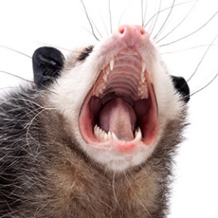
Opossum

Perhaps best known for their hand like feet and having a pouch to carry their young, opossums should also be recognized for their 50 sharp teeth that give them a menacing look. When cornered, opossums are quick to bare their teeth in a show of aggressiveness in the hopes of scaring away whatever presents a threat to them. However, they very rarely actually bite anyone. Their teeth do come in quite handy when they become hungry. They can and will eat just about anything thanks to their teeth.

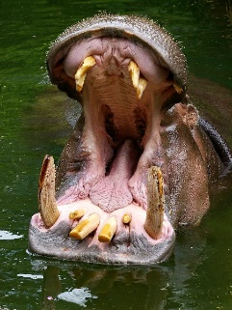
Hippopotamus
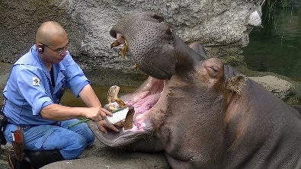
Hippos have 36 teeth. Their canine teeth are sometimes called tusks. At three-feet long, the incisors of a hippo can bite right through a small boat.

Cat
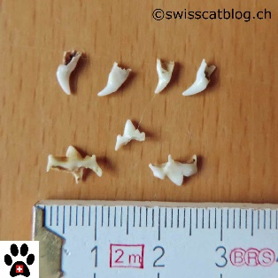
Big cats or little cats share a similar dental design. For one thing, their mouths only move up and down, with no side to side movement. That’s because their teeth are suited to their carnivorous (meat only) diet. Unlike our mouths, a cat’s mouth only has sharp teeth for eating meat. These teeth are sharp like our canines and are designed for getting meat off of bones. Cats grow two sets of teeth in their lifetime, just like us, but their baby teeth never fall out. Cats have 30 teeth.

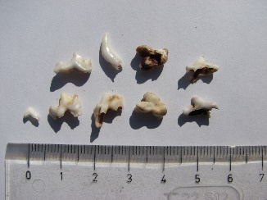
Dog

Adult dogs have 42 teeth. As puppies they have 28 and like humans they lose their “puppy teeth” in order to make way for their adult dog teeth. They make this transition around 4-5 months old but usually end up swallowing their puppy teeth.

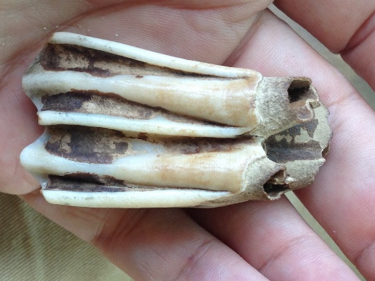
Cow
The herbivore (plants only) diet of cows, determines that they need more teeth like our molars to grind their foods. There are no canine (sharp) teeth in their mouths at all. In fact, cows don’t have any teeth in the upper front of their mouths. The lower front teeth (called “incisors” like our front teeth) are used for tearing off the vegetation, and the back of the mouth is full of molars to grind and grind. Because they use their teeth for grinding so much, the teeth of these animals need to grow a little every year. Otherwise, they might grind them down to nothing.

Whale

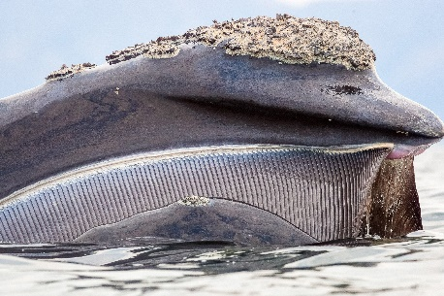
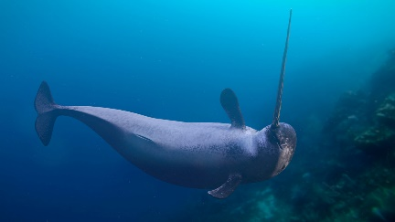
Blue whales are the largest mammals in the world and they don’t have teeth. Where you might expect to find teeth whales instead have a comb-shaped structure, called baleen, that filters small shrimp and fish out of the water with its bristles. So, whatever is left behind goes straight into their bellies. The Narwhal has a horn which is are actually a tooth. It’s scientific name, Monodon monoceros, comes from the Greek term meaning “one-tooth one-horn.” A narwhal’s horn can grow longer than 8 feet and is used to “taste” the concentrations of chemicals in the water around it to find food.

Alligator and Crocodile
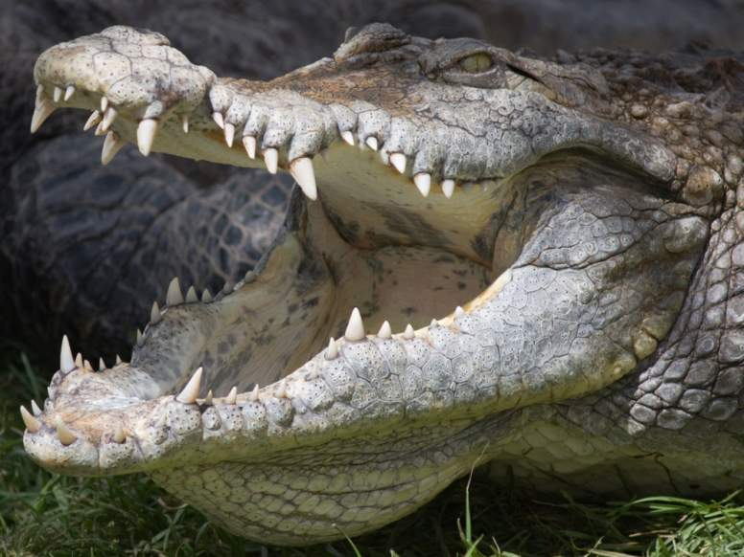

Both are from the same animal family and have teeth that replace themselves when they fall out just like sharks. They can have as many as 3,000 teeth in their lifetimes. Their teeth are actually hollow.

Pig
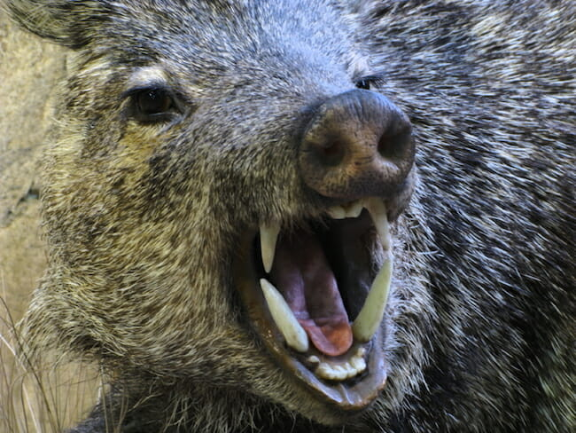
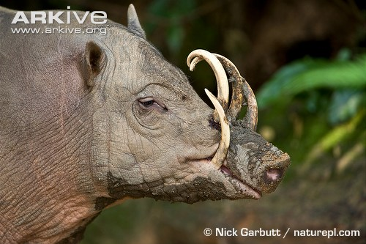
Adult pigs have 44 teeth. Their canines/tusks grow continuously and are sharpened when the lower teeth rub against the upper teeth. Baby piglets have what are called “needle teeth” which they lose as they grow older.

WHAT OTHER ANIMAL TEETH DO YOU WANT TO LEARN ABOUT?

