BRUSHING AND FLOSSING
Brushing our teeth is one of the two most important ways we can keep our teeth clean. With a tooth brush it is estimated that we are cleaning 60% of our tooth surfaces. The other 40% of the tooth surface needs to be cleaned with an interdental tool such as string floss, floss picks, proxabrushes, dental water jets etc.
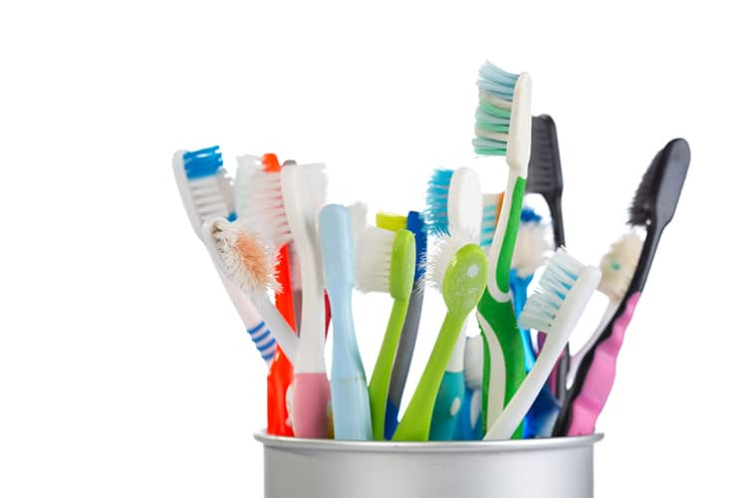
BRUSHING
TYPE OF TOOTHBRUSH
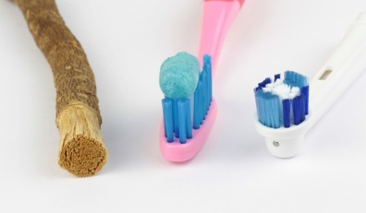
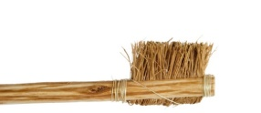
There are many types of toothbrushes out on the market today in both manual and electric varieties. If you can afford an electric toothbrush it can give you a much more thorough cleaning than a manual brush can and is usually recommended by most dentists and hygienists. If you are considering a manual toothbrush the one most important characteristic that toothbrush must have is soft bristles. Stiff bristles accompanied with brushing pressure can cause damage to your gums that can lead to recession, abrasion, erosion, cold sensitivity, and root decay to name a few. This damage is usually irreversible.

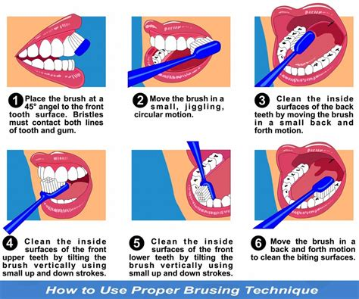
HOW TO BRUSH
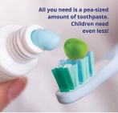
First, place a “pea” size amount of toothpaste on the bristles of the brush. Hold your toothbrush in your fingertips with a light grip and point the bristles approximately 45 degrees towards the tissue. When you are brushing your bristles will be pointing toward the place where your tooth and the tissue meet or at a 45 degree angle.

HOW OFTEN TO BRUSH
The recommendations for how often a person should brush is generally two (2) times a day, once in the morning, before eating, and once in the evening, right before bed and at least an hour after eating. Each of these brushings should be a minimum of two (2) minutes each. However, every person is an individual and things that make that person an individual should also be taken into consideration when choosing how often to brush. A person who has any fillings, current active decay, a lot of soft sticky plaque build-up ie “fuzzy” teeth syndrome, dry mouth and orthodontia ie braces should brush three (3) or more times a day.
FLOSSING
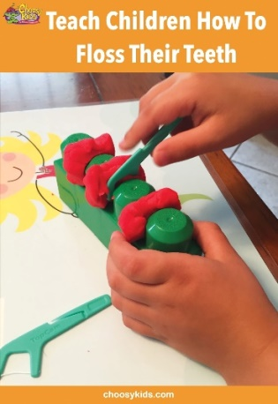
Flossing cleans approximately 40% of your tooth surface. In order to clean 100% of your tooth’s surface you need to brush AND floss. There are all kinds of interdental cleaners that are sold today. String floss, side floss picks, front floss picks, long handled flossers, proxabrushes, rubber tip stimulators, picks that are plastic or wood, water jets, water/air jets. The choices are endless. The one that does the best job, is the simplest, and most inexpensive choice of them all is string floss. However, there are a few people who have a hard time reaching all areas in their mouth or don’t feel coordinated, in those instances any of the “floss/pick/handled” options would be a good choice.

HOW TO FLOSS
The first rule about flossing is you have to do it to make it work for you. #1 RULE: Make sure that whatever you use, or however you are using it, it needs to “scrape” both sides of the teeth while you are in-between the tooth contacts. In order to do this with string floss first you must cut off a piece of string floss approximately the length of your forearm. This amount of floss allows you to wind enough around your fingers to hold it while allowing enough floss to use a new piece whenever debris accumulates on the floss.
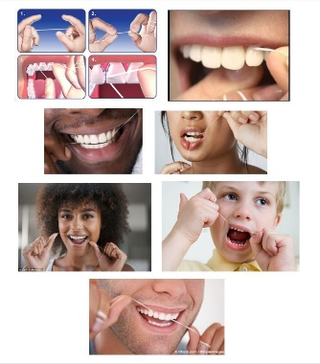
Wrap each end of the floss around your second fingers, at the first knuckle, until there is about 4-5 inches of floss between your two fingers. Using your pointer fingers and thumbs to stabilize the floss you can now maneuver the floss for both the top and bottom teeth.
When you are trying to enter a contact between two teeth if it is tight saw the floss back and forth in order to more gently enter the contact. You do not want to use so much force that you cut the gum tissue if the floss snaps between the contacts. Once you are between the teeth first “push” the floss back against the back tooth and then “scrape” the side of the tooth up and down approximately two to three times. On an up stroke, toward the tooth contact, “pull” the floss towards the other tooth side and the proceed to “scape” the floss up and down approximately two to three times. After “scaping” both sides of the teeth pull the floss straight out of the contact. If the floss is “stuck” or you are having a hard time pulling it up and out then uncoil the floss from one finger and slide the floss out sideways.
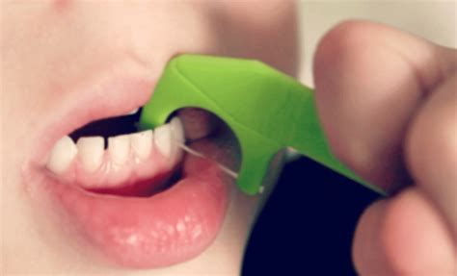
If a floss pick or long handled flosser is used you will have to find what works best for you to get the floss between the contacts but the up and down “scraping” of both sides of the teeth is still the same.

USE OF PROXABRUSHES
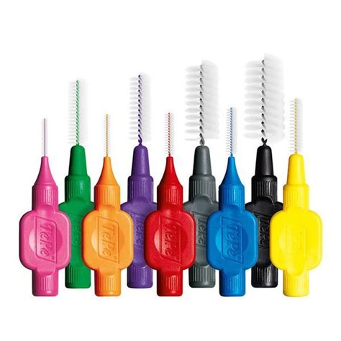
A proxabrush is a small “Christmas tree shaped” brush that fits in-between the spaces between your teeth. Proxabrushes come in many sizes from micro to large. The size you use will be individual to you. For instance if you have very large spaces between your teeth and can see a “dark triangle” between them you may need one of the larger sizes. Try the different sizes starting with the smallest you think you may need but never try to force them between your teeth. Only use them if they are easily moved back and forth between the teeth in a “sawing” motion.

USE OF DENTAL WATER JETS
Dental water jets are also very helpful interdental cleaners but they are not meant to take the place of using a traditional flossing technique. The plaque that is being removed is very sticky and takes a mechanical action in order to be removed from the tooth surface. That being said the water jets are effective for those people who will not floss or who have areas in their mouths that collect debris. You can help to make the dental water jets more effective by placing a cap full of a bacterial killing mouth wash in the water jet water.
To be a good brusher remember to:
BE GENTLE BUT THOROUGH,
USE MORE TIME AND LESS PRESSURE,
BRUSH FOR 2 MINUTES, 2 X A DAY AT A MINIMUM,
THINK LIKE AN ELECTRIC TOOTHBRUSH AND USE A VIBRATORY MOTION. TO DO THIS YOUR TOOTHBRUSH STAYS IN ONE SMALL AREA FOR A LONGER PERIOD OF TIME BEFORE MOVING TO A NEW AREA OF THE MOUTH, OVERLAPPING YOUR SMALL BRUSHING AREAS AS YOU GO AROUND YOUR MOUTH,
AND ALWAYS USE A SOFT BRISTLED TOOTHBRUSH.
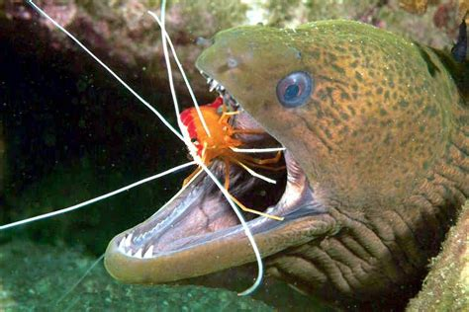
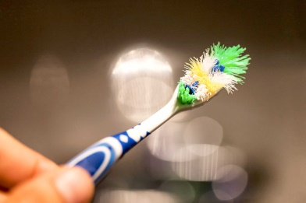
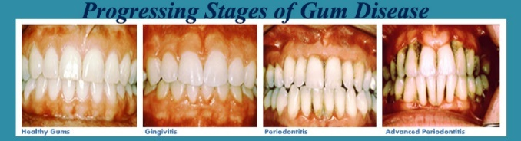
Visit your
Dentist and Hygienist
every 6 months
Your toothbrush should NEVER
look like this

