Welcome all denominations to Allah’s Deen.

The Deen of Allah is Islam.

Islam governs the Universe.

Islam is the first order - law FROM Allah, the Unseen Creator, to HIS creations.

Allah, the Unseen Creator of the Heavens, & the Earth.

The first order-

* Arabic: La-Illa-Ha Illa-Allah.
* English: Take not any Creation of Allah as your deity, except Allah, the Unseen Creator.

Simply means to establish worship in the oneness of Allah, the Unseen Creator of the Heavens, & the Earth. Allah, free from all wonts.

Anyone who implements Islam, the absolute true teachings of Isa – Jesus Christ, the Grandson of the Imran Family.

Indeed, Allah recognizes them as a true \*Muslim – true Believer.

A \*Mushrik is one who denied the Oneness of Allah, even upon their last crucial & final moments, forever burning as a non-believer.

Freedom, freedom to choose.

It is known that Isa – Jesus, joined with all previous Messengers/Prophets/Warners, such as our Heavenly Father Ada’Maa – Adam the First man, Noh – Noah the Arc builder, Idris – Enoch the Grandson of Adam, Dawud – David the Goliath Slayer, and Musa – Moses the half-brother of Rameses, etc.

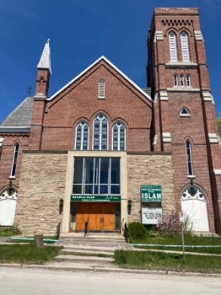Footnote: Names of Messengers/Warners not mentioned in the Quran.

Such as – Krishna, Vishnu, Shiva, Rama, Buddha, etc.

Indeed, Muhammad (PBUH) is the final messenger from Allah, he confirmed that 124,000 Messengers/Prophets/Warners came to guide humanity to be among the righteous. Ada’Maa – Adam Rasool-Allah is the first messenger from Allah; Indeed, Ada’Maa – Adam is our heavenly father, who was created in heaven. This entails that we, here in humanity, are ALL brothers & sisters!

Indeed, the final messenger is Muhammad (PBUH) Rasool-Allah; Muhammad, the Son of Abdullah, the Prophet of Arabia; they all came to establish Allah’s Deen - Allah’s ideology to his creations. La-Illa-Ha Illa-Allah. Take not any creation of Allah as your deity, except Allah.

Simply Means: To establish worship in the oneness of Allah. Allah, the Supreme Unseen Creator of the Heavens, & the Earth. Allah, the ever living, everlasting, free from all wonts. Allah, the Merciful & Compassionate, free from all defects. Allah has no beginning, nor an end. Whereas all things have a start and an end, except…

The cries of the 124,000 Messengers/Prophets/Warners to humanity is an absolute cry/plea, crying out/pleading to not pass without submitting to the oneness of Allah - Islam.

Arabic – Muslim

English – True Believer

Meaning – One who passed accepting the oneness of Allah in full knowing submission, keeping the heart & blood pure to avoid all evils to enjoin good; to be among the righteous.

Arabic – Mushrik

English – non-believer

Meaning – One who denied the oneness of Allah and corrupting not only their blood but enjoining the evils until the grave; to be among the tormented in the rising smoke.