WISH LIST FOR KNOX COUNTY HUMANE
SOCIETY SHELTER ANIMALS
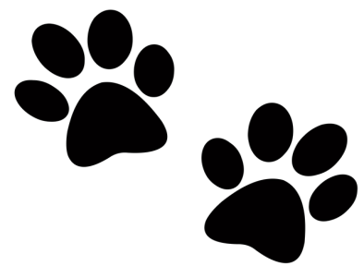
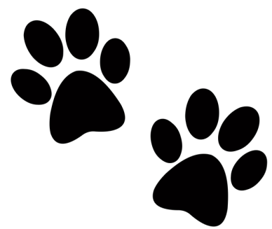
Office Pens
BLEACH & PAPER TOWELS
COPY PAPER – OFFICE SUPPLIES
CLUMPING KITTY LITTER
55 gal LARGE LEAF or 13 gal GARBAGE BAGS
GENTLY USED BLANKETS, TOWELS & RUGS
CEDAR CHIPS FOR THE DOG PENS
PURINA DOG CHOW (GREEN BAG) OR PURINA ONE
Lysol Spray
POSTAGE STAMPS

AMAZON WISH LIST: https://amzn.to/2pJE9zR

VISIT OUR WEBSITE - WWW.KNOXCOUNTYHUMANESOCIETY.ORG
AND LIKE & FOLLOW US ON FACEBOOK WWW.FACEBOOK.COM/KCHSPETS

