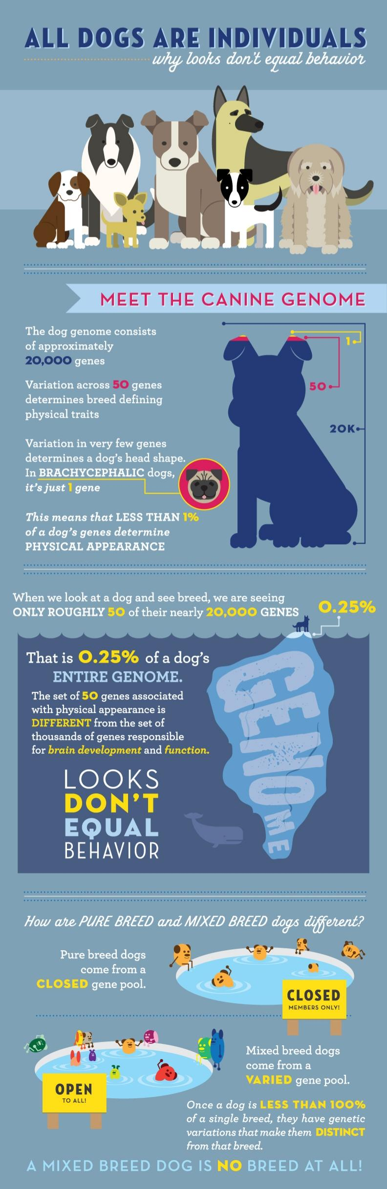
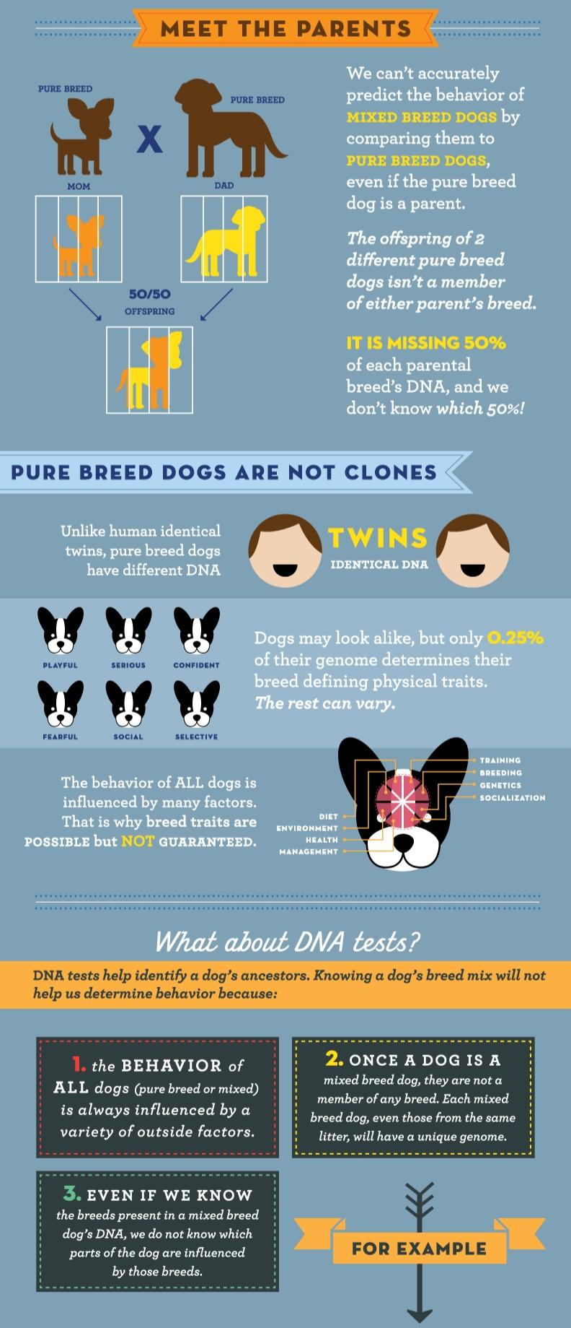
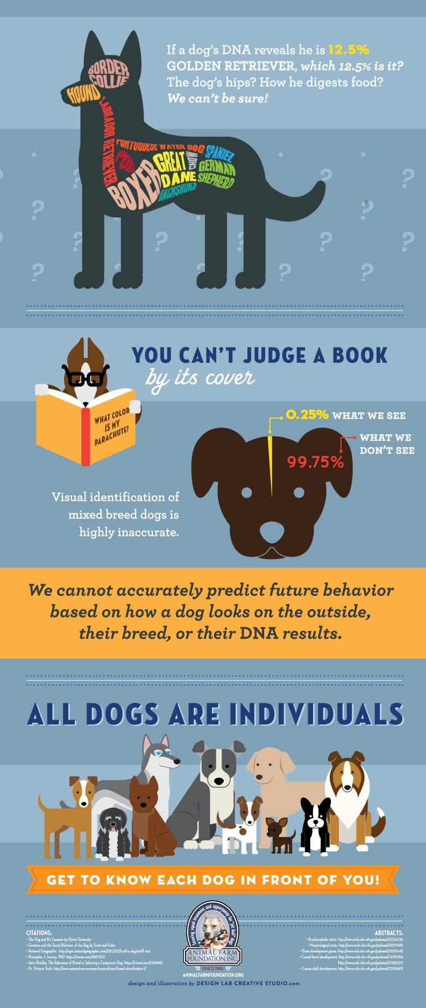

A Closer Look Into All Dogs Are Indiduals: https://animalfarmfoundation.org/2013/10/09/a-closer-look-at-all-dogs-are-individuals-infographic/

