14th ANNUAL EASTMINSTER DOG SHOW
REGISTRATION FORM
(Please complete a separate registration form for each dog.)

Knox County Humane Society - 309-342-1275
Annual Eastminster Dog Show
Sunday, May 5th, 2019
At the Knox County Humane Society (1855 Windish Dr)

Registration @ Noon & Showtime @ 1:00 pm
$15.00 Registration Fee per dog if paid before May 1st
$20.00 Registration Fee per dog Day of Event
Rick Cross Photography will be taking pictures of you and your pet free with each registration.
All dogs are winners, so the winner of each category will be by drawing.

PLEASE PRINT CLEARLY

Name__________________________________________ Address________________________________

City/State/Zip___________________________________________________________________________

Telephone Number_______________________________ E-mail_______________________________

I would like to register my canine companion, Name: ____________________________ in the Dog Show. Breed: _______________________________ (Mixed Breed Dogs welcome to participate in the Show)

Please register my dog for the following group:
(PLEASE SELECT ONE CATEGORY & ALSO BEST DRESSED IF COMPETING IN COSTUME):

( ) Terrier ( ) Hound ( ) Toy ( ) Working
( ) Non-Sporting ( ) Herding ( ) Super Mutt ( ) Best Dressed

Please read and sign the following statement:
The Knox County Humane Society and all other sponsors and contributors are not responsible for any accidents which may occur during this Fundraising Event. In consideration of my entry, I hereby for myself, my heirs, and my executors waive and release all rights for damages against the Knox County Humane Society and any sponsors, officials, or volunteers for this event for any injuries suffered to me, my child(ren), and/or my pet(s) in connection with this event. I also give permission to use my name and photography in connection with this event.

Signature___________________________________________________ Date_______________________

-----------------------------------------------------------------------------------------------------------------------------------
(Parental Consent if under age of eighteen 18)

PLEASE PRINT CLEARLY

Owner’s Name ___________________________________ Dog’s Name ___________________________

Category: ( ) Terrier ( ) Hound ( ) Toy ( ) Working
( ) Non-Sporting ( ) Herding ( ) Super Mutt ( ) Best Dressed
A SPECIAL THANK YOU TO OUR SPONSORS
KCHS – Dog Show 2019 Sponsors

“BEST OF SHOW”
Dave’s Auto Body, Galesburg, IL
Reynolds M. Everett, Attorney at Law, Galva, IL
Kohl’s Department Store, Galesburg, IL
Eric Hanson FM.95, Galesburg, IL
Mechanical Service Inc, Galesburg, IL
Rick Cross Photography, Galesburg, IL

“TOP DOGS”
F & M Bank, Galesburg, IL
Endearing Pets, Knoxville, IL
Tompkins State Bank
Knoxville Veterinary Service, Knoxville, IL
Courtney & Aldrich CPA, Galesburg, IL
Galesburg Toyota, Galesburg, IL

“DOGGONE GREAT”
Galesburg Burlington Credit Union, Galesburg, IL
Midwest Bank of Western Illinois, Galesburg, IL
Sun Loan, Galesburg, IL
McDonalds, Galesburg, IL
Dr. Kandy Sayrs, Galesburg, IL
Yemm Chevrolet, Galesburg, IL
Galesburg Animal Hospital P.C, Galesburg, IL
Animal Medical Center, Galesburg, IL
Bob Lindsay Cars, Galesburg, IL
Tri-States Water, Pools and Spas, Galesburg, IL
Invisible Fence Brand
A THANK YOU TO ALL WHO SUPPORT THE SHELTER
Free Photo with registration
BY RICK CROSS PHOTOGRAPHY
14th Annual Eastminster Dog Show
1855 Windish Drive, Galesburg, IL 61401
Thank you for participating and helping Shelter pets!

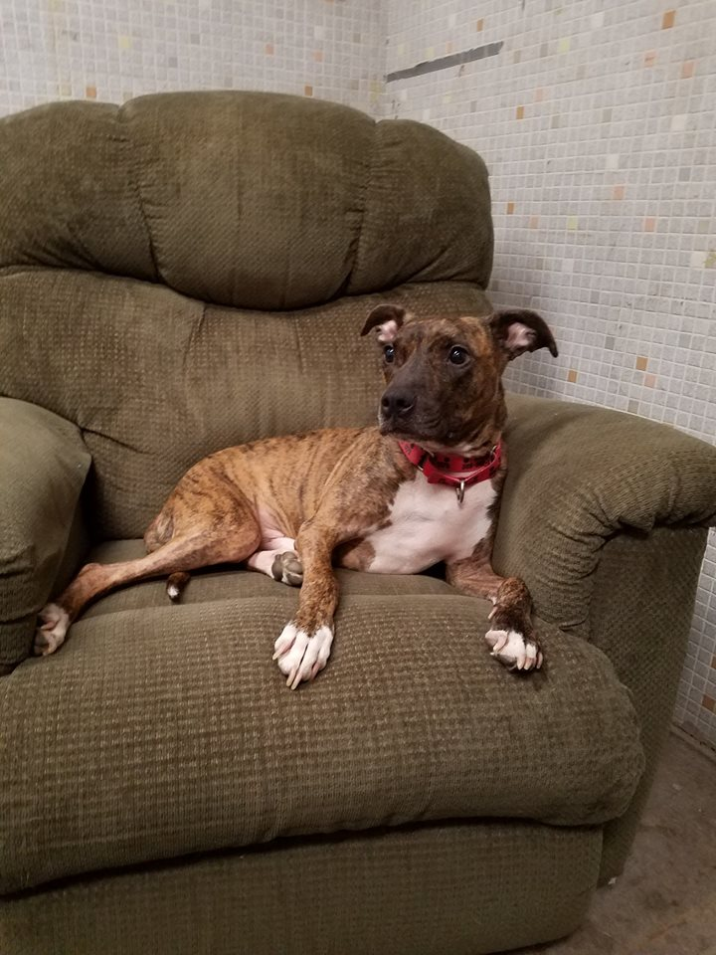

Barry would love for you to attend our annual Eastminster dog Show! If you are unable to attend the event but would still like to help the shelter pets, please consider sending a monetary donation.

.- - - - - - - - - - - - - - - - - - - - - - - - - - - - - - - - - - - - - - - - - - - - - - - - - - - - -
Yes, I would like to support the pets with our donation.
(Please tear off and mail to 1855 Windish Dr, Galesburg IL 61401)

Name: ____________________________________________________________

Address: ___________________________________________________________

Phone: _____________________________________________________________

Donation Amount:$________________

