Turkey Fest Stationary Greetings!

In preparation for the much anticipated 16th Annual 2023 Turkey Fest World Championship Invitational, we want to again recognize and thank you for supporting the Chamber of Commerce!   It is through the support of Local Sponsors like you that the Chamber has realized so much success with Turkey Fest!  It is our sincere hope that we can count on your support again this year.

We will be celebrating the **16th Annual Clay County Turkey Fest on April 12-15, 2022**. The **Battle of the Beards** (the amateur competition) takes place from April 6-9th. Sign up a team and compete to be the $2,000 champion! The **Festival** is scheduled for Saturday, April 9. Bring your family to enjoy a fun-filled festival on the square featuring children's activities, wildlife demonstrations, vendors, and of course, festival food! This festival has truly become the place to be, drawing in nearly 6,000 participants each year. Top the night off by attending the **Full Strut Dinner & Dance** on Saturday evening along with over 400 others. Enjoy exquisite fine dining, a live and silent auction where you can bid on a world class hunt with your favorite Pro hunt team as well as other high ticket items. For your entertainment, live Texas music will be provided this year by **Erick Willis**

Over the past 15 years, **this event has raised an estimated $250,000.00** that has benefited multiple county projects including:

* The Visitor Center's complete caboose refurbishment and landscaping project
* Underwriting of the Turkey Fest Scholarship Barrel Races
* Significant contributions to the Clay County Christmas Lighting Project on the courthouse square
* Seasonal banners placed on Highway 82 used to promote Clay County events including:
  + Pioneer Reunion, Turkey Fest, and Clay County Christmas

Please review the Commitment Form and return it via mail or e-mail.  The Chamber will invoice you with your pledge amount so that you will have record of your sponsorship if you require it.  Kate Hopkins, Chamber Executive Director, is always a welcoming voice in providing information; please feel free to call her at 940.538.5261.

Thank you in advance for your support! Here's to an even bigger and better Clay County Turkey Fest!

Sincerely,

Kate Hopkins

Kate Hopkins

2023 Turkey Fest Local Sponsor Chair

**2023 SPONSORSHIP & SUPPORTERS LEVELS**

**BOSS GOBBLER - $1,000**

4 complimentary "Full Strut Dinner & Dance" tickets

2 complimentary tickets to the “Roost”

Acknowledgement at Events

Logo printed on Turkey Fest shirt

Website/Facebook recognition

**STRUTT’N TOM - $750**

2 complimentary "Full Strut Dinner & Dance " tickets

2 complimentary “Roost” tickets

Acknowledgement at Events

Logo printed on Turkey Fest shirt

Website/Facebook recognition

**GOBBL’N TOM - $500**

2 complimentary "Full Strut Dinner & Dance " tickets

Acknowledgement at Events

Logo printed on Turkey Fest shirt

Website/Facebook recognition

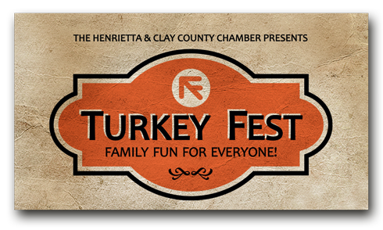

2022 TF SPONSORSHIP COMMITMENT

__________________________________________

Company

__________________________________________

Contact Name

__________________________________________

Address City

__________________________________________

State Zip

__________________________________________

Phone

__________________________________________

E-mail & Billing E-mail (if different)

__________________________________________

Signature Date

**BOSS GOBBLER - $1,000**

**STRUTT’N TOM - $750**

**GOBBL’N TOM - $500**

**CHAMBER USE**

Date Pmt Received: ____________ Cash or Check # ____________ Collected by: _______________

P.O. Box 75 • Henrietta, Texas 76365 • 940.538.5261 • ClayCountyTurkeyFest.com

*Sponsored by The Henrietta & Clay County Chamber of Commerce*