ReEntry Preparation Guide
2022 Edition

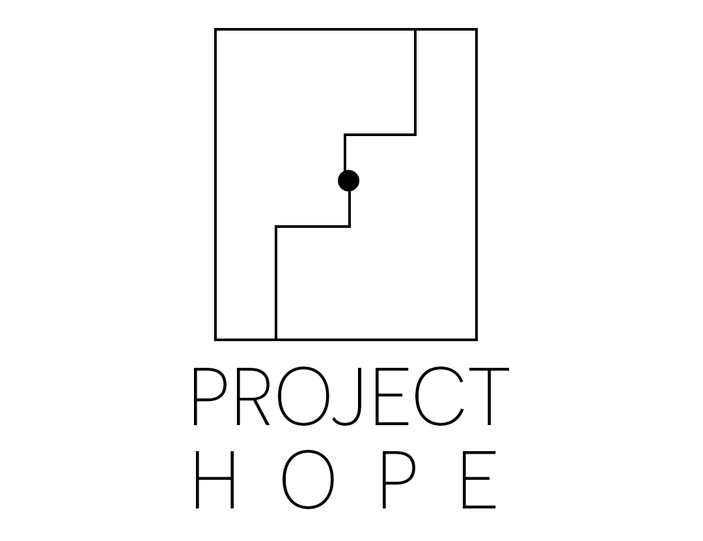

The Liberation Foundation
511 North Broad Street, Unit 1006, Philadelphia, PA 19123

Notice:
Please be advised that The Liberation Foundation is not a law firm, and cannot provide legal advice. The enclosed materials are not a substitute for regular engagement with and adherence to your assigned probation or parole officer. This information is provided only to inform you of opportunities that may be available to you as you return from incarceration, it is not an exhaustive list of resources and should not be used as your only research source. Ranging from obtaining a license or ID to finding educational and career opportunities, the resources in this handbook will help you think about your next steps. Please note that The Liberation Foundation does not offer ongoing reentry services and cannot guarantee that the programming listed throughout the handbook will be available to you. The Liberation Foundation is in no way responsible or liable for the quality of these programs, nor your engagement with them.
You are responsible for adhering to all conditions of your release. While the resources below are designed to assist you in actualizing your home plan, the organizations and opportunities described here are not a substitute for maintaining your legal obligations as they relate to your terms of release.
You can contact The Liberation Foundation at 511 North Broad Street, Unit 1006, Philadelphia, PA 19123 or via email at outreach@liberation-foundation.org.

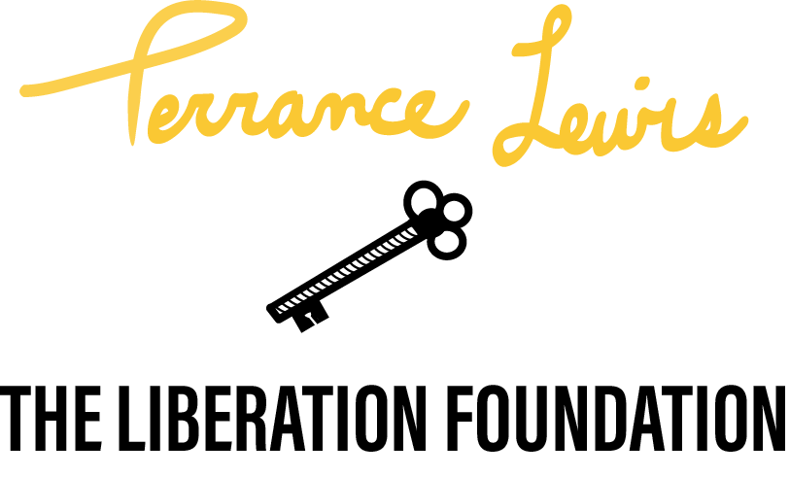

Table of Contents
First Steps ReEntry Checklist 1
Pre-Return Preparation Flowchart 3
Getting Started: Finding Transportation, Obtaining IDs, and Receiving Benefits 7
Searchable Databases and Connective Hubs 7
Social Services 9
Transportation Services 12
Obtaining or Renewing your State ID 13
Obtaining a Driver’s License 18
Obtaining a Birth Certificate 19
Registering to Vote 20
Technology: Finding Internet Access, Creating an Email Address & Computer Classes 22
Technology 22
Free emailing 22
Free Cell Phone Services 22
Computer Classes and Services 23
Accessing Healthcare, Benefits & Mental Health Services 25
Healthcare 25
Mental Health Services 29
Hotlines 35
Alcohol and Substance Abuse Services 36
Victim Services 38
Mentorship, Life Coaches, and Support Based Organizations 40
Legal Services 42
Legal Services 42
Accessing Education: GED Assistance & Higher Education Opportunities 45
GED or High School Equivalency Assistance 45
High School Diploma Correspondence Programs 46
Higher Education Opportunities 46
Self-Paced and Correspondence Courses by Mail 47
Employment Upon Release: Job Searching, Building Resumes & Opportunities 49
Job-Searching: The Basics 49
Building a Resume 49
Job Training and Career Development Programs: 50
Employment Upon Release: Job Searching, Building Resumes & Opportunities 57
Finding Housing 58
Housing Services 58
Financial Literacy: Money Management & Financial Services 64
Money Management 64
Financial Literacy Assistance 65
Benefits & Assistance 68
Appendix 72
Free Internet Access 73
Example Resume Prompt 74
Completed Example Resume 75

First Steps ReEntry Checklist
Check off the boxes to the right as you complete each part of your home plan.
Immediate Release
Know the conditions of your release and supervision
Make a plan for transportation from the facility
Make a plan for taking your belongings and release documents with you
Make a plan for parole-approved housing immediately after your release: do you have a residence or can you stay with a family member/ friend? If not, look into halfway houses or living centers to apply to.
Obtain contact information of your supervisor or parole officer
Visit the Philadelphia Police Headquarters at 750 Race St, Philadelphia, PA 19106 within 24 hours after your release to receive your Yellowcard and inquire about parole conditions.
Important Documents
Folder with all release paperwork
Birth Certificate
Non-driver ID card or License ID
Social Security Card
Mailing Address (though not a document it is important that you have an address that people can send important documents to.)
Employment
Prepare your resume, including any jobs you held while incarcerated.
Collect necessary IDs (social security, ID card).
Identify employment or work with your local CareerLink.

Make sure you have contact information (email, phone, and address) to give potential employers.
Technology
Set up an email account.
Get a library card to access free internet.
Get a cell phone and phone-number. Set up your voicemail.
Housing
Make a long-term housing plan: Where will you stay? What can you afford?
Look into public and private housing options.
Prepare how you will explain your history to potential landlords.
Healthcare
Find out how and where you will be able to continue getting any medication you are prescribed.
Explore your health insurance options: Medicare or Medicaid
Find local mental health support groups or low cost mental health services.
Finances
Open a bank account.
Learn about credit and check your credit score.
Find out if you owe any outstanding fees to the court.
Transportation
Use public transportation to save costs.
Get a local transportation card.

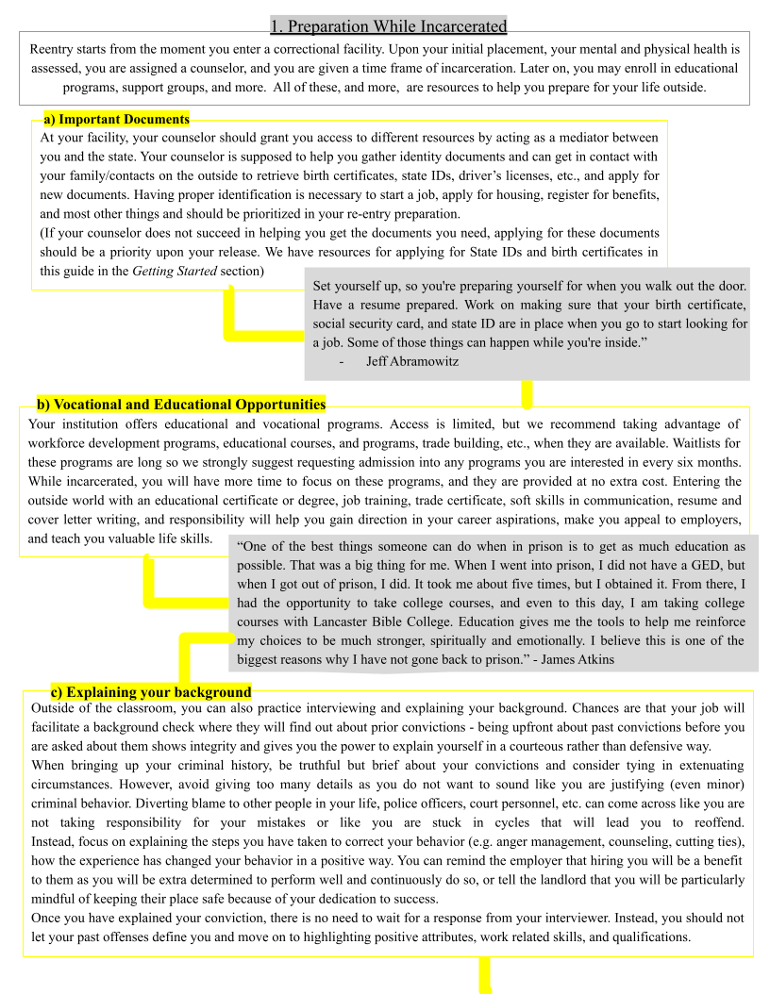
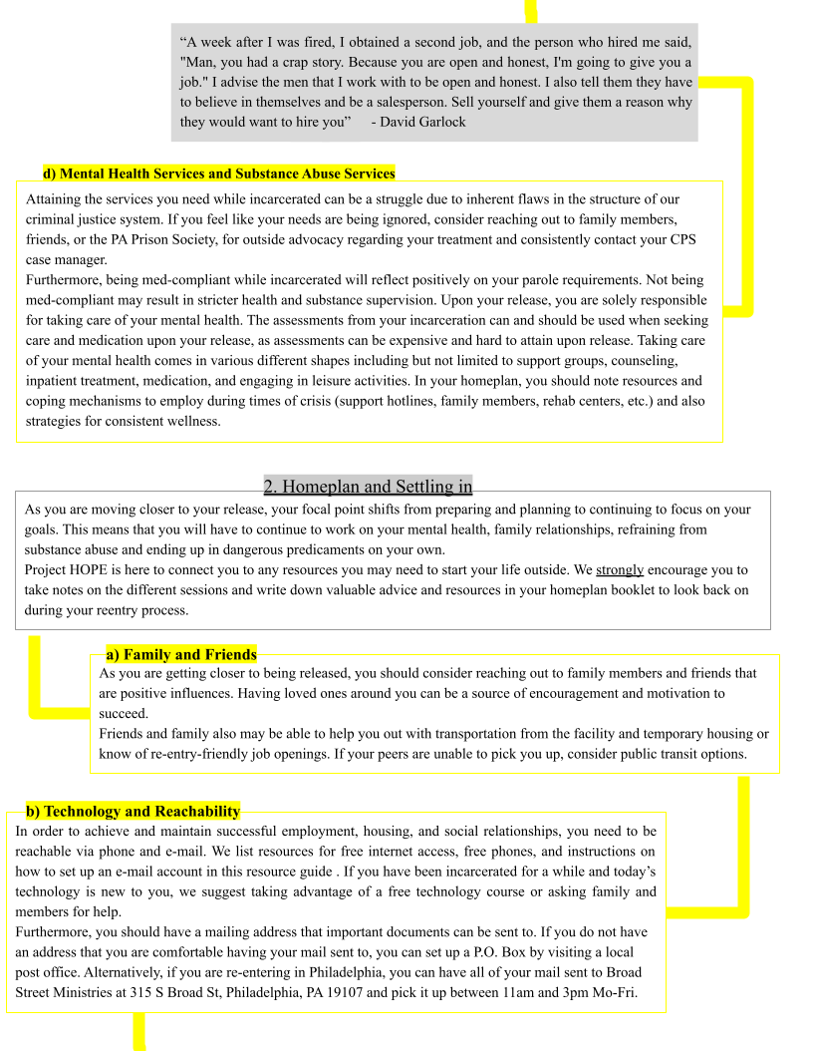
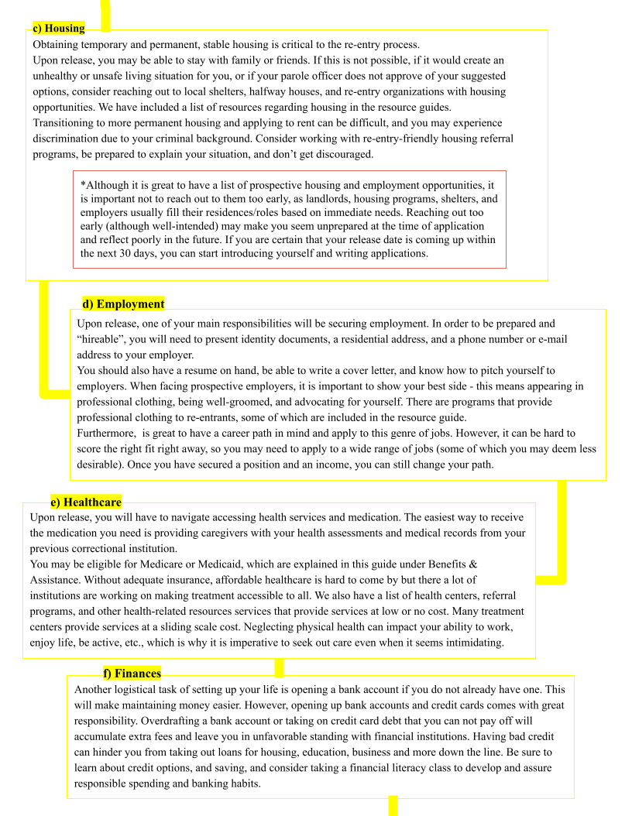
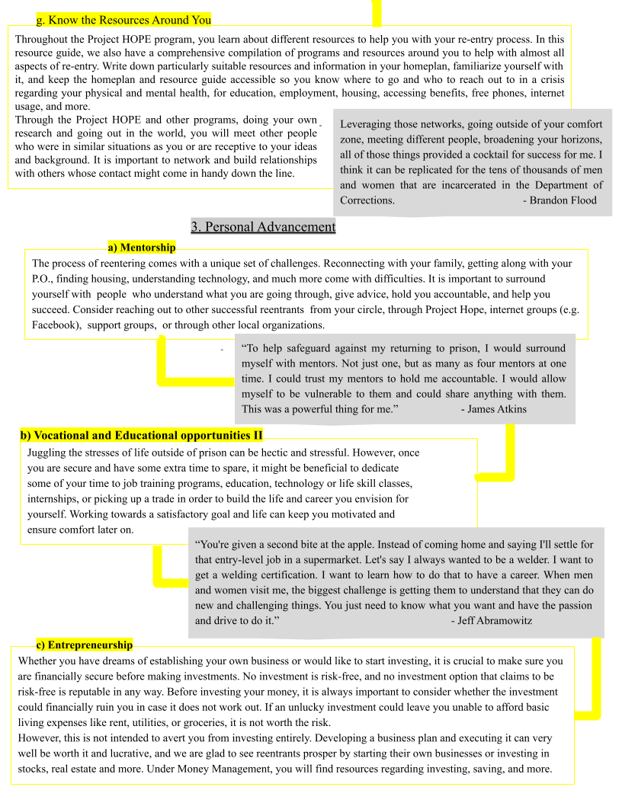

Getting Started: Finding Transportation, Obtaining IDs, and Receiving Benefits

Searchable Databases and Connective Hubs:

These online websites and support centers will provide you with a thorough list of reentry services near you. For specific opportunities, continue to the following sections.

PA 211
If you need to connect with resources in your community, but don’t know where to look, PA 211 is a great place to start. From help with a utility bill to housing assistance, after-school programs for kids, and more, you can dial 211 or text your zip code to 898-211 to talk with a resource specialist for free. Their specialists will listen to your needs, and give you information on programs in your community that might be able to help.
- Visit the link to access a collectivized list of reentry programs and resources in your zip code: https://www.pa211.org/search/19103/50/?search_term=Ex-Offender%20Reentry%20Programs

Fair Shake Reentry Packet
Fair Shake is a comprehensive, interactive database dedicated to increasing reentry success for returning citizens across the country. Their database includes the nation’s largest reentry Resource Directory with over 14,500 entries and 300+ reentry guides, employment tools for both formerly incarcerated people and employers, an Educate Yourself! section with links to many free web-based education resources, and much more.
- Direct link to their website: https://www.fairshake.net
FindHelp.org
Find Help is America’s leading social care network, and includes over 300,000 human-verified services across the country.
- Visit the link and type in your zip code to connect to free or reduced-cost financial assistance, food pantries, medical care, housing, education, and more: https://www.findhelp.org/?ref=ab_redirect
Department of Corrections Interactive Reentry Map:
The interactive reentry service map that displays services for individuals in Pennsylvania by county. After choosing a county, you may select the service you are interested in (employment, domestic violence & victim rights, transportation, physical and mental health, etc.)
- Visit http://reentrymap.cor.pa.gov/
Getting Started: Finding Transportation, Obtaining IDs, and Receiving Benefits
United Way of the Capital Region
Connects community health workers to residents to help people navigate the HealthCare System, provides workforce development guidance and referrals to help unemployed and underemployed people through their first year of unemployment, refers vulnerable people during urgent situations to receive basic needs
- You can call them at (717) 732-0700 or visit http://www.uwcr.org to learn more.
- They are located at 2235 Millennium Way Enola, PA 17025 - available 24/7
Breaking The Chainz
The Breaking The Chainz Community Resource Center connects people with both temporary and permanent solutions for any problem they may be facing regarding re-entry, health, employment, food pantries, housing, transportation, legal aid, elderly assistance, utilities, and more.
- They are located at 2134 North 6th Street, Harrisburg, PA 17110, and are open Monday through Friday from 10:00 am to 2:00 pm.
- To learn more, visit https://breakingthechainz.webs.com/, email them at BreakingTheChainzInc@gmail.com, or call them at (717) 525-9448
Philadelphia Reentry Coalition Resources List
The Philadelphia Reentry Coalition comprises 115 members, including local, state, and federal government agencies, community-based service providers, researchers, advocates, returning citizens, faith-based groups, and others. Their aim is to bring reentry-focused Philadelphia organizations and agencies together to collectively reduce recidivism.
- The link will redirect you to a comprehensive list of documents and resources regarding finding housing, clearing your criminal record, accessing benefits, knowing your employment rights, etc: https://www.philadelphiareentrycoalition.org/reentry-resources-list

Getting Started: Finding Transportation, Obtaining IDs, and Receiving Benefits

Social Services
Upper Dauphin Human Services Center (UDHSC)
UDHSC offers food, clothing, and other household utilities and essentials, in conjunction with provisioning aid regarding utility bill payments and other public service agencies. They are open to walk-in visits and to calls. They are located at 727 Main Street, Lykens, PA 17048, and are open from 8 am to 4 pm Monday through Friday. Their Food Bank/Clothing Bank Hours are 9 am - 11 am & 1:30 pm - 3:30 pm. Entrance is in the rear of the building, off the alley. Please bring photo ID and proof of residency.
- To learn more, visit https://www.upperdauphinhumanservices.com/ or you may reach them at 717-453-9352 or via e-mail at udhumanservices@gmail.com
Dauphin County Department of Human Services:
The Department of Human Services is the link between Dauphin County’s residents and the humanitarian services. They can provide you with resources and services regarding alcohol and drug issues, mental health, intellectual disabilities, adult and juvenile probation, problems that may arise with aging, and more.
- Visit https://www.dauphincounty.gov/government/human-services to learn more about their services. For general inquiries and referral services, may contact them at 717-780-6288 to make an appointment at 2 South Second Street, Harrisburg, PA 17101.
- Drug & Alcohol Services:
  - 1100 South Cameron Street, Harrisburg, PA 17104-2531
  - Phone: (717) 635-2254
- Area Agency on Aging
  - 2 South Second Street, Third Floor, Harrisburg, Pa 17101
  - Phone: (717) 780-6130
- Mental Health/Autism/Developmental Programs
  - 100 Chestnut Street, 1st Floor, Harrisburg, PA 17101
  - Phone: (717) 780-7050
- Children & Youth
  - 1001 North 6th Street, Harrisburg, PA 17101
  - Phone: (717) 780-7200
- Probation Services
  - 917 Gibson Blvd, Steelton, PA 17113
  - Phone: (717) 780-6900
- Northern Dauphin Human Services Center
  - 295 State Drive, Elizabethville, PA 17023
  - Phone: (717) 905-2700
Getting Started: Social Services
Tri-County Community Action
This organization’s mission is to dismantle the cycle of poverty in the Cumberland, Dauphin, and Perry Counties. They developed a local Theory of Change and provide services relating to early childhood and family development, housing security, community development, employment, education, and financial empowerment. They are located at 1514 Derry Street, Harrisburg, Pennsylvania 17104.
- Call 717-232-9757 or visit https://cactricounty.org/ to learn more.

Dauphin/ Cumberland/ Perry County Assistance Office
Pennsylvanians can seek assistance and services for themselves and their families from professionally trained staff members at county assistance offices. You may receive in-person help with applying for the Supplemental Nutrition Assistance Program (SNAP), cash assistance, health care coverage, home heating assistance (LIHEAP), family planning, child care, school meals, and long-term living services.
- Dauphin- They are located at 2432 N 7th St, Harrisburg, PA 17110
  - You may reach the office at (717)-787-2324 or 1-800-269-01733 (Toll-Free) or visit https://www.dhs.pa.gov/ for more information.
- Cumberland- They are located at 33 Westminster Dr, Carlisle, PA 17013
  - You may reach them at (717)-240-2700 or 1-800-269-0173 (Toll-Free)
- Perry- They are located at 100 Centre Dr, New Bloomfield, PA 17068
  - You may reach them at (717)-582-2127 or 1-800-991-1929 (Toll-Free)

Join Hands Ministry Inc.
Join Hands Ministry supports residents of Perry County and beyond who are seeking assistance with daily living concerns. They distribute donated appliances like air conditioners, microwaves, electric stoves, washers, and furniture. They also provide assistance with access to medical services and prescriptions, utility assistance, auto assistance, financial planning, and more.
- They are located at 51 South Church Street, New Bloomfield, PA 17068
- You can reach them at (717) 582-7844 or visit https://joinhands.help/ to find out more.

Getting Started: Social Services
Cumberland County Adult Reentry Program (CCARP)
CCARP aims to provide human and social services relating to an offender’s basic needs and address barriers to their successful reentry into the community. They offer mentoring services, starting while the person is incarcerated, a computer literacy program where a free refurbished desktop computer is awarded, financial literacy & budgeting classes and one-on-one counseling, employment assistance, vocational training, and referrals to other community-based agencies.
- visit https://www.cumberlandcountypa.gov/4379/Cumberland-County-Adult-Reentry-Program- to learn more. You can contact them via email at ReentryProgram@CumberlandCountyPA.gov, or call (717)240-6522 for more information
- They are located at 4 East Liberty Avenue, Carlisle, PA 17013
Mayor’s Office of Reintegration Services—RISE
RISE works closely with enrolled participants to develop individualized plans focused on successful and permanent reintegration and long-term self-sustainability. Services provided include case management, courses in life skills and job readiness, linkages to various wrap-around supports, and employment assistance.
- They are located at 1425 Arch Street, First Floor, Philadelphia, PA 19107
- Visit their website at: https://www.phila.gov/departments/office-of-reentry-partnerships/
- Contact them at orp@phila.gov or 215-683-3370.
Getting Started: Securing Transportation

Transportation Services
Family Circle Ministries
Family Circle Ministries uses church buses or personal vehicles to transport men and women to work, appointments and church. They offer these services to people currently living in halfway houses, people who have been released, and people facing homelessness.
- Visit https://familycircleministries.org/ to learn more about their services, call 717-439-0466, or email ssands@familycircleministries.org
- Their main office is located at 80 Brooklane Court, Elizabethtown, PA 17022
- Their sharing center and satellite office is located at 105 Main Street, Lykens, PA 17048

Christian Life Assembly
Christian Life Assembly offers a range of services to the community, including free basic car repair and maintenance services (changing brakes, oil, etc.) on one Sunday per month and by appointment only. They are located at 2645 Lisburn Road, Camp Hill, PA 17011.
- Call them at (717) 737 6560 to schedule an appointment or submit a car repair request via this link: https://clacamphill.churchcenter.com/people/forms/310941.

Getting Started: Finding Transportation, Obtaining IDs, and Receiving Benefits

Obtaining or Renewing your State ID:
Getting a State ID is an important first step. A valid ID is often required for job applications, accessing healthcare, and acquiring housing. Please also seek opportunities to obtain an ID before returning home, as this opportunity is offered within many SCI facilities.
- Method 1: Impact Services First Step ID program:
  - The First Step ID Program helps inmates obtain identity documents they need to be able to apply for employment and benefits. They make the process simple and fast by filling out the paperwork for you. Once released, participants can come to their office to pick up their documents.
  - Contact: Adele Hedgespeth 215-739-1600, info@impactservices.org
  - Address: 1952 E. Allegheny Avenue Philadelphia, PA 19134
  - Visit their website: https://www.impactservices.org/jobs/reentry-programs
- Method 2: PennDOT: Getting a State ID:

Step 1: You may mail the appropriate form following the instructions listed on the form to PennDOT, or visit your local Driver's License Center and take along the following:
  - A completed Form DL-54A (PDF), “Application for Initial Photo Identification Card”
  - Acceptable Proof of Identification
  - Your Social Security Card: https://www.ssa.gov/myaccount/replacement-card.html
  - A check or money order payable to PennDOT for the appropriate fee (cash is not accepted) and, if you are 18 or older, two acceptable forms of address verification are required.
- Step 2: When your application and supporting documentation have been reviewed and processed, a Driver’s License Center staff member will direct you to the Photo Center to have your photo taken for your Photo ID card.
- Step 3: Once your photo has been taken, you will be issued your Photo ID card.
- Method 3: Broad Street Ministry’s free State ID program:
  - Broad Street Ministry’s free State ID program helps returning citizens obtain a State ID at no cost. Broad Street Ministry is located 315 S. Broad Street Philadelphia, PA 19107 and is open from 11:30am - 3:00pm Monday through Friday. Here are the qualifications you will need in order to obtain your State ID:
Getting Started: Finding Transportation, Obtaining IDs, and Receiving Benefits
- If you’ve never had a State ID, if you lost your ID, or if your ID was stolen, you will need to go to Broad Street Ministry during open hours and ask for staff member Aaliyah Davis (Mail & ID Manager). Let them know you need an ID and ask them to give you a “Peppermint Letter” to take to PennDOT at 801 Arch Street, Philadelphia, PA 19107. Take the letter along with your social security card and birth certificate to this specific PennDOT and you will be able to obtain a free ID.
- If you DID have your State ID but it’s expired or needs to be renewed, go to Broad Street Ministry and ask for a homeless advocacy letter. They will give you this letter which you will take to PennDOT at 801 Arch Street, Philadelphia, PA, 19107 to retrieve your ID.

- Method 4: Pennsylvania Department of Transportation provides Free IDs for Pennsylvanians Experiencing Homelessness:
  - All incarcerated individuals and/or individuals in halfway houses, shelters or hotels qualify for this free ID program according to the PA Homeless Photo Identification Card fact sheet.
  - How to apply for the free PA State ID card:
    - The applicant must visit their local PennDOT center and inform the counter staff they are applying for a new State ID, or renewing an old State ID, and are requesting a free ID due to their homeless status because they just came home.
    - PLEASE BRING YOUR PRISON ID WITH YOU to PennDOT. If you have your social security card, bring this as well.
    - If you are incarcerated, ask your prison social worker to get your PA State ID for you. This is YOUR right.
*If you are homeless, please write to the Liberation Foundation at outreach@liberation-foundation.org, and we will assist you with a letter verifying your homeless status.

Getting Started: Finding Transportation, Obtaining IDs, and Receiving Benefits
Documents you need in order to obtain your State ID and how to obtain them:
- Social Security Card - The social security online application is free and will take anywhere between 35 minutes to an hour to complete. Here are some key items that you MUST have to complete your online application successfully:
- U.S Mailing Address - PO Box, Business Address is not acceptable
- Email address - Please have your username and password available and login to ensure you have access
- Your social security number
- Have access to a working computer for an hour
- Have access to a working cell phone for an hour
- Your PA State ID or Driver’s license 8 digit number
  - First, you need to create an email account and make sure you write down your username and password for that account.
  - Next, you go to ssa.gov. Scroll to the bottom of the page to the ITEMS OF INTEREST section. Select “Replacement Social Security Card”.
  - Then you select “Create your account” You will be taken to the next page and you will see the blue link that reads “sign in with LOGIN.GOV”, and the green link which reads “sign in with ID.me” Two links beneath that, on those colored links you will select the “Create an account” link.
  - You will be prompted to the secure login page, where you can insert your email address and create a password. Select Create an Account.
  - On the next screen, you will input the same email you used to create your account and select your preferred language. (English - default, Espanol, Francais). Check the box that reads: I read and accept the login.gov Rules of Use and click submit.
  - Within 2 minutes, you should receive an email from Login.gov which asks you to confirm your email address. Click the blue Confirm your email address link, which will be located in the body of the email. When you click that button, you’ll be prompted back to the secure login page automatically and input the same password you used for step D. (Word of advice: try and keep the same usernames and passwords as much as possible).
  - The next screen will be an Authentication Method Setup. Which is an extra layer of security to keep your account safe! Scroll to the bottom of this page and select Text or Voice Message. - If you do not have a phone, please use the phone of a trusted

Getting Started: Finding Transportation, Obtaining IDs, and Receiving Benefits
member of your circle that you have consistent access to i.e. spouse, children, sibling, parent, friend, or case worker. Click continue.
  - The next screen will have you Send your security code via text message (SMS) or phone call. Insert your number or the number of someone you trust, and you can either select for them to send a code via text message or phone call. (We recommend text messages, as you won’t risk missing the call, it’s easier on the battery life of the phone, and if it’s loud, you can still read the message regardless of the noise), You should immediately receive a code to your phone via text or phone call. Insert that code into the website in the box that reads “One-time code” and click enter. Please note: the code expires within 10 minutes. If for some reason, you do not enter the code in the time frame, select resend code. The next screen will congratulate you on making your account. Select Agree and Continue.
  - After this step, you will finally be at the stage to verify who you are in order to obtain your social security card. On this page, you will ABSOLUTELY need these four qualifications to obtain your social security card. Scroll to the bottom of the page, click I agree to the terms of service, and click next.
- Have a valid email address
- Have a Social Security number
- Have a U.S. mailing address
- Be at least 18 years old
  - The next page is the “Please tell us who you are” page. Here, you will insert your legal first, middle initial, last name, and suffix given to you at birth. Do not use aliases unless you have legally changed your name! Then, insert your social security number given to you at birth, your date of birth, home address, or address where you want the card sent to. This must be a residential address. It cannot be a business address or a PO Box. Enter in your 10-digit phone number (ex) 215-XXX-XXXX). Click next at the bottom of the screen.
  - The next page will ask you if you want to add an extra level of security. For the purpose of the Reentry Guide, we will select the first option on the screen, which is: “No, thanks. I don’t want to add Extra Security at this time.” Click next.
  - You will then come to the “Get your activation code” page, where you will again be asked how you want to receive your activation code. For the purpose of the Reentry Guide, we will select TEXT MESSAGE and click next. With your phone in hand,

Getting Started: Finding Transportation, Obtaining IDs, and Receiving Benefits
you should receive a message that says, “Your Social Security Activation Code is XXXXXXX. Enter that number and click next.
  - The next page is a Congratulations page. Click next. After that, there will be another terms of service page. Scroll to the bottom of the page, click the box that reads “I agree to the Terms of Service”, then click next.
  - On the next page, you’ll be in your mySocialSecurity account. Select “Request a Replacement Social Security Card”. You’ll be prompted to the next page to ask if your email address is still xxxx@xxxx.com? Click yes. Another question will appear underneath it and ask do you have a state driver’s license or ID card? If yes, select yes, then select the state you have your license or ID. The next question will read: are you requesting a replacement card for someone else; select no. Then it will ask if you need to change the name on your card. After that, it will have your birthday pop up, and the question will read: Is Month/Date/Year the date of birth on your driver's license or ID Card? Select yes. Next question: Do you have a mailing
address? Select yes. The final question will read: do you need to change your date of birth, place of birth, citizenship, or parents’ names? Select No. Click Next.
  - You will be prompted to another verification screen where you will need to input your identity again. You will insert your full legal name at birth and social security number. Select the type of State Identification you have (Driver’s license or State ID). Next, you will enter your State ID/driver's license number, which is an 8-digit number located on the front of your ID/Drivers license. Then you’ll select the state where it was issued, enter your U.S. mailing address and a daytime phone number. Scroll to the bottom to the electronic signature section. Read the description, click the “I have read and agree with the statements above” button, and click submit.
  - *PLEASE PRINT THE CONFIRMATION PAGE FOR YOUR RECORDS!!

- Pennsylvania State ID/ Driver's License number.

  - If you HAD a State ID in the past but do not have it now, you can call the DMV customer service number at 717-412-5300. You will be asked a series of questions to establish your identity in order to receive your driver's license number or State Identification number. When you call, let the receptionist know that you had your ID/driver’s license before and that you need the 8-digit number because you misplaced it.
Getting Started: Finding Transportation, Obtaining IDs, and Receiving Benefits

Obtaining a Driver’s License:
- PennDOT: Getting a Driver’s License:
  - Step 1: Get an initial learner’s permit. An initial Learner's Permit is issued to any individual, 16 years of age or older, who has never been licensed to operate a vehicle, a new resident who has never been licensed, or a new resident who has been licensed in another state but whose driver license has expired over 6 months ago.
  - Step 2: Visit a Driver’s License Center with the following:
- The completed DL-180 (PDF linked here)
- Proof of identity, which is listed on the reverse side of DL-180 (PDF). Note: If you are changing your name, you must present original documents supporting name changes such as a marriage certificate, divorce decree, or court order.
- Two acceptable proofs of residency, listed on the reverse side of DL-180 (PDF), if you are 18 years of age or older.
- Your Social Security card.
- All required forms are available online at www.dmv.pa.gov
- All PennDOT Driver License Centers and the Riverfront Office Center Customer Counter accept debit and credit cards. All of PennDOT's Driver License Centers accept debit or credit cards, checks, or money orders as forms of payment, but no cash.
  - Step 3: Take your eye screening and Knowledge Test at a PennDOT Driver License Center. Once passed, you will be issued your Initial Learner's Permit.
  - Step 4: Schedule a road test either online or by calling 717-412-5300. Additionally, certain third-party businesses are certified by PennDOT to administer the road test for a market-driven fee.

Getting Started: Finding Transportation, Obtaining IDs, and Receiving Benefits

Obtaining a Birth Certificate:

For online services: You may order a birth certificate online (24 hours/day, 7 days/week) from Pennsylvania's only authorized vendor at mycertificates.health.pa.gov. In addition to the standard birth certificate fee of $20, a $10 processing fee also applies. Payment is by credit or debit card. If applying by mail, please submit payment in the form of a check or money order made payable to “VITAL RECORDS”. Cash is not accepted.

Office Hours and Locations: Vital Records Offices are open for walk-in services, Monday through Friday, 8:00AM – 4:00PM. Closed holidays.
- Erie: 1910 West 26th Street, Erie, PA 16508
- Harrisburg: Forum Place, 1st Floor, 555 Walnut Street, Harrisburg, PA 17101
- New Castle: 105 Nesbitt Road, New Castle, PA 16105
- Philadelphia: 110 N. 8th Street, Philadelphia, PA 19107
For further information, please visit: https://www.health.pa.gov/topics/certificates/Pages/Birth-Certificates.aspx
Free birth certificate services:
- Governor Tom Wolf put in place a Pennsylvania law that individuals experiencing homelessness can get the $20 birth certificate fee waived. You can access the form here.
  - In addition to filling out the free birth certificate application, you must have an advocate fill out and sign the bottom section before you submit it. Here’s a list of qualified individuals that can fill out the advocate section at the bottom of the application:
    - PROJECT HOPE staff (reach out to us at outreach@liberation-foundation.org)
    - Director of the facility where the individual is residing. Example: prison social worker, captain, or any case manager
    - Attorney/lawyer who is representing you
- YOU MUST HAVE BEEN BORN IN PENNSYLVANIA TO QUALIFY

Getting Started: Registering to Vote

Registering to Vote:
You can register to vote through the Pennsylvania Department of State’s online application. Before you begin, be sure to have your Pennsylvania driver’s license or PennDOT ID card handy. If you don’t have one, there are other options. Once you submit your online application, it will be forwarded to the appropriate county voter registration office for processing.
WHO CAN REGISTER AND VOTE?
You may register and vote if you hold citizenship in the United States for at least one month before the next election; are a Pennsylvania resident and resided in your election district for at least 30 days before the next election; and will be at least 18 years of age on the day of the next election.
If you meet any of the below qualifications, you can register to vote:
- Are convicted of a misdemeanor and are confined in a penal institution
- Were released (or will be released by the date of the next election) from a correctional facility or community confinement facility upon completion of your term of incarceration for conviction of a misdemeanor or a felony
- Are on probation or released on parole
- Are a parolee living in a community confinement center (except for state intermediate
punishment (SIP) inmates)
- Are under house arrest (home confinement), regardless of conviction status or the status of the conditions of confinement

WHO CANNOT REGISTER TO VOTE? You are not eligible to register and vote if you:
- Are currently confined in a penal institution for conviction of a felony (even if you are also incarcerated for one or more misdemeanor offenses) and will not be released from confinement before the next election
- Are in a community confinement facility or other alternative correctional facility for conviction of a felony and will not be released before the date of the next election
- Were convicted of violating any provision of the Pennsylvania Election Code within the last four years
Getting Started: Registering to Vote
HOW CAN YOU REGISTER TO VOTE?
If you are qualified to register to vote you may apply to register:
- Online: You may visit and submit online voter registration applications or download and print the voter registration application from the Department of State’s website at register.votespa.com.
- Mail: You can obtain a voter registration application by contacting your county board of elections.
- Phone: You may also request a voter registration mail application over the phone by calling the Department of State at 1-887-VOTESPA (1-887-868-3772).
VOTING WHILE INCARCERATED:
- Contact your county board of elections to request an absentee ballot application or download, complete, and mail the absentee ballot application to your county board of elections.
- Upon receiving your absentee ballot, you must complete the ballot in secret, enclose it in the envelope marked “Official Absentee Ballot” and then place it in the second envelope.
- Fill out, date, and sign the declaration of the elector printed on the second envelope.
- Seal the envelope and mail it to your county board of elections.
*Important Information for Registrants Confined in a Penal Institution: If you were registered to vote before being confined, your residence is the address where you were last registered before confinement; or the address (other than the penal institution) that you established as your residence address; or the address you established as your permanent address.
WHERE DO YOU REGISTER?
If you are in a penal institution, your residence for voter registration is:
- The last place you registered to vote before confinement in a penal institution; or your last known address before confinement; or
- A new residence established while confined (for example, if your spouse establishes a
new residence where you intend to reside upon your release from confinement). A penal institution or community confinement facility cannot be your residence address for registering to vote; however, you may use those locations for your mailing address.
Relevant Websites:
- https://www.cor.pa.gov/community-reentry/Pages/Voting-Rights.aspx
- https://www.pavoterservices.pa.gov/Pages/VoterRegistrationApplication.aspx

Technology: Finding Internet Access, Creating an Email Address & Computer Classes

Technology
Public libraries in your town, city, or county will have free technology centers. You can use the computers in tech centers to access your email anytime. Setting up an email address is very important when applying for jobs.
To set up an email account, you must have a cell phone to send and receive text messages. You might be texted a code at your phone number to verify your identity. If you do not have access to a cell phone, you can create a free account at https://protonmail.com/signup without including a phone number.

These services currently offer free emailing:
- Google Mail or “GMAIL”: www.gmail.com
- Outlook: https://outlook.live.com/owa/
- AOL: https://login.aol.com
- ProtonMail: https://protonmail.com/signup (no phone number necessary)
- Computer Skills Website: https://www.fairshake.net/computer-skills-email-2/

Free Cell Phone Services:
- If you are a Pennsylvania resident, you can qualify for an assurance wireless phone. To qualify, you would need to collect government assistance in some form, such as:
  - Medical
  - SNAP/food stamps
  - Social security
  - Housing assistance
- Safelink Wireless provides a free cell phone and airtime each month to low income individuals through the federal Lifeline program. There are no long-term contracts, credit checks, or early termination policies. For more information about eligibility, contact them at corporateoffice@tracfone.com, call them at 800-723-3546, or visit https://www.pa211.org/agency/21976/25595/

Technology: Finding Internet Access, Creating an Email Address & Computer Classes
- Most social services agencies know about the assurance wireless or qlink wireless free phone service. Just let them know that you want the free assurance wireless service, and you should be able to apply on the spot. In Philadelphia, Assurance wireless representatives usually set up posts near most homeless shelters and will complete the application for the participant on the spot for free, and they'll leave with a phone. They set up posts in front of Broad Street Ministry on Thursdays during open hours when the weather breaks, 15th and JFK, Walmart on Christopher Columbus Boulevard in South Philly. To apply online and have a phone shipped to a local address, visit https://www.assurancewireless.com/apply-now. To speak to an Assurance Wireless representative in your neighborhood, call 1-888-898-4888.

Computer Classes and Services
New Hope Ministries
New Hope Ministries is a faith-based social service agency that provides food and basic needs, stability and workforce development programs, as well as youth programs. They hold computer classes in a 6-week format and meet one day per week to prepare participants to pass the Digital Literacy Exam. You can sign up through the Mechanicsburg New Hope Center and will be contacted via phone or postcard once program dates are set.
- You can contact them at (717) 766-7333 and info@nhm-pa.net
- 5228 E. Trindle Road, Mechanicsburg, PA 17050

PA Careerlink South Central Region
PA Careerlink is partnering with Senior Planet from AARP to help people over the age of 50 learn new computer skills including but not limited to navigating zoom, google, workspace, smartphones, cloud storage, choosing computers and setting up affordable home internet. Visit https://www.pacareerlink.pa.gov/ to learn more.
- Classes are hosted at 100 N Cameron Street, Suite 101, Harrisburg, PA 17101

Technology: Finding Internet Access, Creating an Email Address & Computer Classes
Employment Skills Center Carlisle
The Employment Skills Center offers free Digital Literacy Classes, GED preparation, ESL courses, workforce development training, and more. Their digital literacy classes focus on basic keyboarding and mouse skills, e-mail, and navigating the internet. Their Microsoft Excel and Outlook classes will give more in-depth skills, suitable for adults who wish to enhance their technology skills and get started on a new career path. While the Digital Literacy class is open to all residents of Cumberland County who have a valid PA State ID or Driver’s License, the Microsoft Excel and Outlook Course require a High School Diploma or Equivalency.
- Visit https://employmentskillscenter.org/programs/computer-training/ or call 717-243-6040 for more information
- They are located at 29 South Hanover Street, Carlisle, PA, 17013

Professional & Educational Empowerment Center
PEEC offers daily computer lab drop-in hours for community members to use computers, wi-fi, phone and printer/fax machines. PEEC’s mission is to expand technological access by creating an inclusive space that connects community members to job readiness training, educational programming, financial literacy classes, and technical skill-building workshops. PEEC is another resource for connecting social services, including housing and employment searches, and more.
- They are located at 219 N Pitt Street, Carlisle, PA 17013 United States
- You may contact them at +1 717-249-7267

Fairshake’s Building Computer Skills
Visit Fairshake’s “Building Computer Entry Skills at https://www.fairshake.net/building-computer-skills-2/ to learn computer skills online.

Accessing Healthcare, Benefits & Mental Health Services

Healthcare
PA Enrollment Services (https://www.enrollnow.net/):
The Department of Human Services works with PA Enrollment Services to enroll members in the HealthChoices program. The HealthChoices enrollment specialists help people who are enrolled in Medicaid to choose a health plan.
- You can call an enrollment specialist at 1-800-440-3989. If you need to apply for Medicaid first, you may apply online at https://www.compass.state.pa.us/compass.web/Public/CMPHome or contact your local County Assistance Office. Find your County Assistance Office here: https://www.dhs.pa.gov/Services/Assistance/Pages/CAO-Contact.aspx/.

Oak Street Health (https://www.oakstreethealth.com/locations/pennsylvania):
This primary care center in Pennsylvania accepts Medicare insurance. They provide chronic condition care, wellness & preventive care, psychiatry, behavioral health, and medicare benefit support.
Locations:
- Aramingo- 3621 Aramingo Ave. Philadelphia, PA 19134
  - M-F 8:00am-5:00pm
- Cheltenham- 2401 West Cheltenham Ave. Wyncote, PA 19150
  - M-F: 8:00am-5:00am
- Cobbs Creek- 6232 Market Street Philadelphia, PA 19139
  - M-F: 8:30am-4:30am
- Fern Rock -1200 West Godfrey Ave Suite 3100 Philadelphia, PA 19141
  - M-F 8:00am - 5:00pm
- Germantown - 220 West Chelten Ave Philadelphia, PA 19144
  - M-F 8:00am - 5:00pm
- Parkside - 5050 Parkside Ave, Suite 2 Philadelphia, PA 19131
  - M-F 8:00am - 5:00pm
- Roosevelt - 2311 Cottman Ave, Suite 71 Philadelphia, PA 19149
  - M-F 8:00am - 5:00pm
- South Philly - 2310 S. Christopher Columbus Blvd Philadelphia, PA 19148
  - M-F 8:00am - 5:00pm
- Strawberry Mansion - 2301 North 29th St Ste 500 Philadelphia, Pa 19132
  - M-F 8:00am - 5:00pm
- University City - 37 South 40th St Second Floor Philadelphia, PA 19104
  - M-F 8:00am - 6:30pm

Accessing Healthcare, Benefits & Mental Health Services
Philadelphia Health Access Network (PHAN)
PHAN impacts individuals by giving them the tools and confidence to navigate the healthcare system, leading to increased continuity of coverage and ultimately, better health outcomes. Over the past five years, PHAN has enrolled over 9,500 Pennsylvanians in healthcare coverage and fielded tens of thousands more questions about health coverage that come in through their toll-free health insurance helpline. Beyond this, PHAN works to ensure that those who have enrolled understand their benefits, know how to access them, and ultimately are empowered to get the care they need.
- Through this link https://pahealthaccess.org/gethelp/ or through calling (877) 570-3642, PHAN will help set you up with an affordable healthcare provider, and help you figure out if you are eligible for other benefits. You may also email them at helpline@pahealthaccess.org with any questions.
Planned Parenthood - Harrisburg
Planned Parenthood provides sexual and reproductive health services, including HIV and STD testing, to men and women. Clinical fees are calculated on a sliding scale. Planned Parenthood accepts uninsured and underinsured patients and will not turn away anyone due to their inability to pay.
- They are located at 1514 N Second ST, Harrisburg, PA 17102
- You can contact them at 717-234-2468 or visit https://www.plannedparenthood.org to learn more
- Call 1-800-230-7526 to find another location near you
Beacon Clinic for Health and Hope
The clinic provides primary care, diagnostic testing, basic healthcare services, screenings, chronic health condition management, and education, dental services, and mental health counseling at no cost to uninsured and underinsured residents of Cumberland, Dauphin and Perry counties. They also refer patients to other health services and insurance counselors. Schedule an appointment and bring a photo ID, proof of financial need, and residency in the greater Harrisburg area.
- To learn more, schedule an appointment, or start eligibility screening, call 717-775-1111, e-mail executivedirector@beaconclinicpa.org or visit https://beaconclinicpa.org/.
- located at 248 Seneca St, Harrisburg, PA 17110 (rear of St. Paul’s Episcopal Church)

Accessing Healthcare, Benefits & Mental Health Services

Mission of Mercy Clinic
The Mission of Mercy Clinic provides free healthcare, dental care, and medications to uninsured and underinsured patients in Pennsylvania and Maryland. They are fully equipped to provide continuity and care for their patients, not just in emergency or screening services. They are not governmentally funded and can provide you with free services even then other health centers do not deem you as eligible. Appointments are required. To learn more, visit https://www.amissionofmercy.org/
Locations in PA:
- Harrisburg Brethren in Christ Church
  - 2217 Derry Street, Harrisburg, PA 17104
  - to schedule an appointment, call 717-315-9813
- Gettysburg Foursquare Church
  - 328 W. Middle Street, Gettysburg, PA 17325
  - to schedule an appointment, call 717-339-6914
- Dental Services
  - call (410) 390-1314 and leave a message for all dental inquiries

Family First Health
This health center provides primary care with a focus on wellness and prevention. Additionally, their Caring Together Program focuses on catering to the needs of HIV-positive persons by providing free and confidential HIV testing, medical care and case management, medication and nutrition consultation, providing access to transportation, food pantries, housing, utility, prescription drug, and insurance assistance for eligible clients. They will see you regardless of your ability to pay and provide services with a sliding scale discount. They are located at 308 Market Street, Lewisberry, PA 17339
- To schedule an appointment, call 717-845-8617, option 6.

Sadler Health Center
Sadler Health Center provides primary care, dental care, pediatrics, addiction recovery, insurance enrollment, and behavioral health services in the Cumberland and Perry Counties. Their aim is to fill the gaps and disparities in health, and they provide all services with the possibility of a sliding scale discount.
- Visit www.sadlerhealth.org to find out more
- Carlisle:
  - 100 North Hanover Street, Carlisle, PA 17013

Accessing Healthcare, Benefits & Mental Health Services
  - call (717) 218-6670 or 1-866-723-5377 to schedule an appointment or inquire about services and cost
- Loysville
  - 1104 Montour Road, Loysville, PA 17047
  - call (717) 960-4380 or 1-866-723-5377 to schedule an appointment or inquire about services and cost
- Mechanicsburg-coming soon

Hamilton Health Center - Medical, Dental & WIC Offices of Harrisburg
Provides primary and preventative care, including dental services, STD testing, and treatment, diabetes management, vaccinations, mental health assessments, injury treatments, and more. All services are provided at a sliding cost scale (free for some).
For general inquiries and appointments: 717-232-9971. For same-day appointments: (717) 230-3957.
Locations:
- Medical, Dental, Pediatrics and Women’s Health Services (Main Site):
  - 110 South 17th Street, Harrisburg, PA 17104
  - Phone: (717) 232-9971
- Hamilton Health Center of Perry County
  - 46 Red Hill Court, Newport, PA 17074
  - Phone: 717-204-7865
- Hamilton FamilyCare at Millersburg
  - 1000 Evelyn Drive, Millersburg, PA 17061
  - Phone: (717) 692-4761
- Union Deposit Family Practice
  - 895 South Arlington Ave
  - Harrisburg, PA 17109
  - Phone: 717-232-0500
- Middletown Clinic – St. Peter’s Lutheran Church
  - 121 N Spring Street, Middletown, PA 17057-1424
  - Phone: 717-836-6067
- Elizabethville WIC Program
  - 45 S. Market Street, Elizabethville, PA 17023
  - Phone: 717-362-6760
- Grantville Satellite Clinic – Faith United Church of Christ
  - 117 North Faith Road, Grantville, PA 17028
  - Phone: 717-230-3979
Accessing Healthcare, Benefits & Mental Health Services
Perry County Health & Dental Center
  - 1104 Montour Rd. Loysville, PA 17047
  - Phone: 717-960-4380
- Cumberland County Health Center
  - 100 North Hanover St. Carlisle, PA 17013
  - Phone: 717-218-6670

Mental Health Services:
The Following Resources are connective hubs for low to no cost mental health and counseling services.
NAMI Dauphin County, NAMI Cumberland and Perry Counties:
NAMI Dauphin County is an affiliate of The National Alliance on Mental Illness (NAMI), the nation's largest grassroots mental health organization. They offer numerous free crisis hotlines, support groups, family resources, and peer-led programs that include free education, skills training, and support.
- To contact NAMI Dauphin county, call 717-233-1164 or e-mail info@nami-dauphincounty.org. Visit http://nami-dauphincounty.org to learn more.
- To contact NAMI Cumberland and Perry Counties, call 717-620-9580 or e-mail info@namicppa.org. Visit https://namicppa.org/ to learn more.
NAMI can help connect you with emergency services, mental health and food resources, and information. If you are experiencing a mental health crisis call: 717-763-2222 (Camp Hill area), 717-243-6005 (Carlisle area), or 717-233-1164 (Harrisburg area). National Suicide Prevention Lifeline 1-800-273-TALK extension 8255.

Accessing Healthcare, Benefits & Mental Health Services
Mental Health Association Pennsylvania
The Behavioral Health Navigator Program of the MHA Pennsylvania will help you access and navigate behavioral health services and support systems for yourself, your child, a family member, or someone else you know. Navigators can connect you with resources for mental health and substance abuse services, answer your questions about publicly funded behavioral health systems, and follow up as needed with calls and connections. You can choose to remain anonymous or share a name when speaking with your navigator.
- To learn more, visit https://mhapa.org/ or you can reach out to a navigator by calling 717-346-0549 or (toll-free) 1-866-578-3659, ext. 4, or by e-mailing navigator@mhapa.org.
WellSpan Philhaven Harrisburg
Wellspan Health is a community counseling agency that offers counseling for adults and children experiencing stress, anxiety, sadness and other mental health concerns at more affordable rates than other therapy providers. They also accept Medicaid and Medicare and offer sliding scale discounts.
- They are located at 2601 Herr Street, Harrisburg, PA 17103.
- To learn more, visit https://www.wellspanphilhaven.org/ or you may contact them at 717-230 9622.
Pressley Ridge
Pressley Ridge is a non-profit that aims to rebuild communities and families by providing various different mental health services, including parenting and child behavioral assistance, drug and alcohol prevention/ education, anger management, as well as assessments and counseling for anxiety, job and life stress, trauma, depression and more. They accept Medicare and provide services on a sliding scale basis. Pressley Ridge Camp Hill is located at 50 Utley Street, Camp Hill, PA 17011
- To learn more, visit https://www.pressleyridge.org/ and you can call them at 717-744 2673.

Accessing Healthcare, Benefits & Mental Health Services
Sadler Health
Sadler Health Center provides primary care, dental care, pediatrics, addiction recovery, insurance enrollment, and behavioral health services in the Cumberland and Perry Counties. Their behavioral health services include screening for and treating anger management, anxiety, depression, PTSD, grief and loss, family relationship issues, stress, sleep, quitting or cutting back on alcohol or drugs, and more. They provide in-person appointments as well as telepsychiatry. You can apply for a sliding fee discount for these services.
- Visit www.sadlerhealth.org to find out more
- Carlisle:
  - 100 North Hanover Street, Carlisle, PA 17013
  - call (717) 218-6670 or 1-866-723-5377 to schedule an appointment or inquire about services and cost
- Loysville
  - 1104 Montour Road, Loysville, PA 17047
  - call (717) 960-4380 or 1-866-723-5377 to schedule an appointment or inquire about services and cost
- Mechanicsburg–coming soon

CMU
The CMU Mental Health Services group provides support and resources for individuals with mental health issues and/or Intellectual and Developmental Disabilities in Dauphin County. Part of their mental health initiative is offering free case management services and acting as a gateway to access necessary mental health, medical, social, financial, vocational, and educational resources. Case managers assist in identifying and securing resources for individuals to live independently in the community. The goal is to support individuals in achieving the highest level of independence and personal growth. Similarly but separately, support coordinators assist individuals with intellectual and developmental disabilities by collaborating with recipients to create an Individual Support Plan with services that fit them. IDD services are only provided after an extensive intake system. To establish eligibility, contact 717-232-8761 or toll-free 866-820-3516 and ask for the IDD Intake Department or the Mental Health Services Department.
- To learn more visit https://www.cmupa.org/ or call 717-232-8761

Accessing Healthcare, Benefits & Mental Health Services
Jewish Family Service
JFS’s capable, nonjudgmental clinicians offer therapy services for anxiety and depression, trauma therapy, older adult therapy, child and family services and more. They are committed to providing financial and food support and other needed services to those who are struggling mentally, physically, and financially through their Project Lift and Back on Track. JFS accepts most major Health Insurance companies, Medicare, and Medicaid. For those without insurance or means to pay, fees are determined on a sliding scale based on income.
- For more information or to schedule an appointment, call 717-233-1681 or visit https://jfsofhbg.org/
- They are located at 3333 North Front Street, Harrisburg, PA 17110

Ponessa Behavioral Health
Ponessa provides mental health treatment services including but not limited to substance use disorder outpatient services, treatment for depression, anxiety, trauma, ADHD, personality disorders, and parent-child problems. Their fees vary with services but they are able to offer flexible private plans when needed. They accept private insurance as well as Medicare, Medicaid, and other public funding sources. To learn more, visit https://www.ponessa.com/.
Locations:
- Dauphin County- 900 North 6th St., Harrisburg, PA 17102; Phone (717) 233-4027
- Cumberland/ Perry Counties- 11 Sprint Dr., Suite 4, Carlisle, PA 17015; Phone (717) 386-5237
- Lebanon County- 15 South 9th St., Lebanon, PA 17042; Phone (717) 273-5992

Behavioral Health and Wellness Academy
The Behavioral Health and Wellness academy provides outpatient therapy, psychological evaluations, consultation, and more to individuals, couples and families. They provide services at a sliding scale discount for those who qualify. To learn more, visit http://www.thebehavioralhealthandwellnessacademy.com/. You can contact them at 717-810-1974 or admin@thebhwa.com to inquire about cost, intake sessions, teletherapy, and more.
Locations:
- Lebanon-701 Cumberland Street Suite 201, Lebanon, PA 17046
- Lancaster: - 48 N. Queen Street, 2nd Floor Rear, Lancaster, PA 17603
- Hershey- Chronicle Building 513 West Chocolate Avenue, ​Suite 100, Hershey, PA 17033

Accessing Healthcare, Benefits & Mental Health Services
DBHIDS | Department of Behavioral Health and Intellectual Disability Services
They offer services through a network of provider agencies to offer behavioral health care, intellectual disability support, and early intervention services in one comprehensive, integrated system. The 24-hour Mental Health Delegate Line provides a variety of services, including consultations, referrals, deployment of crisis specialists, and short-term mental health residencies.
- For more information on the services offered, visit https://dbhids.org/. The cost is free. Contact them at (215) 685-6440.

Open Path Philadelphia, PA
Open Path Philadelphia is an online service that will match you with a Therapist that will provide low-cost personal psychotherapy services between $30 and $60 dollars per session. Sessions are offered in person and online. You will also be responsible for paying a one-time $59 fee for a lifetime Open Path membership. You can search for a therapist for free before booking a session or purchasing a membership. Visit https://openpathcollective.org/city/philadelphia/ to learn more.
Courdea
Courdea provides treatment for behavioral, mental health, and relationship concerns. They are experts in treating people who have acted harmfully or have personal and relationship issues. Courdea accepts a growing list of private insurance and may offer fees on a sliding scale. Fee subsidies are available for some clients receiving treatment for harmful behavior.
- To learn more, call 215-242-2235, email office@courdea.org or visit https://www.courdea.org/treatment-2/treatment/
Accessing Healthcare, Benefits & Mental Health Services
Pennsylvania Counseling Services
Pennsylvania Counseling Services provide various types of mental health treatments, and drug and alcohol treatments, including counseling, Transcranial Magnetic Stimulation for depression, inpatient and outpatient recovery assistance, group therapy, and more. The Day Reporting Center in Lebanon County also offers job skill and job search training, financial literacy, budgeting, and money management classes, GED preparation, and more. They accept most insurances, including Medicare and Medicaid. To learn more, visit https://pacounseling.com/.
- Carlisle, Children’s services
  - 1 Greystone Road, Carlisle, PA 17013
  - phone: (717) 245-9255
- West Shore
  - 445 Gettysburg Pike, Mechanicsburg, PA 17055
  - phone: (717) 795-8363
- 17th Street
  - 548 South 17th Street, Harrisburg, PA 17104
  - phone: (717) 695-7919
- Harrisburg
  - 4918 Locust Lane, Harrisburg, PA 17109
  - phone: (717) 671-9610
- Children’s Services Harrisburg
  - 297 Care Street, Harrisburg, PA 17109
  - phone: (717) 526-4881
- Lebanon Headquarters
  - 200 North 7th Street, Lebanon, PA 17046
  - phone: (717) 272-5464
- Renaissance
  - 618 Cumberland Street, Lebanon, PA 17042
  - phone: (717) 274-2741
- Children’s Services Lebanon
  - 350 North 6th Avenue, Lebanon, PA 17046
  - phone: (717) 274-9682
- Day Reporting Center
  - 624 Cumberland Street, Lebanon, PA 17042
  - phone: (717) 450-5666
- Recovery Center
  - 701 Chestnut Street, Lebanon, PA 17042
  - phone: (717) 450-5033
Accessing Mental Health Services: Hotlines

Hotlines
Note: In case of emergency, always call 911. For a complete list of crisis hotlines and resources: visit https://www.apa.org/topics/crisis-hotlines
24-Hour National Suicide Prevention Lifeline | 1-800-273-8255
Available 24 hours a day, 7 days a week via phone and online chat. The National Suicide Prevention Lifeline provides free and confidential support for people in distress, prevention and crisis resources for you or your loved ones, and best practices for professionals.
National Domestic Violence Hotline | 1-800-799–7233
Available 24 hours a day, 7 days a week via phone and online chat. The National Domestic Violence Hotline (The Hotline) is available for anyone experiencing domestic violence, seeking resources or information, or questioning unhealthy aspects of their relationship.
National Alliance on Mental Illness (NAMI) Helpline | 1-800-950–6264
Available Monday through Friday, 10:00am to 6:00pm Eastern Standard Time. The NAMI Helpline assists individuals and families with questions about mental health disorders, treatment, and support services.
SAMHSA’s National Helpline | 1-800-662-4357
SAMHSA’s National Helpline is a free, confidential, 24/7, 365-day-a-year treatment referral and information service (in English and Spanish) for individuals and families facing mental and/or substance use disorders.
Get help immediately by calling 1-888-501-8982 to speak with an addiction helpline advisor now. In case of an emergency, always call 911.
Contact Helpline | (717) 652-4400, 1 (800) 932-4616 |
Free 24-Hour Hotline providing Dauphin County specific community resources, referrals, and listening services to residents in need. Learn more at http://www.contacthelpline.org/.

Homeless Outreach | 215-232-1984
This free, 24/7 hotline connects people experiencing homelessness to in person support that facilitates housing placement and other services.
Accessing Mental Health Services: Alcohol and Substance Abuse Services

Alcohol and Substance Abuse Services

Conewago Place
The inpatient drug and alcohol treatment program for men focuses on an holistic approach to achieve and maintain sobriety. They target patients’ spiritual, physical, mental, and emotional needs and provide various types of individual and group therapy, gardening activities, job training, music therapy, nutrition training, ServSafe and First Aid/CPR certifications, and more.
- To learn more about their programming and services, visit their website at https://www.firetree.com/locations/conewago-place/ or call 1-888-347-3873.

Hazleton Treatment Center (outpatient opioid treatment)
Hazleton Treatment Center is an outpatient treatment center located in the Hazleton Shopping Center that provides substance abuse medication-assisted treatment and individual/group counseling. They are willing to accept patients with criminal backgrounds on an outpatient basis and offer bilingual services. They are located at 534 W Broad St., Hazleton, PA 18201
- To learn more, call their 24 hour service number at (570) 535-3412 or visit https://pinnacletreatment.com/location/pennsylvania/hazleton/hazleton-treatment-services/

Sadler Health
Sadler Health Center provides primary care, dental care, pediatrics, addiction recovery, insurance enrollment, and behavioral health services in the Cumberland and Perry Counties. You can apply for a sliding fee discount for these services. Their addiction recovery program provides Medication for Opioid Use Disorders (MOUD), along with counseling and therapy, weekly meetings, and a non-judgmental support system that enforces structure and accountability.
- Visit www.sadlerhealth.org to find out more
- Carlisle:
  - 100 North Hanover Street, Carlisle, PA 17013
  - call (717) 218-6670 or 1-866-723-5377 to schedule an appointment or inquire about services and cost
- Loysville
  - 1104 Montour Road, Loysville, PA 17047
  - call (717) 960-4380 or 1-866-723-5377 to schedule an appointment or inquire about services and cost
- Mechanicsburg-coming soon
Accessing Mental Health Services: Alcohol and Substance Abuse Services
The RASE Project (Recovery Advocacy Service Empowerment)
The RASE Project is a Recovery Community organization entirely composed of staff and volunteers from the Recovery Community with the aim to serve the Recovery Community. Their RASE House is a Transitional Housing Program where people who are motivated in their recovery, but not ready to live on their own, can cohabitate in a family-like setting with other motivated residents and an on-site manager. This program is fostered via a combination of mandatory 12-step meeting attendance, self-support, educational groups, and recovery plan development. You also have the option for outpatient counseling and support groups or to be matched with a certified recovery specialist for one-on-one services.
- To find out more, call 717-232-8535, e-mail info@raseproject.org, or visit www.raseproject.org
- Their main office is located at 100 North Cameron Street, Suite 401-E, Harrisburg, PA 17101.

Accessing Mental Health Services: Victim Services and Domestic Abuse Support

Victim Services

Victim/Witness Assistance Program
The Victim/ Witness Assistance Program assists crime witnesses and victims by providing advocacy support, information, and referrals.
- You can call them at (717)-780-7075 or visit https://www.victimwitness.org/ for more information
- They are located at ​25 South Front Street, ​Harrisburg PA 17101

Cumberland County Victim Services Division
The Cumberland County Victim Services Division is an initiative of the District Attorney’s office to assist victims and witnesses of crime during their involvement with the criminal justice system and help victims recover from physical, emotional, or financial impact of the crime.
- To learn more, visit https://www.cumberlandcountypa.gov/131/Victim-Services-Division
- You can contact them via phone at (717)-240-6220 (Carlisle), 1-888-697-0371 (Toll-Free) or at (717)-761-5599 (Camp Hill) or by email at victims@ccpa.net
- They are located at 1 Courthouse Square, Room 201, Carlisle, PA 17013 and at 2120 Market Street, Camp Hill, PA 17011.

Perry County Victim Witness Program
This program assists and advocates for victims of crime through emotional support, providing companionship at criminal or juvenile proceedings, giving immediate notice of release of an adult offender who victimized you, notifying you of the details of the final disposition of the case, explaining your rights as a victim, preparing you for court appearances, and more.
- To learn more, visit https://www.pcvwp.org/
- You can contact them via phone at (717)-582-5122, via e-mail at info@pcvwp.org, or by mailing their P.O. Box at Perry County Victim Witness Program PO Box 518, New Bloomfield, PA 17068

Beauty After Bruises
Beauty After Bruises connects survivors of childhood trauma, childhood sexual assault and/ or long term adult trauma with skilled Complex-PTSD therapists and, when available, offers financial assistance to cover a portion of the out-of-pocket costs of ongoing therapy.
- To learn more about their services, visit https://www.beautyafterbruises.org/ or you can contact them at (717) 461-9916 or beautyafterbruises@gmail.com for information on intake, eligibility, and more.
- They are located at 275 Cumberland Parkway Plaza #255, Mechanicsburg, PA 17055

Dawn’s Place
Dawn’s Place supports and assists women leaving prostitution or who were victims of human trafficking. Individual and group counseling is provided to address the social and psychological trauma underlying the client's involvement with Commercial Sexual Exploitation. This includes past sexual, physical, and mental abuse, posttraumatic stress disorder, and more.
- To learn more about their services, visit https://www.ahomefordawn.org/
- You may contact them at info@ahomefordawn.org, or 215-849-2396. If you need immediate assistance, please call the 24-hour National Human Trafficking Resource Center at 1-888-3737-888.

Mentorship, Life Coaches, and Support Based Organizations
Mentors/Life Coaches and Support-Based Organizations
The Pennsylvania Prison Society
The Pennsylvania Prison Society offers a variety of individual and group programming for currently incarcerated persons and those who have returned home, family support programs, and advocacy resources.
- To learn more, call 215-564-4775, email helpline@prisonsociety.org, or visit https://www.prisonsociety.org/services/support-for-people-in-prison

A Miracle 4 Sure
A Miracle 4 sure is focused on improving the lives of formerly incarcerated persons and their family members by spreading access to education, mentoring, and housing assistance. They provide one on one mentoring services, as well as weekly group meetings designed to guide men through their reentry processes. Their B.A.R.S. program is a mentoring program designed to help men reach their highest potential through focusing on character development, aimful and specific goal setting, and achieving, and destroying the cycle of hopelessness. Their Standards for Success program prepares (and dresses) ex-offenders to make great impressions at job interviews and in the professional world. They also provide Family Reunification Support to individuals and groups through a 12-week Certificate Program to help repair parent-child relationships after incarceration.
- Visit https://www.amiracle4sure.com/ to learn more
- You may email them at mcurrynixon@amiracle4sure.com or call (717) 232-0100
- They are located at 1735 State Street, Harrisburg, Pa 17103
I’m FREE (Females Reentering Empowering Each Other)
I’m FREE is a women-centered non-profit serving incarcerated and formerly incarcerated women through mentorship and programming to support transition back to society. They offer gender-responsive, trauma-informed care, give consultation to agencies and services, provide a 7-week, cognitive shifting empowerment training for justice-involved women, provide a package with basic necessities for graduates upon release, and offer short & long-term post-release aid & services.
- To learn more visit https://www.imfreeonline.org call 267-281-3733 or email ImFREEonline@gmail.com
- They are located at 1175 Marlkress Road, #2021 Cherry Hill, NJ 08034

Mentorship, Life Coaches, and Support Based Organizations
Sound Community Solutions
Sound Community Solutions provides transitional housing, a job readiness program, mentoring parenting groups, parole assistance, and more. Their job readiness program R4W includes a workshop that teaches participants how to impress prospective employers, covers legal issues, assists with resume writing, and features a mock interview. They also provide mentorship for persons on parole in PA to guide you through the reentry process and can serve as a mediator between you and your parole officer.
- To receive mentorship, ask your parole agent for a referral to:
  - Sound Community Solutions 2001 N. Front St., Building 2 Suite 321 Harrisburg, PA 10102
  - Phone: 717-961-9740
  - E-mail: office@scsinc.org
- To inquire about or participate in other resources, you can contact them at the same number, email or address, or visit them at https://soundcommunitysolutions.org/.
Ardella’s House
Ardella’s House helps women assess their strengths and needs while guiding them as they think about their goals and how to reach them. Development of each woman’s service plan includes an assessment of immediate needs and her history and goals related to livelihood, housing, health and wellbeing, family reunification, and criminal justice compliance. They also offer parenting sessions, 1-on-1 mentoring, and health/sexuality services. You must be referred by a social worker, be at least 90 days clean in recovery from substance abuse problems, and at least 18 years of age to access their services.
- You may contact them at (215) 200-6006 or ardellashouse@gmail.com.
- They are located at 2428 N. 33rd Street Philadelphia, Pennsylvania 19132.
- Learn more at https://www.ardellashouse.org/.

Someone To Tell It To
This organization matches people who need someone to talk to with a listening ear. They want to foster a sphere of compassionate listening, healthy vulnerability, and meaningful relationships and diminish loneliness. Their services are donation based and they do not turn people away based on their ability to pay for care. They are located at 922 N 3rd St, Harrisburg, PA 17102.
- To learn more about their services, visit https://someonetotellitto.org/ or you may contact them at info@someonetotellitto.org.

Legal Services

Legal Services
Notice: The Liberation Foundation is not a law firm and cannot provide legal advice.
MidPenn Legal Services
Midpenn Legal Services is a non-profit, public-interest law firm that provides free legal advice and representation to low-income residents and survivors of domestic violence and sexual assault in Central Pennsylvania. Their Employment Law Project assists in eliminating barriers of employment, including obtaining unemployment compensation, clearing or sealing criminal records, expungement, and helping people preserve their jobs. Their Public Benefits Program provides free representation in cases involving medical assistance, Supplemental Nutritional Assistance Program (Food Stamps), Low Income Heating and Energy Assistance Program (LIHEAP), Unemployment Compensation, and Women Infants and Children (WIC). Survivors of domestic assault and sexual violence can access free legal representation related to protection orders, family law, housing, and more.
- To apply for services, call (800) 326-9177 or visit https://www.midpenn.org/ to learn more
Locations:
- Harrisburg Office- 213-A N. Front St., Harrisburg, PA 17101-2240
  - phone: (717) 234-0492, toll free: (800) 932-0356
- Carlisle Office-401 E. Louther Street, Suite 103, Carlisle, PA 17013
  - phone: (717) 243-9400, toll free: (800) 822-5288
- Lebanon Office-1150 Chestnut Street, Suite 1, Lebanon, PA 17042
  - phone: (717) 274-2834
- Lewistown Office-3 West Monument Square, Suite 303, Lewistown, PA 17044
  - phone: (717) 248-3099
Community Justice Project (CJP)
CJP provides legal assistance in class action litigation, administrative law, legislative advocacy, and more to help create positive change for low-income residents of Pennsylvania. They assist with housing and tenant rights (for example, when repairs to your mobile home or apartment were not made, incorrect rent has been demanded, eviction has been threatened), employment (when you do not receive minimum wage or overtime or you are treated unfairly in the workplace), immigration matters (general guidance, renewal of work permits, U-visa, T-visa, VAWA, etc), discrimination, language access, consumer rights, and more.They are located at 118 Locust St., Harrisburg, PA 17101
- To learn more, visit https://www.communityjusticeproject.org/ or can call them at 717-236-9486 or toll free at 1-800-322-7572
Legal Services
Regional Housing Legal Services (RHLS)
RHLS is a nonprofit law firm that focuses on affordable and sustainable housing, community development, utility matters, and preservation of home ownership. Their greater goal is to make safe and affordable housing more accessible to lower-income Pennsylvanians. They do not provide services to for-profit organizations or individuals and assess costs at a sliding scale.
- To learn more or access their client intake form, visit https://www.rhls.org/. You may call them at 215-572-7300 ext. 100 with any questions or email RHLSAdmin@rhls.org
Pennsylvania Legal Aid Network
Their website offers answers to your legal questions, allows you to chat with a support agent, and to locate public defenders or legal aid providers in your county. They are located at The Louise Brookins Building 118 Locust Street, Harrisburg, PA 17101.
- To learn more visit https://palegalaid.net/find-legal-help, email info@palegalaid.net with direct inquiries, or call 717-236-9486

Senior Law Center Services
SeniorLAW Center provides a wide array of civil legal services across Pennsylvania. With offices in Philadelphia, Bucks, Chester, Delaware and Montgomery Counties, as well as statewide services for older Pennsylvanians through its statewide PA SeniorLAW HelpLine, they pursue justice for older people.
- To learn more visit https://seniorlawcenter.org/
- Phone: Intake Line (215) 988-1242, Monday through Thursday, 10:00 a.m. – 12:00 p.m.
- Walk-Ins for emergencies only: Tuesdays and Thursdays, 9:00 a.m. – 12:00 p.m. at Two Penn Center, 1500 John F. Kennedy Boulevard, Suite 1501 Philadelphia, PA 19102
Women’s Law Project
Women’s Law Project is a nonprofit public interest legal organization working to defend and advance the rights of women, girls, and LGBTQ+ people in Pennsylvania and beyond.
- To view their resources, visit https://www.womenslawproject.org/need-help/.

Legal Services
National Clearinghouse for the Defense of Battered Women
The mission of the National Clearinghouse for the Defense of Battered Women is to secure justice for victims of battery charged with crimes related to their battering and prevent further victimization of such people who have been arrested, convicted, or incarcerated. They can assist the local counsel and/or advocates of incarcerated victims with clemency, parole applications, and other legal actions for free. At this time, the National Clearinghouse is unable to provide letters of support for defendants in cases that do not involve the death penalty. CDBW also does not provide direct representation or legal advice, nor do they provide financial assistance.
- You can reach them at 215/763-1144 or 800/ 903-0111 x3​ or via email at ncdbw@ncdbw.org
- Learn more at https://www.ncdbw.org/for-those-charged-with-a-crime.

PA Health Law Project
The Pennsylvania Health Law Project is the only legal aid group in Pennsylvania dedicated to protecting and advancing healthcare rights. They are committed to protecting and advancing health care rights through free legal services, community education,and advocacy. Their website provides helpful information on accessing mental health treatment and getting help with prescription medications. They provide free legal help and services to people when their Medicaid and Medicare services are not working well for them. To learn more, visit www.phlp.org, call 1-800-274-3258, or email staff@phlp.org

Accessing Education: GED Assistance & Higher Education Opportunities

GED or High School Equivalency Assistance
OIC
OIC hosts adult education classes related to a broad variety of topics. They provide free GED and HISET classes, Digital Literacy Programs, and ESL classes, as well as free job fairs, career guidance, resume/cover letter workshops, weekly re-entry support group meetings, and more.
- To learn more, visit http://oicoftricounty.org/, call 717-238-7318, or e-mail info@tricountyoic.org
- They are located at 500 Maclay Street, Harrisburg, PA 17110.

Harrisburg Area Community College (HACC)
HACC offers a variety of options to help students transition into college and/ or workforce development training programs. They offer free GED Preparation classes year-round in mornings and evenings. The classes are held at HACC’s Midtown Trade and Technology Center, Midtown 1 Building at 1 HACC Drive, Harrisburg, PA, 17110.
- Visit https://www.hacc.edu/ProgramsandCourses/AdultEducationGED/index.cfm to learn more. You can register for their GED orientation online at https://goo.gl/forms/Xn18vuJ8wwYXrTyw2, by calling 717-780-2442, or by emailing ged@hacc.edu

Carlisle Area School District
Through a partnership with the Employment Skills Center, the Carlisle Area School District offers free GED preparation classes. The classes are located at Carlisle High School at 623 W Penn Street, Carlisle, PA 17013.
- To learn more, visit https://www.carlisleschools.org/community/adult_literacy or you can call (717) 243-6040 to inquire about registration and ask other questions about the program

Employment Skills Center
Carlisle’s Employment Skills Center offers free GED preparation courses for four months at a time. Their day-time classes are offered in person, and their night-time classes are offered online.
- Visit https://employmentskillscenter.org/programs/ged-program/ to learn more, or you can contact Jason Davies via email at jdavies@employmentskillcenter.org or call him at (717) 243-6040 ext. 4428 for more information
- The Employment Skills Center is located at 29 South Hannover Street, Carlisle, PA 17013

Accessing Education: GED Assistance & Higher Education Opportunities

High School Diploma Correspondence Programs
American School
Offers accredited middle school and high school courses at an affordable cost. www.americanschool.org.
- You can reach them at 2200 East 170th Street Lansing, IL 60438, 708-418-2800, customerrelations@americanschool.org, or learn more at www.americanschool.org.
Brigham Young University (BYU)
BYU Independent Study is a nonprofit educational program that offers online courses for university, middle, and high school and free non-credit courses.
- You can reach them at 120 Morris Center Provo, UT 84602-0300, indstudy@byu.edu, and 1-800-914-8931. Learn more at https://is.byu.edu/.
North Dakota Center for Distance Education
Offers a High School Diploma program with a variety of courses available.
- For more information, contact NDCDE to speak to an academic advisor. You can reach them at 4776 28th Ave S Suite 301 Fargo, ND 58104, ndcde.enroll@k12.nd.us or 701-298-4830. Learn more at www.ndcde.org.

Higher Education Opportunities
Community College of Philadelphia’s I Am More reentry engagement program
I Am More is a college-wide initiative designed to holistically address the academic, career and social needs of formerly incarcerated students as they pursue a certificate or associates degree at the college
- Visit https://www.ccp.edu/student-support/i-am-more-reentry-engagement-program, contact Derrick A. Perkins 215.751.8877, or email iammore@ccp.edu to learn more.

Accessing Education: GED Assistance & Higher Education Opportunities

Self-Paced and Correspondence Courses by Mail
Seattle Central Community College
This Washington-based community college offers more than 30 self-paced courses that can be taken by mail. All courses must be completed within six months of their start date, and enrollment is open to anyone 18 years or older. The credits earned from these courses may be applied to associate degree programs at the school. Some courses available by mail include: Principles of Accounting, Microeconomics, Medical Terminology, General Psychology, U.S. History, Oceanography, History of Jazz, and Human Nutrition.
- To learn more visit https://seattlecentral.edu/programs/elearning/self-paced or contact the Distance Education program and request an enrollment packet at 206.934.4060 or by email at DisLrn@seattlecolleges.edu

Oklahoma State University
Oklahoma State University’s (OSU) Office of Individual Study offers a variety of courses that can be completed in a flexible, self-paced manner. Most courses must be completed within one year, though some have shorter time frames. It is not possible to complete an entire degree program through Individual Study at OSU, but students can apply their credits towards an on-campus degree program. Individual Study courses available from OSU include: Technical Writing, Fire Protection Management, Introduction to Literature, Elementary German, Calculus, Linear Algebra, American Government, and Meteorology.
- To learn more, visit https://is.okstate.edu/, email ics-inf@okstate.edu, or call the Office of Individual Study at 405-744-6390.
Adams State University
This University offers correspondence courses at the undergraduate and career levels for prisoners. They are regionally accredited by the North Central Association of Colleges and Schools, offer a Masters of Business Administration degree, and offer all of their courses in a paper-based format. They are also very prisoner-friendly, offer all of the courses required to earn their master’s degree, and even waive their application fee for incarcerated students.
- Get Started: Contact the program at correspondence@adams.edu or 1-800-548-6679. Learn more at https://www.adams.edu/academics/print-based/prison-college-program/. Their address is: Adams State University Extended Studies, 208 Edgemont Boulevard, Suite 3000, Alamosa, CO 81101

Accessing Education: GED Assistance & Higher Education Opportunities
Colorado State University at Pueblo
CSU-Pueblo’s Independent Study Program provides digital and print-based correspondence courses. To learn more visit https://www.csupueblo.edu/extended-studies/independent-study/index.html, reach out to Jessica.Gama@csupuebo.edu, or call 719-549-2397. Their address is: 2200 Bonforte Blvd., Pueblo, CO 81001

Employment Upon Release: Job Searching, Building Resumes & Opportunities

Job-Searching: The Basics
For most jobs, you will generally need:
- A State ID
- An address to list as your residence
- A resume

Building a Resume
Your resume is a document showing your contact information, work history, educational background, and other qualifications for a job. Resumes typically highlight your employment history in chronological order—with the most recent job listed first, followed by the job before that and so on. You may also include volunteer experience or training programs on a resume. Some resumes are organized by skills, instead of by time order.
If you took advantage of training and work opportunities in prison, you can include these experiences on your resume. Write the name of the facility and your job title. (Example: House of Corrections, Clerk). You should also mention the skills you used and developed and the contributions you made to the department. If you completed any education while in prison, write the name of the institution and details of the training in the education section.
Employers may not be interested in your early careers or prison-related jobs from more than 10 years ago. Resumes are not the place to mention your criminal background or your weaknesses, but you should not lie about your past. Resumes should communicate what you can do for the employer. Criminal history can always be addressed during the interview.
Carry copies of your resume to interviews, meetings, and job fairs. Leave copies of your resume with placement agencies. It is also advisable that you create two or more resumes, each with a different focus, if you are applying for a wide range of jobs. If you have different types of jobs in your work history, you may emphasize some experiences in applying for one job and others for another job, according to the job requirements.
Remember, once you’ve completed your resume, save it on a disc, flash drive, or computer! You can also email it to yourself so you have it on hand! The Free Library of Philadelphia has resume-building software on almost all its public computers. Please contact your neighborhood library for assistance or visit the Workplace department at Parkway Central Library to get help with your resume.
An example of a strong resume is in the appendix on pages 77 & & 78.
Employment Upon Release: Skills & Training Opportunities

Job Training and Career Development Programs:
Baker Industries
Baker Industries’ workforce development program is designed to unlock each person’s unique potential by breaking the barriers to employment for adults currently on parole or probation, people with substance use disorder who are in an active recovery program, people struggling with housing insecurity or people challenged by intellectual or physical disability. Each program participant will work for regular hourly compensation while also being able to engage in workshops, social events, support groups, and more designed to build the confidence and skills needed to succeed in the workplace. (*This program can not support people convicted of sex crimes).
- You can contact Charmane Ogawa at (215)291-5700 or via e-mail at charmane@bakerindustries.org for more information
- You can visit https://www.bakerindustries.org/ to learn more
- They are located at 3630 I Street, Philadelphia PA, 19134 and 184 Pennsylvania Avenue, Malvern, PA, 19355 (610)296-9795
New Leash on Life
New Leash on Life is a non-profit organization that reconnects past offenders with life skills, transportation, and employment opportunities to prevent and reduce recidivism. Participants are paired with life skill and job training, as well as paid internships and employment opportunities for a successful return to society through economic development. Furthermore, this organization rescues shelter dogs that are at risk of being put down by pairing the dogs with people experiencing incarceration or parole.
- Contact Rob Rosa at 215-595-2495 or via e-mail at robert@newleashonlife-usa.org to inquire about intake and other questions
- You can check out https://newleashonlife.org/ to find out more

Hands from the Heart
Hands from the Heart is another Home Healthcare Services agency that has hired parolees in the past. Hands from the Heart provides excellent care for patients struggling with the effects of aging, disability, Alzheimers, and more. They are hiring certified CNA’s, Home Health Aides, Direct Care workers and family caregivers in Philadelphia, Norristown, Lancaster, Harrisburg, Coatesville, Bethlehem, and Allentown.
- They are located at 1 Bala Ave Suite 420, Bala Cynwyd,Pa 19004
- You can reach their office at (844) 646-6366 or email HRstaff@handsfromtheheart.org
Employment Upon Release: Skills & Training Opportunities
Tri-County Opportunities Industrialization Center
OIC’s Project SOAR (Skills - Opportunities - Achievement - Responsibility) is a comprehensive re-entry program for men living in Harrisburg that aims to assist reentrants in finding and maintaining employment, engaging in educational programs, sustaining a stable residence and successfully addressing substance abuse and mental health issues.
- To find out more about Project SOAR, contact Christina Johnson at 717-238-7318 or at cjohnson@tricountyoic.org.
The Program “It’s About Change”
This non-profit organization provides re-entry services regarding family reunification, housing assistance, mentoring, workforce development, and more. Their workforce development program provides assistance in acquiring identity documents, acquiring a GED or high school diploma, job placement, computer literacy, financial literacy, resume-writing, customer service skills, and more. After a comprehensive intake, they may also provide transportation assistance, interview clothes, work uniforms, steel-toe boots, two-way radios, and non-slip shoes as needed.
- Their workforce development program is located at 220 E King Street, York, PA and you can call them at (717) 238 9950 or e-mail them at info@theprogramitsaboutchange.org.
- Other programs and resources are also available at 1515 Derry Street, Harrisburg, PA, 17104.

Eye Glass Labs
There are various eyeglass stores with on-site manufacturing labs around Harrisburg. At these labs, work tasks are focused around taking measurements for glass lenses, as well as making and cutting the lenses. These companies offer reliable employment and have hired re-entrants in the past.
- Weber Vision Care
  - 4392 Sturbridge Dr # 102, Harrisburg, PA 17110
  - You may call this store at 717-652-7710
- LensCrafters Harrisburg
  - They are located 3501 Paxton St Unit S1, Harrisburg, PA 17111
  - You may call this store at 717-564-2229
- LensCrafters Camp Hill
  - They are located 76 S 32nd St, Camp Hill, PA 17011
  - You may call this store at 717-731-7200

Employment Upon Release: Skills & Training Opportunities
Pathstone
Pathstone’s Workforce Development initiative aims to deliver targeted education, training, and employment support services, to returning/ reentering citizens, agricultural workers, veterans, and others facing unemployment or underemployment. Besides job training and certifications, collaborative case management, and job placement, Pathstone PA also provides housing counseling. They are located at 1625 North Front Street, Harrisburg, PA 17102 .
- To learn more, visit https://pathstone.org/workforce-development/ and you can reach them at 717-234-6616 or 10800-888-6770.
TLC Work-Based Training Program Inc.
TLC Construction and Renovation collaborates with CRAM (Christian Recovery Aftercare Ministry) to provide formal job training and on-the-job training in construction and renovation trades to other ex-offenders. TLC Construction and Renovation is owned by Tarik Casteel, who has offended in the past, and now secures renovation and construction contracts that create employment for other reentrants. They are located at 597 Division Street, Harrisburg, PA 17110.
- To learn more, visit http://tlcwbt.org/ or you can contact at 717-565-9343 or by email at mail@tlcwbt.org
Opportunity Construction
Opportunity Construction specializes in construction, construction inspection, work zone safety and traffic control. They offer training and job certificates and benefits and encourage ex-offenders, veterans, women, or anyone who has been “pushed aside” a real chance at success.
- To learn more, visit http://opportunityconstructionllc.com/ or call 717-461-0780

Cumberland County Adult Reentry Program (CCARP)
CCARP aims to provide human and social services relating to an offender’s basic needs and address barriers to their successful reentry in the community. Part of their initiative is connecting criminal justice-impacted people with employment opportunities and assisting them with gaining the necessary skills, access to the internet and computers, and mentoring.
- You can contact them via email at ReentryProgram@CumberlandCountyPA.gov, or call (717)240-6522 for more information
- They are located at 4 East Liberty Avenue, Carlisle, PA 17013

Employment Upon Release: Skills & Training Opportunities
Inmates to Entrepreneurs: Free Entrepreneurship Classes
Inmates to Entrepreneurs is an organization that provides people with criminal backgrounds access to entrepreneurship classes both in-person and online. A national, free eight-week course is offered via Zoom several times a year. Visit their website to register for the class of your choice. Be prepared to provide your name, email address, and fill out a brief survey about your background. Register for the eight week course at: https://inmatestoentrepreneurs.org/programs/eight-week-course/

Online Database: Dauphin County resources for previously incarcerated individuals.
Visit https://dauphin.pa.networkofcare.org/pr/index.aspx to find job opportunities, apprenticeship opportunities, and other programs. This resource list is continuously updated, however TLF cannot guarantee that these programs will be available to you. Contact the program coordinators to inquire about enrollment.
P.R.O.B.E. (Potential Reentry Opportunities in Business and Education)
P.R.O.B.E. offers Career Development and Financial Literacy programs to help participants achieve economic self-sufficiency. Their New Choices Program is a free service designed to assist displaced homemakers, dislocated workers, and individuals in a career transition. Their Financial Literacy Project is free to all Lebanon County residents. The program is a collaborative effort of more than 12 local human service agencies, businesses, and financial institutions to promote sound financial literacy practices in Lebanon County.
- The Lebanon office serves Lebanon & Western Berks Counties:
  - 303 Chestnut St., Suite 1, Lebanon, PA 17042
  - Phone: (717) 273-2090
- The Tri-County office serves Cumberland, Dauphin, & Perry Counties:
  - Phone: (717) 939-2260

Employment Upon Release: Skills & Training Opportunities
Pennsylvania CareerLink Apprenticeship Search
CareerLink apprenticeships offer a combination of structured learning with On-The-Job training from an assigned mentor. Related instruction, technical training, or other certified training is provided by apprenticeship training centers, technical schools, community colleges, and institutions employing distance and computer-based learning approaches. Apprenticeships are paid programs that aim to provide workers with advanced skill sets that meet the specific needs of employers and prepare them for their future workforce.
Use the search feature at the bottom of the page to search for Registered Apprenticeship programs in your region. Your local PA CareerLink® office will be able to connect you to apprenticeship opportunities and may be able to provide additional funding and other resources to support your apprenticeship training.
- To learn more, find your local PA CareerLink® office at https://www.pacareerlink.pa.gov/jponline/Apprenticeships/BecomeApprentice

Structural Steel Worker
Ironworkers Local 404 offers three-year apprenticeship programs that offer between $20.26 and $30.38 per hour plus instant benefits and healthcare. As an apprentice, you will learn structural steel erection, rigging, forklift operation, welding, fence installation, and more. In order to qualify, you have to be in good physical condition (as the work is physically demanding and often happens outside), be able to pass annual and random drug and alcohol screenings, have a valid driver’s license and have a high school diploma or GED. To apply, you fill out an in-person application at 404 Union Hall, 981 N Peiffers Lane, Harrisburg, PA 17109, OR 431 Wyoming Avenue, Scranton, PA 18503
Construction Craft Laborer
Construction Craft Laborers work with basic construction materials such as concrete, lumber, sand, and bricks. The wages for this position range between $23.01 to $30.63 plus benefits. To apply for a registered, paid apprenticeship as a Construction Craft Laborer, contact Connie Levkovich at 717-671-9878 at the Laborers District Council of Eastern PA, 6740 Allentown Blvd, Harrisburg, PA 17112-3392. Applicants are required to successfully complete a knowledge test, pre-commencement strength test, and have a valid ID.
- https://www.pacareerlink.pa.gov/jponline/Common/RAProgramCourseDetails?s5jimO1t16r7v87p2XkCrLHW__LnOzowSRxyZxtT8h4-wppcmfbxJrDrp3fU7GCCTEGqC8LmUAy7C6I2XIv5ovfvKze9cqmC
Employment Upon Release: Skills & Training Opportunities
Instrumentation Technician
Instrumentation Technicians perform tests and maintenance on mechanical, electrical, and instrumentation equipment, to ensure maximum safety and functionality. To apply for a registered, paid apprenticeship as an Instrumentation Technician at GlaxoSmithKline, contact Giovan Lane at 610-917-6284, located at 893 River RD, Consohocken, PA 19428-2631. The program length is 750 hours.
- https://www.pacareerlink.pa.gov/jponline/Common/RAProgramCourseDetails?B9@YXLhOdlldKNkMiD5shRzY9WuvgKKdi3bSDQrZTp4-xryb3C@ij1c0KVp1u5qdiPG1A8dPJ237J98jnImZWWqBaNKHb13d

Material Coordinator
Material Coordinators are responsible for a broad range of duties related to inventory management and the oversight of products and materials. To apply for a registered, paid apprenticeship as a Material Coordinator at GlaxoSmithKline, contact Giovan Lane at 610-917-6284, located at 893 River RD, Consohocken, PA 19428-2631. The program length is 975 hours.
- https://www.pacareerlink.pa.gov/jponline/Common/RAProgramCourseDetails?wo2LlbRQ2R5aqEZAvHrf7IM9PMmfuynewE2wH5RiemE-FXATLLiL34KPGmOsNALR4q3d0KpXY@EauvgXoAx_GAFfBkA1TdLR

Maintenance Mechanic
To apply for a registered, paid apprenticeship as a Maintenance Mechanic at GlaxoSmithKline, contact Giovan Lane at 610-917-6284, located at 893 River RD, Consohocken, PA 19428-2631.
- https://www.pacareerlink.pa.gov/jponline/Common/RAProgramCourseDetails?kdOZK4TJl_0LRunAggMGewudeZ380HDG8x3hfgVKgpk-V6M_bnLxELNvKb9qXZuLMe7V06uHLATdEfkR6JOiyRLwoila_VbL
Electrician
To apply for a registered, paid apprenticeship as an electrician, contact Christi Buker via phone at 717-697-7553, or PO Box at Central Pennsylvania Chapter Independent Electrical Contract, PO Box 1146, Mechanicsburg, PA 17055-1146. The program length is 576 hours.
- https://www.pacareerlink.pa.gov/jponline/Common/RAProgramCourseDetails?j7Hq6kb6lHDnyHM4n_af5fCzNaoSq0Sp8aRccYosTYY-FxVjN002ZMPzSgEbXl71x5JfdVH2QGsYyvIbuckm2s09kTk7jfN1

Employment Upon Release: Skills & Training Opportunities
Tool and Die Maker
To apply for a registered, paid apprenticeship as a tool and die maker at ​​Davies Precision Machining, contact Shane Kohr at 2400 Colebrook RD, Lebanon PA 17042-9500. The program length is 792 hours.
- https://www.pacareerlink.pa.gov/jponline/Common/RAProgramCourseDetails?jsg33LvLZ6TyX8kjpCtZD@UooKDULEgcbj_Ft3nhzkI-FFkhFvev_ZyOomHcBHMUwwNCEWyzSH6aTxS9SJm2sk7N1HTohCFU

Cook, Pastry Chef (Hotel & Restaurant)
To apply for a registered, paid apprenticeship as a cook/ pastry chef, contact Glenn Meck at 717-273-8551, located at Lebanon County Career & Technology Center, 833 Metro Dr, Lebanon, PA 17042-9159.
- https://www.pacareerlink.pa.gov/jponline/Common/RAProgramCourseDetails?kx4ePmgxY_VEohy_12b0k0n6ASZBRyUdW8orTQZyjeE-asa0yt1XiRf6RIR1rvIKdoHQGHES7A0HlE5P8RrZdqJ6udeQ0QyK

Machinist
To apply for a registered, paid apprenticeship as a Machinist, contact Shane Kohr at 2400 Colebrook RD, Lebanon PA 17042-9500.
- https://www.pacareerlink.pa.gov/jponline/Common/RAProgramCourseDetails?SGIg41GcO@Pl6qSuL8KMEKOTSYFTbqftHnXXXEFBDY0-abZRBK3QSiLZKLeUCkkOfcZUFrk_AuB@bxQwmL@tczUi8QAKRUBO

Quality Control Technician
Quality control technicians are responsible for testing materials and finished products to ensure they conform to all applicable laws and company standards. To apply for a registered, paid apprenticeship as a Quality Control Technician at the Manufacturers Association of South Central PA, contact Chris Zimmerman at 717-843-3891or via mail at 160 Roosevelt Ave Ste 400, York, PA 17401-3379. They offer employment opportunities across South Central PA, including Carlisle.
- https://www.pacareerlink.pa.gov/jponline/Common/RAProgramCourseDetails?Du56kDczUp@vcDXgLTKsMbnrARA26J36HXoki6A6cH4-bozNTG1lrLSpq_rrMIIUsXLolLALdpCEd3YsmJLXupNDKThSNoTU

Employment Upon Release: Job Searching, Building Resumes & Opportunities
Center for Employment Opportunities (CEO)
CEO provides people returning from prison immediate paid employment, skills training, and ongoing career support. To offer work experience, CEO operates transitional work crews that provide supplemental indoor/outdoor maintenance and neighborhood beautification services to more than 40 customers across the U.S. CEO guarantees every participant who completes a one-week job-readiness orientation up to four days a week of transitional work on a crew and daily pay. In addition to work and daily pay, CEO provides a robust set of vocational support services: when on days participants are not working, they can receive job coaching to find full-time employment. Once participants find full-time positions, CEO continues working with them for a year to ensure they have the support they need to grow in their careers.
How it works:
- Step 1: Get a referral: If you are on community supervision, CEO can work with you to get a referral from your parole or probation officer. Once you are referred, CEO will contact you and invite you to the next scheduled orientation.
- Step 2: Attend Orientation: When you come to orientation, please bring a completed CEO referral form, a release form, a government-issued photo ID, and your Social Security card or birth certificate. During your scheduled orientation with CEO, you will learn how CEO works, enroll in the program, and learn how to earn a paycheck on a transitional work crew. The Liberation Foundation can assist you with printing the required forms if needed.
- Step 3: Begin work: In addition to job coaching and other employment services, CEO conducts outreach to businesses on your behalf and provides retention support for a year after you obtain full-time employment.
- For further information, visit https://ceoworks.org/, call 212-422-4430, or email info@ceoworks.org.
Impact Services
Impact Services provides many workforce, business, and housing programs to returning citizens. These programs connect persons with jobs, help ex-offenders to develop skills for reentry into the workforce, provide assistance with and connection to housing opportunities, as well as trade training and apprenticeship programs. Impact Services also provides assistance in obtaining the necessary identification documentation for employment.
- Visit https://www.impactservices.org or call (215) 739-1600 to access a full list of their resources

Finding Housing

Housing Services

Community Corrections Centers (CCCs);
A Community Corrections Center is a residential facility that provides a structured and supervised living environment for persons we are reentering the community. CCCs are typically operated by state or local correctional agencies, and are designed to help individuals transition back into the community by providing access to services such as job training, education, and counseling. Eligibility for CCCs typically depends on factors such as offense history, the availability of bed space, and the individual's need for a structured and supervised living environment. If you are interested in entering a CCC upon your release, speak with your case manager to see if you are eligible for a referral.
- Vsit https://www.cor.pa.gov/community-reentry/BCC_Operations/Pages/Maps.aspx for more information.

Community Contract Facilities (CCFs):
A community contract facility is a private entity contracted by the Bureau of Community Corrections. These residential facilities focus on supportive, transitional, and accountable reentry through professional contacts, reentry services, workshops, and peer support to assist with goal development and successful transition home. There are specific services available for veterans, substance use disorders, and mental health diagnoses.
- For more information, visit https://www.cor.pa.gov/community-reentry/BCC_Operations/Pages/BCC-FAQs.aspx

Affordable Housing Center of Pennsylvania:
This non-profit housing counseling agency provides free housing counseling for the greater Philadelphia area, serving as a resource center and advocate for their clients. They assist with purchasing your first home, searching for options to maintain your status as a homeowner, foreclosure prevention counseling, Homeowner emergency loan assistance programs, rental and eviction assistance, utility assistance, and more. They are located at 846 N Broad Street, 1st Floor, Philadelphia, PA, 19130.
- To learn more visit https://www.ahcopa.org/, email kbigos@ahcopha.org, or call 215-765-1221

Finding Housing
Family Circle Ministries
Family Circle Ministries offers mentoring services to people who are/were currently or formerly incarcerated and also help releasees find housing. Their program has direct supervision of 29 units, which they fill with releases and also work with other organizations to help find and refer for housing for formerly incarcerated people. Furthermore, they accept donated furniture, appliances, beds, kitchen utensils, assorted clothing, hygiene products, and more, which they give to their clients at no cost. Their main office is located at 80 Brooklane Court, Elizabethtown, PA 17022, and their satellite office and sharing center is located at 105 Main Street, Lykens, PA 17048
- You can learn more at ​​https://familycircleministries.org/ or contact them at 717-439-0466 or via email at ssands@familycircleministries.org

A Miracle 4 Sure
A Miracle 4 sure is focused on improving the lives of formerly incarcerated persons and their family members by spreading access to education, mentoring, and housing assistance. They provide one on one mentoring services, as well as weekly group meetings designed to guide men through their reentry processes. Their B.A.R.S. program is a mentoring program designed to help men reach their highest potential through focusing on character development, aimful and specific goal setting, and achieving, and destroying the cycle of hopelessness. Their Standards for Success program prepares (and dresses) ex-offenders to make great impressions at job interviews and in the professional world. They also provide Family Reunification Support to individuals and groups through a 12-week Certificate Program to help repair parent-child relationships after incarceration. They are located at 1735 State Street, Harrisburg, Pa 17103
- Visit https://www.amiracle4sure.com/, email them at mcurrynixon@amiracle4sure.com, or call 717-232-0100 to learn more.

Christian Churches United’s HELP Ministries
They offer rapid rehousing, rental assistance, case management, emergency shelter and budget counseling to find long term living arrangements to those experiencing homelessness. Their program covers residents of Cumberland, Dauphin, Lebanon, and Perry counties.
- All HELP Ministries assistance is being coordinated by phone at 717-238-2851. If there is no answer, leave a message or send an email to help@ccuhbg.org and a staff member will contact you within 1 business day. Visit https://www.ccuhbg.org/what-we-do/help-ministries.html to find out more.
Finding Housing
Emphasys Housing Locator
Is a toll free, bilingual call center that connects people seeking housing with supportive service agents who will access housing information like affordable listings, vouchers, service providers, and more. Emphasys employs and trains people with backgrounds of incarceration, addiction, and housing crises, who are understanding of housing barriers and complications and will connect you with resources and listings to fit your situation.
- Their toll-free number is 1-877-428-8844 (Monday-Friday 9am-8pm) and their e-mail address is contacthl@emphasys-software.com.

Brethren Housing Association
This organization’s mission is to help individuals and families find and maintain stable housing. They provide transitional housing, one-on-one housing counseling, youth programs, financial education, a “Prepared Renters” education program, and more. They are located at 219 Hummel Street, Harrisburg, PA, 12104.
- For more information, call (717)-233-6016, e-mail bha@bha-pa.org, or visit their website at https://www.bha-pa.org

YWCA Harrisburg
YWCA Harrisburg offers a range of housing programs, including emergency, transitional, permanent, single-room-occupancy, and section 8 options, to women and men with families. Their Emergency Shelter provides housing to single women and women with children for up to 30 days. While staying here, representatives assist in developing service plans, provide referrals and monitor progress weekly. Their Bridge Housing program is a goal-oriented housing program and employment program for women and women with children who are homeless for any reason. Bridge Housing staff will help participants eliminate potential barriers to self-sufficiency, such as a poor credit rating, lack of high school diploma or training, or a criminal record. YWCA also has a program that connects women with disabilities with permanent housing, and covers a portion of the rent until participants achieve self-sufficiency.
- Referrals for their Emergency Shelter are accepted through the HELP office at 717-238-2851. After business hours, contact Crisis Intervention at 717-232-7511.
- To apply for any of their housing programs, complete an application at http://www.ywcahbg.org/programs/housing-and-homelessness-programs#.Y4lS5i2B3rA and email it to housing@ywcahbg.org (requires a copy of photo ID, Social Security card, and birth certificate). For more information, contact Christina Free at (717) 234-7931 ext. 3052 or cfree@ywcahbg.org. Their address is 1101 Market St., Harrisburg, PA 17103.
Finding Housing
Harrisburg Housing Authority
The Harrisburg Housing Authority is an agency that services the residents of Harrisburg, PA through direct affordable housing and supportive resources. Their services include Housing Choice Vouchers, Public Housing, and site developments. They primarily serve low-income and indigent residents, but anyone can apply for their services.
- To learn more about Harrisburg’s Housing Authority, visit https://harrisburghousing.org/ or call 717-257-5420
Unit Based Voucher Program and Public Housing
The Public Housing Authority’s Unit Based Program (Section 8) provides rental assistance to eligible low-income households through contracts with property owners. Under this program, individuals pay a portion of their rent (between 26-30% of their adjusted income, based on family size or specific program) and PHA pays the rest. The income limit for this program is 50% of the Area Median Income as established by HUD. Persons must find a rental unit individually before being referred to their Housing Authority for eligibility screening for the program. To be eligible for affordable housing, you must usually meet certain criteria such as having low income, being a senior citizen, or having a disability. Public housing is intended to provide safe, decent, and affordable housing to those who may not be able to afford housing in the private market. Public housing units are usually made up of apartments or townhouses and are rented to qualified households at rates based on the household's income. Eligible households include those that are low-income, elderly, or disabled and meet certain requirements set by HUD.
- To learn more about Dauphin County Housing Authority visit https://www.dauphinhousing.org/ or call 717-939-9301

Interfaith Shelter for Homeless Families
This organization offers 30-day emergency shelter, assistance in finding and securing permanent housing, basic needs like clothing, food, and baby supplies, case management/ counseling and referrals to other agencies for employment, mental and physical health, child care, etc. This shelter is the only shelter in the area that allows families to stay together during their stay. All of their services require a referral but are provided free of charge.
- To get referred to their program, call 717-232-7511. To ask about their services, contact 717-652-8740 or e-mail lpeck@cchbg.org
- They are located at 120 Willow Road, Suite C, Harrisburg, PA 17109

Finding Housing

Shalom House
Shalom House provides a temporary 21-bed shelter for women and children who have nowhere else to go. As an emergency shelter, Shalom House provides for their basic needs: a bed, assistance with food resources, clothing, health and hygiene supplies, and a temporary address and telephone number. Shalom House's extended case management services help women move toward self-sufficiency, to never become homeless again. Experienced caregivers know when to listen, when to hug, and when to give advice. Shalom House services include case management, referral services, life skills training, and computer facilities to expand current skills and prepare a resume.
- If you are in need of shelter, call Help Ministries at 717-238-2851 or 717-232-7511.
- To learn more, visit https://shalomhouse.net/ or you can contact them at 717-232-3482 and info@shalomhouse.net
Fair Housing Council of the Capital Region
The Fair Housing Council aims to provide comprehensive services to address and promote fair housing, and anti-discrimination rights. They provide free Landlord/Tenant dispute settlement assistance, Landlord/Tenant rights information, a home buyer workshop, credit counseling to help people realize their goal of homeownership, and emergency rental assistance.
- Learn more at https://www.pafairhousing.org/ or contact them at 717-238-9540, or via email at pafairhousing@pafairhousing.org.

Family Promise Harrisburg Capital Region
Family Promise coordinates compassion, local resources/partners, and skill-building opportunities to address the root causes of family homelessness. They provide prevention services like case management, skill-building classes, and links to community resources before families reach a crisis. When families become homeless, Family Promise provides shelter and case management. Their Road to Success Program helps unemployed and underemployed people find jobs where they can earn a living wage, and provides transportation services, and childcare.
- For more information, call 717-737-1100, email casemanager@familypromisehcr.org, or visit https://www.familypromisehcr.org/.
- They are located at 56 Erford Road, Camp Hill, PA 17011

Finding Housing
Rental Assistance
The U.S. Department of Housing and Urban Development offers extensive information about reduced cost living accommodations, public housing, rent vouchers, and tenant rights. Please visit the website to learn more about their offerings, and if any of their services are right for you.
- https://www.hud.gov/topics/rental_assistance

U.S. Department of Housing and Urban Development
Use this website to pinpoint affordable housing assistance, public housing assistance, affordable elderly and special needs housing assistance, and resources for homelessness near your current location.
- https://resources.hud.gov

Salvation Army
The Salvation Army is an Evangelical Christian organization that services all people, regardless of background. They offer a variety of programs and services such as food pantries, homeless shelters, casework services, life skills training, domestic abuse shelters, job training, and rehabilitation.
- Visit https://easternusa.salvationarmy.org/eastern-pennsylvania/greater-philadelphia/ or call 215-787-2812 to learn more about their services.

Financial Literacy: Money Management & Financial Services

Money Management
- Get a bank account: Go to a local bank or credit union. Look for a bank or credit union where you can open a free checking account. Get a debit card with your checking account, so you can use your debit card to take money out of your checking account without needing cash. Consider adding a free savings account as well. You will gain a small amount of interest for depositing money in your savings account. Make sure that you set up an online account with your checking and/or savings account. Ask at your bank or credit union if you need help with setting this up. If you are in Philadelphia, the Philadelphia Federal Credit Union is a good place to consider: https://www.pfcu.com. Another good option in the Philadelphia area is PNC Bank: https://www.pnc.com/en/personal-banking.html. However, there are many other banks or credit unions with similar services, so consider whatever ones are nearest to you and offer free or low cost checking accounts with debit cards and online accounts for managing your money. Prior to purchasing investments in the stock market, or any other investments, you should already have set up your bank accounts, saved beyond your emergency fund, and have begun building credit. Thereafter, consider speaking with your local bank or credit union for investment opportunities.
- These websites are useful resources to learn about money management and investments, including stocks and real estate. These resources can teach you many of the relevant concepts and terms that you’ll need to understand the technicalities of money management and investing. However, it’s important to have someone with experience guide you in the right direction.
  - Financial Empowerment Center (https://fecpublic.org) to receive free, one-on-one financial counseling.
    - For those in Philadelphia, you can get more information about local Financial Empowerment Centers here: https://www.phila.gov/programs/financial-empowerment-centers/.
    - If you live in another area, look up Financial Empowerment Centers near you. Also take a look at the free counseling resources listed here: https://www.magnifymoney.com/blog/investing/financial-advice/.
  - Prior to purchasing real estate, speak to the Pennsylvania Housing Financing Agency (PHFA) for free counseling on purchasing a home: https://www.phfa.org/counseling/homebuyers.aspx.

Financial Literacy: Money Management & Financial Services
  - Advice, news, and information on personal finance, home financing, and investments:
    - https://www.nerdwallet.com
    - https://www.thepennyhoarder.com
    - https://www.wisebread.com
    - https://www.bankrate.com
  - Check and track your credit score and learn how to improve your credit score:
    - https://creditkarma.com
  - Resource to learn about investing in the stock market:
    - https://www.investopedia.com
  - Finding and buying real estate:
    - https://www.realtor.com
    - https://www.zillow.com
    - https://www.redfin.com
  - For a classic account of personal finance advice, see this free PDF of The Richest Man in Babylon, which was written in 1926, but remains relevant as ever for understanding how to manage your money wisely:
    - https://thediamondsmine.com/files/Ebooks/Clason-RichestManInBabylon.pdf.

Financial Literacy Assistance
Financial Empowerment Center (https://fecpublic.org) to receive free, one-on-one financial counseling.

Professional & Educational Empowerment Center
PEEC offers daily computer lab drop-in hours for community members to use computers, wi-fi, phone, and printer/fax machines. PEEC’s mission is to expand technological access by creating an inclusive space that connects community members to job readiness training, educational programming, financial literacy classes, and technical skill-building workshops. PEEC is another resource for connecting social services, including housing and employment searches, and more.
- They are located at 219 N Pitt Street, Carlisle, PA 17013.
- Learn more at https://www.carlislehopestation.org/ or you may contact them at 717-249-7267

Financial Literacy: Money Management & Financial Services
P.R.O.B.E. (Potential Reentry Opportunities in Business and Education)
P.R.O.B.E. offers Career Development and Financial Literacy programs to help participants achieve economic self-sufficiency. Their Financial Literacy Project is a collaborative effort of more than 12 local human service agencies, businesses, and financial institutions to promote sound financial literacy practices in Lebanon County.
- Lebanon Office (serves Lebanon & Western Berks Counties) 303 Chestnut St., Suite 1, Lebanon, PA 17042
- Learn more at https://www.probepa.org/ or call(717) 273-2090

Cumberland County Adult Reentry Program (CCARP)
CCARP aims to provide human and social services relating to an offender’s basic needs and address barriers to their successful reentry in the community. They offer financial literacy and budgeting services, as well as mentoring services, a computer literacy program, employment assistance, vocational training, and referrals to other community-based agencies.
- You can contact them via email at ReentryProgram@CumberlandCountyPA.gov, or call (717)240-6522 for more information
- They are located at 4 East Liberty Avenue, Carlisle, PA 17013

Pennsylvania Counseling Services
The Day Reporting Center in Lebanon County offers job skill and job search training, financial literacy, budgeting, and money management classes, GED preparation, and more.
- They are located at 624 Cumberland Street, Lebanon, PA 17042 and reachable by phone at 717-450-5666. Visit https://pacounseling.com/ to learn more.
The Program “It’s About Change”
This organization provides re-entry services regarding family reunification, housing assistance, mentoring, workforce development, and more. Their workforce development program includes financial literacy classes, assistance in acquiring identity documents, acquiring a GED or high school diploma, job placement, computer literacy, resume-writing, customer service skills, and more.
- To learn more, visit https://theprogramitsaboutchange.org/ or you can call them at 717-238 9950 or e-mail them at info@theprogramitsaboutchange.org.
- Other programs and resources are also available at 1515 Derry Street, Harrisburg, PA, 17104.
For further financial resources, take a look at: https://www.magnifymoney.com/blog/investing/financial-advice/.
Financial Literacy: Money Management & Financial Services
Small Business Development Centers
If you are interested in starting a business, you search for Small Business Development Centers such as Eastern Pennsylvania District SBDC https://www.sba.gov/district/eastern-pennsylvania, Widener University SBDC https://widenersbdc.org/team/ or enroll in the Inmates to Entrepreneurs virtual counsel.

Pennsylvania Housing Financing Agency (PHFA)
Prior to purchasing real estate, speak to the Pennsylvania Housing Financing Agency (PHFA) for free counseling on purchasing a home: https://www.phfa.org/counseling/homebuyers.aspx. Alternatively, you can avail yourself of home-buying resources provided by the Fair Housing Council of the Capital Region.

Fair Housing Council of the Capital Region
The Fair Housing Council aims to provide comprehensive services to address and promote fair housing, and anti-discrimination rights. They provide free home buyer workshops, credit counseling to help people realize their goal of homeownership, and emergency rental assistance.
- They are located at 2100 North 6th Street, Harrisburg, PA 17110
- You can contact them at (717) 238-9540, or via email at pafairhousing@pafairhousing.org
Women's Business Enterprise Center
WBEC’s women’s business development center provides an array of business training and consulting services to women throughout Pennsylvania, including the greater Philadelphia and Pittsburgh area, Delaware, and South Jersey. Their business training is offered to women online and in-person.
- To learn more, visit https://wbeceast.com/start-your-business/ or call their Philadelphia location at (215) 790-9232
- Their address is 123 S.Broad Street, Suite 500 Philadelphia, PA 19109.

Inmates to Entrepreneurs: Free Entrepreneurship Classes
Inmates to Entrepreneurs is an organization that provides people with criminal backgrounds access to entrepreneurship classes both in-person and online. A national, free eight-week course is offered via Zoom several times a year. Visit their website to register for the class of your choice. Be prepared to provide your name, email address, and fill out a brief survey about your background. Register for the eight week course at: https://inmatestoentrepreneurs.org/programs/eight-week-course/.

Benefits & Assistance
Benefits & Assistance

SNAP (Supplemental Nutrition Assistance Program)
SNAP helps Pennsylvanians buy food. People in eligible low-income households can obtain more nutritious diets with SNAP increasing their food purchasing power at grocery stores and supermarkets. Those who are eligible receive an Electronic Benefits Transfer (EBT) ACCESS Card to make food purchases. Visit https://www.dhs.pa.gov/Services/Assistance/Pages/SNAP.aspx to learn more.
How to Apply:
- Online: Apply for or renew your SNAP benefits online by using COMPASS.
- In-person: File an application at your county assistance office. You can download an application right here, fill it out, and return it to your county assistance office:
  - Application for cash assistance, SNAP, and Medical Assistance benefits (English version)
  - If you need help completing the application form or need more information about benefits, trained county assistance office staff can help you in person.
Who Can Apply:
- The head of the household, the spouse of the head of household, any other responsible household member, designated authorized representative (can be a friend, relative, neighbor, or anyone else the applicant trusts to go food shopping and use their SNAP benefits)

Simple SNAP application:
Use the Simple SNAP application for if everyone in the household is age 60 or older or has a disability, purchases and prepares food together, and does not receive any earnings from work. (A household is a group of people who usually purchase and prepare meals together. People in the household are not required to be related.) If you are 60 or older, find helpful information on our SNAP for Older Adults page.
- Simple Application for Simple Application for Supplemental Nutrition Assistance Program (English)
- Solicitud simple para el Programa de Asistencia Nutricional Suplementaria (Spanish)
If applying online, COMPASS will detect if you qualify for the simplified application and provide it for you.

Benefits & Assistance
WIC (Women, Infants, and Children)
The Special Supplemental Nutrition Program for Women, Infants, and Children (WIC) helps pregnant women, mothers, and caregivers of infants and young children learn about good nutrition to keep themselves and their families healthy. It provides nutrition services, breatfeeding support, health care, and social service referrals, and healthy food to eligible participants. Women who are pregnant or had a baby in the past six months or twelve months if breastfeeding; infants and children under age five; and fathers, grandparents, and foster parents who are the legal guardian of a child under age five may apply for WIC. Eligible participants must reside in Pennsylvania, have a medical or nutritional risk, and have low income.
- To learn more about eligibility, their program offerings, or to apply, visit https://www.health.pa.gov/topics/programs/WIC/pages/wic.aspxor call 1-800-942-9467 to be connected to a WIC office.

Medicaid
Medicaid provides health coverage to millions of Americans, including children, pregnant women, parents, seniors and individuals with disabilities. To be eligible for Pennsylvania Medicaid, you must be a resident of the state of Pennsylvania, a U.S. national, citizen, permanent resident, or legal alien, in need of health care/insurance assistance, whose financial situation would be characterized as low income or very low income. You must also be one of the following: pregnant, or be responsible for a child 17 years of age or younger, or have a disability or a family member in your household with a disability. To learn more about the program, please visit https://www.benefits.gov/benefit/1148 page or call 1-866-550-4355.

Benefits & Assistance
To be eligible for Medicaid, you must have an annual household income (before taxes) that is below the following amounts:

Household Size* | Maximum Income Level (Per Year)
1 | $17,131
2 | $23,169
3 | $29,207
4 | $35,245
5 | $41,284
6 | $47,322
7 | $53,360
8 | $59,398

To apply online, please visit the COMPASS online application portal. For additional application information, visit the Health Care/ Medical Assistance page. You will be able to download an application form directly from the site. You may also find out if you qualify through the Marketplace application. The direct application link can be accessed here: Apply for Pennsylvania Medicaid.

Benefits & Assistance
Social Security Disability Eligibility
www.disabilityapplicationhelp.org/ provides a free disability case evaluation service. This online help form is for anyone interested in finding out if they are eligible for Social Security Disability or Supplemental Security Income benefits. Based upon your age, work history, and medical conditions, you may be eligible for either Social Security Disability Insurance (SSDI), or Supplemental Security Income (SSI). For more information visit Supplemental Security Income (SSI) in Pennsylvania or call 1-800-772-1213.

Free to Affordable Internet Access
Affordable Connectivity Program (ACP) provides a discount of $30 per month toward internet service for eligible households. The city of Harrisburg partnered with Comcast to provide broadband access and mobile service options that the ACP discount can be applied to. Comcast’s Internet Essential Plus includes 100 Mbps Internet speeds, a cable modem, and unlimited data for $29.95/month, or essentially free after applying the discount. The discount can also be applied to the Internet Essentials option ($9.95/month before the discount) or Xfinity mobile ($45/ month before the discount).

U.S. Small Business Administration Microloans
The microloan program provides loans up to $50,000 to help small businesses and certain not-for-profit childcare centers start up and expand. To apply for a microloan, work with an SBA-approved intermediary in your area (https://www.sba.gov/partners/lenders/microloan-program/list-lenders). SBA-approved lenders make all credit decisions and set all terms for your microloan.

Benefits & Assistaance
The Pennsylvania Office of Vocational Rehabilitation
The Pennsylvania Office of Vocational Rehabilitation, or OVR, provides vocational rehabilitation services to help persons with disabilities prepare for, obtain, or maintain employment. OVR provides services to eligible individuals with disabilities directly and through a network of approved vendors. Services are provided on an individualized basis.
OVR provides a wide range of services to eligible applicants. Some services can help you overcome or lessen your disability; others can directly help you prepare for a career. The services you receive will be arranged to meet your individual needs. The OVR Office Directory at https://www.dli.pa.gov/Individuals/Disability-Services/ovr/Pages/OVR-Office-Directory.aspx will help you find an OVR district office near you.
- To review the Pennsylvania Human Services Department’s services, visit: https://www.dhs.pa.gov/Services/Assistance/Pages/default.aspx.

Dauphin/ Cumberland/ Perry County Assistance Office
Pennsylvanians can seek assistance and services for themselves and their families from professionally trained staff members at county assistance offices. You may receive in-person help with applying for the Supplemental Nutrition Assistance Program (SNAP), cash assistance, health care coverage, home heating assistance (LIHEAP), family planning, child care, school meals, and long-term living services.
- Dauphin:
  - You may reach the office at (717)-787-2324 or 1-800-269-01733 (Toll-Free) or visit https://www.dhs.pa.gov/ for more information
  - They are located at 2432 N 7th St, Harrisburg, PA 17110
- Cumberland
  - You may reach them at (717)-240-2700 or 1-800-269-0173 (Toll-Free)
  - They are located at 33 Westminster Dr, Carlisle, PA 17013
- Perry
  - You may reach them at (717)-582-2127 or 1-800-991-1929 (Toll-Free)
  - They are located at 100 Centre Dr, New Bloomfield, PA 17068

Appendix

Free Internet Access
Internet Access:
Free wireless internet is available at all of Delaware County’s library branches and can be accessed on personal laptops, tablets, or other devices that are equipped with wireless network capabilities. The libraries also offer desktops and laptops for in-library use.
The Cumberland County Library System and Lebanon County Library System also offer free wireless Internet access to the public for use with library-owned computers and laptops, as well as personal laptops and other mobile devices.
The John Graham library in Cumberland County also lends devices and hot spots. Patrons must be 18 years of age or older to check out a hotspot, with a valid DCDL library card in good standing. Hotspots may be checked out for two weeks or 30 days, depending on the location. The hotspot can provide internet access for up to 15 devices. The Annville Free Library in Lebanon County has 5 hotspot devices to lend out for up to 3 weeks.

Example Resume Prompt

FIRST NAME, LAST NAME
PLACE YOUR ADDRESS HERE
CITY, STATE, ZIP CODE
AREA CODE, PHONE NUMBER
EMAIL

SUMMARY OF SKILLS

- What skills do you have to bring to the competitive market?
- This includes professional training that you’ve completed. (Example: Mental Health Training, First Aid Training, etc)
- This also includes any technological knowledge that you have.
- How is your communication? (Example: strong communication and public speaking skills)
- How is your commitment to the industry you’re heading into?

PROFESSIONAL EXPERIENCE

COMPANY NAME HERE CITY, STATE
YOUR JOB TITLE HERE START YEAR - END YEAR

- What were your immediate job duties?
- How have you thrived in this role? (Did you lead, manage, or get recognized for your work?)
- How have you developed professionally in this role?
- What type of work environment was this? (Example: fast-paced)

EDUCATION

SCHOOL NAME, SCHOOL CITY, STATE, COUNTY DEGREE, DIPLOMA OR TRADE NAME

REFERENCES

REFERENCE FIRST & LAST NAME, EMAIL OR PHONE NUMBER, PROFESSIONAL OR PERSONAL REFERENCE

INCLUDE 3 REFERENCES

Completed Example Resume
MARY GREEN
123 CALHOUN STREET
TRENTON, NJ, 08618
215-555-5555
marygreen@gmail.com

SUMMARY OF SKILLS

- SERVSAFE CERTIFIED (2022)
- ANTI OPPRESSION AND RACISM PROFESSIONAL TRAINING
- MICROSOFT OFFICE EXPERT, CUSTOMER RELATIONSHIP MANAGEMENT
- PROLIFIC PUBLIC SPEAKER
- LIVED EXPERIENCE IN THE PRISON SYSTEM
PROFESSIONAL EXPERIENCE

COMMONWEALTH OF PENNSYLVANIA COAL TOWNSHIP, PA
HEAD CHEF 2015 - CURRENT

- DELEGATE DAILY KITCHEN MAINTENANCE AND COOKING TASKS
- CREATE MEAL REGIMENT FOR THE WEEK
- OVERSEE THE PROGRESS OF SOUS CHEF & LINE COOKS
- WORK IN A FAST-PACED ENVIRONMENT WITH CHANGING TEMPERATURES
- LOG MEALS SERVED

COMMONWEALTH OF PENNSYLVANIA COAL TOWNSHIP, PA
BLOCK MAINTENANCE 2009 - 2015

- RESPONSIBLE TO PROPERLY DISPOSE OF ALL BLOCK DEBRIS
- REQUIRED TO FOLLOW STRICT HEALTH AND SAFETY GUIDELINES WHEN HANDLING TRASH AND BODILY FLUIDS
- SWEEP & MOP FLOORS, PLUNGE TOILETS, PAINT, BUILDING REPAIR AND HVAC
- REQUIRED TO PERFORM ALL JOB DUTIES UNDER REGULARLY CHANGING PACE AND WEATHER CONDITIONS

EDUCATION
STRAWBERRY MANSION HIGH SCHOOL, PHILADELPHIA, PA, DIPLOMA 2004-2009

REFERENCES
CARLOS MAJOR, CLINICAL PSYCHOLOGIST
MAJORPAYNE@AOL.COM OR 215-777-7777, 10 YEARS KNOWN

