CONSCIOUS LEADERSHIP COMPETENCE DIAGNOSTIC

(SHORT FORM)

1.0 Introduction
Welcome to the CONSCIOUS Leadership Competence Diagnostic (CLCD) from Invictus Leadership. This short-form questionnaire offers a rapid developmental snapshot across the four core competence domains of the CONSCIOUS Leadership Competence Framework: Cognitive, Emotional, Social and Meta Competence. It provides a concise baseline for reflection and growth.
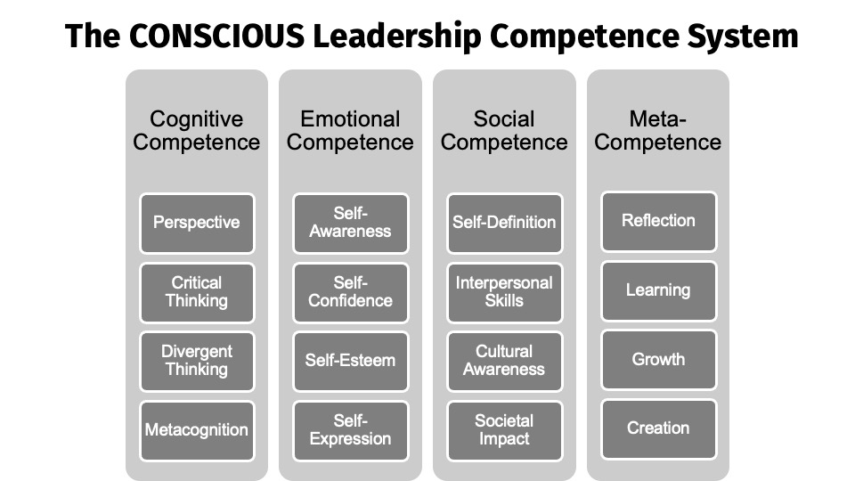

1.1 Purpose
The purpose of this diagnostic is to identify your broad strengths and development opportunities across 16 sub-competences. Your results support conscious leadership development and help you direct focus to areas where the greatest growth is possible.

1.2 Definitions of the Four Competences
Cognitive Competence – Helps leaders identify personal biases, gather situational insight and apply intentional decision-making.
Emotional Competence – Strengthens self-awareness, confidence, esteem and expression for grounded leadership.
Social Competence – Enhances leadership identity, interpersonal skills, cultural awareness and societal consideration.
Meta Competence – Supports long-term reflection, learning, growth and creation as adaptive capabilities.

1.3 How to Complete the Questionnaire
Rate each statement on a 1–5 scale reflecting your typical behaviour:
1 = Never true | 2 = Rarely true | 3 = Sometimes true | 4 = Often true | 5 = Almost always true
Respond instinctively; this is a developmental tool, not a performance evaluation.

1.5 Short-Form Questionnaire (16 Items Total)

================================

Each statement represents one of the 16 sub-competences.

Cognitive Competence
# | Sub-Competence | Statement | 1 | 2 | 3 | 4 | 5
1 | Perspective | I recognise when my assumptions shape how I interpret a situation.
2 | Critical Thinking | I question information and assumptions before reaching a conclusion.
3 | Divergent Thinking | I generate multiple ideas or possibilities before deciding.
4 | Metacognition | I am aware of how my thinking patterns influence my behaviour.
Total Score

Emotional Competence
# | Sub-Competence | Statement | 1 | 2 | 3 | 4 | 5
5 | Self-Awareness | I notice my emotional reactions early and understand their impact.
6 | Self-Confidence | I trust my ability to handle challenges even when uncertain.
7 | Self-Esteem | I feel inherently worthy and recognise my strengths.
8 | Self-Expression | I communicate my thoughts and feelings clearly and constructively.
Total Score

Social Competence
# | Sub-Competence | Statement | 1 | 2 | 3 | 4 | 5
9 | Self-Definition | I can clearly articulate who I am as a leader and what I stand for.
10 | Interpersonal Skills | I build rapport, listen well and collaborate effectively.
11 | Cultural Awareness | I adapt my behaviour to cultural expectations in different contexts.
12 | Societal Impact | I consider the wider implications of my decisions beyond my organisation.
Total Score

Meta Competence
# | Sub-Competence | Statement | 1 | 2 | 3 | 4 | 5
13 | Reflection | I regularly reflect on experiences to gain insight.
14 | Learning | I apply feedback and adapt quickly based on new information.
15 | Growth | I actively seek stretch opportunities that develop my leadership.
16 | Creation | I generate and pursue new ideas, initiatives or possibilities.
Total Score
Overall Competence Score

1.6 Scoring System (Short Form)

================================

Step 1 — Add your four competence totals:
Each competence has four questions.
Possible score per competence: 4–20
Competence | Item Numbers | Score (4–20)
Cognitive | 1–4 | ______
Emotional | 5–8 | ______
Social | 9–12 | ______
Meta | 13–16 | ______

Step 2 — Calculate your Overall Score:
Add all four competence totals.
Overall possible score: 16–80

Overall Score: ______ / 80

================================

1.7 Guidance Based on Overall Competence Banding
Your overall score summarises your broad CONSCIOUS leadership capability across the four competence domains. Each band reflects your current level of internal capacity and highlights the type of development that may benefit you.

Score 16–35 — Significant Development Needed
You may be operating reactively in several areas, with thinking, emotion, social interactions and learning patterns feeling inconsistent or unpredictable.
Suggested next steps:
Begin small: increase weekly reflection, notice emotional triggers, and identify one interpersonal behaviour to strengthen. A structured development programme will accelerate stability and capability.

Score 36–55 — Foundational Competence
You demonstrate functional capability in many situations, but your leadership effectiveness may fluctuate under pressure or complexity.
Suggested next steps:
Build routines that improve consistency — weekly reflection, clearer communication, examining assumptions and creating small learning goals. Formal development can help you consolidate these behaviours.

Score 56–68 — High Functioning Competence
You think clearly, regulate emotion reasonably well, relate effectively and engage in growth-focused behaviours. Your leadership is generally reliable and constructive.
Suggested next steps:
Now focus on refinement: deepen emotional presence, expand perspective-taking, stretch your creativity and strengthen your influence. Advanced development pathways can help you leverage your strengths strategically.

Score 69–80 — Exceptional Competence
You are a consistently CONSCIOUS leader, demonstrating strong capability across cognition, emotion, relationships and self-evolution.
Suggested next steps:
Focus on mastery: mentoring others, shaping culture, modelling developmental practices and stepping into more complex leadership roles. Higher-level coaching can help you extend your systemic impact.

================================
At Invictus Leadership we have a range of development offerings no matter what your level of competence is including:

- CONSCIOUS Leadership Full Diagnostic Assessment
- CONSCIOUS Leadership Competence System Training
- Leadership Development Coaching & Mentoring
- Bespoke Organisational Packages

Please visit our website www.invictusleadership.co.uk or get in touch for a further discussion info@invictusleadership.co.uk

