Intensive 3 Day 3 Quiz

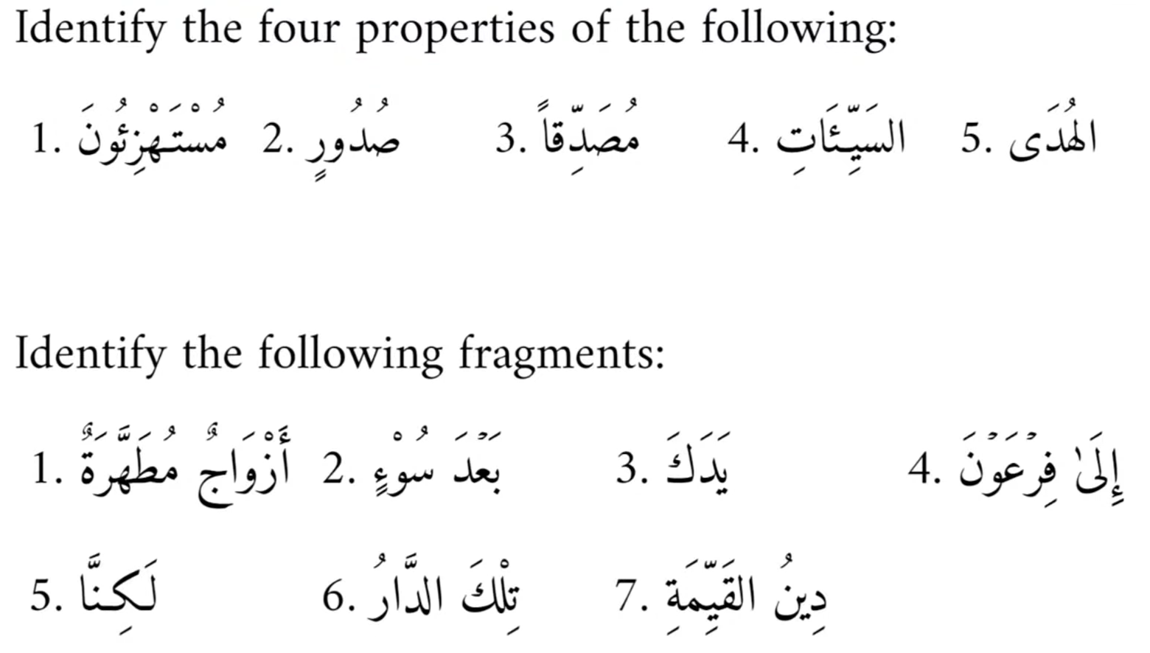

Answers
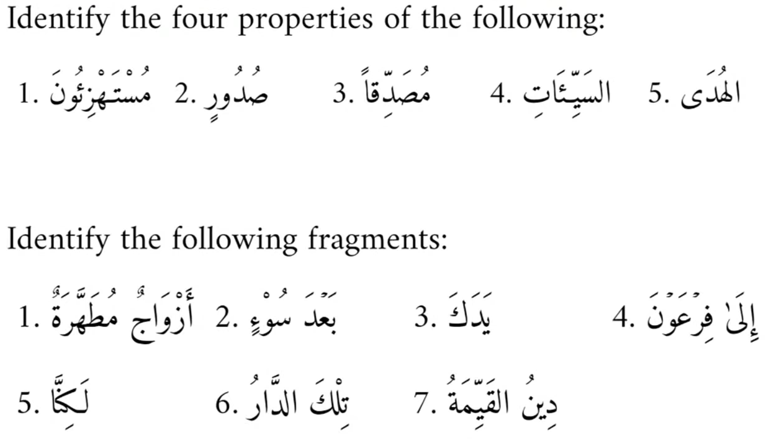
- Raf’, plural, masculine, common
- Jarr, singular, masculine, common
[Note: this is actually a non-human broken plural so it’s actually singular feminine, but since we did not know the meaning, singular masculine will be awarded a mark]
- Nasb, singular, masculine, common
- Nasb/jarr, plural, feminine, proper
[Note: if you had singular instead of plural, this is also technically correct]
- Raf’/nasb/jar [non-flexible], singular, masculine, proper
[Note: not all words ending in are ى feminine. If you had feminine instead of masculine, this will be given 1 mark as you don’t know the meaning. Also note that this cannot be a light dual, because words with ال cannot be light, and even if it was light dual, it wouldn’t be written with a ى]

- Mowsoof and sifah
[Note: feminine sifah could be because the mowsoof is a broken plural]
- Idafah (mudaf + mudaf illaih)
- Idafah (mudaf [ism] + mudaf illaih [attached pronoun]
- Harf of Jarr (إِلَى) + Jarr majroor
- Harf of Nasb (لَكِنَّ) [with the attached pronoun نَا]
- Ismul isharah and musharun illaih
- Idafah [mudaf + mudaf illaih]

