# KANDI KANE CHRISTMAS TREE FARM'S CRAFT FAIR

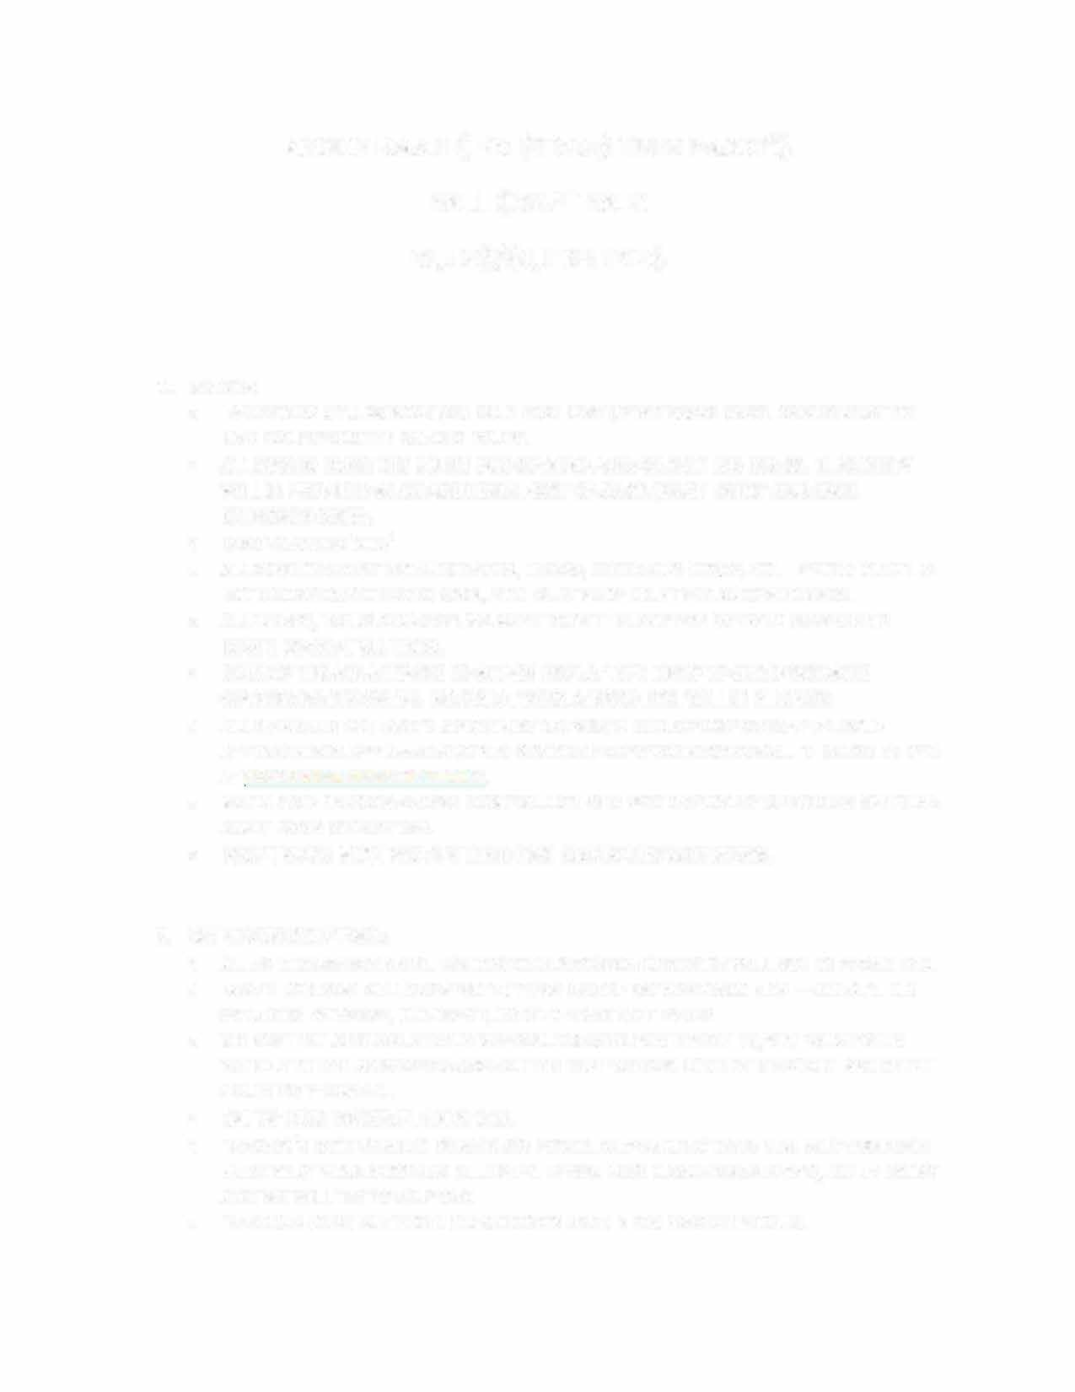

**RULES/GUIDELINES**

## BOOTH:

* + ALL SPACES WILL BE ASSIGNED ON A FIRST COME/FIRST SERVE BASIS. SPACES MUST BE PAID FOR BEFORE THESPACE IS YOURS.
  + ALL BOOTHS (WHETHER UNDER OUR COVERED AREA OR NOT) ARE $50.00. ELECTRICITY WILL BE PROVIDED AT NO ADDITIONAL COST (YOU MUST BRING YOUR OWN EXTENSION CORD).
  + BOOTHS ARE 10' X 10'
  + **ALL** VENDORS MUST PROVIDE TABLES, CHAIRS, EXTENSION CORDS, ETC. IF YOUR BOOTH IS NOT UNDER OUR COVERED AREA, YOU MUST PROVIDE A TENT AND SANDBAGS.
  + ALL CHAIRS, TABLES AND DISPLAYS MUST BE IN THE CONFINES OF YOUR DESIGNATED BOOTH SPACE AT ALL TIMES.
  + ONLY ZIP TIES ARE ALLOWED TO ATTACH DISPLAY TYPE ITEMS TO OUR DESIGNATED COVERED BOOTH SPACES. NO NAILS, TACKS, SCREWS, ETC, WILL BE ALLOWED.
  + ALL PAYMENTS FOR BOOTH SPACE MUST BE PAID IN FULL BY ONE WEEK AFTER YOUR APPLICATION IS APPROVED AND YOU ARE NOTIFIED OF SUCH APPROVAL. THIS CAN BE PAID AT [WWW.](http://WWW/)KANDIKANETRE ES.COM.
  + KANDI KANE CHRISTMAS TREE FARM WILL DO OUR BEST TO SPACE SIMILAR ITEM VENDORS APART FROM EACH OTHER.
  + FOOD TRUCKS MUST PROVIDE THEIR OWN ELECTRICITY/GENERATORS.

1. **SET UP/BREAK DOWN:**
   * ALL SPACES ARE ASSIGNED. RELOCATION OR SWITCHING SPACES WILL NOT BE PERMITTED.
   * BOOTH VENDORS WILL BE EXPECTED TO BE ON SITE BETWEEN 8:00 A.M. - 9:00 A.M. ON THE MORNING OF THE CRAFT FAIR TO START SETTING UP.
   * WE ASK THAT AS SOON AS EACH VENDOR UNLOADS FOR THE SET UP, YOU MOVE YOUR

VEHICLE TO THE DESIGNATED AREA SO THE NEXT VENDOR CAN DO THE SAME. WE EXPECT COURTESY FROM ALL.

* + SET UP MUST BE COMPLETE BY 9:45.
  + VENDOR'S BOOTHS MUST BE MANNED FOR OUR OPENING AT 10:00 A.M. AND SOMEONE MUST BE AT YOUR BOOTH AT ALL TIMES. IF YOU NEED A BATHROOM BREAK, LET US KNOW AND WE WILL TRY TO HELP OUT.
  + VENDORS MUST NOT BEGIN BREAK DOWN UNTIL 4 P.M. WHEN WE CLOSE. NO VENDOR VEHICLES ARE ALLOWED IN THE BOOTH AREA BETWEEN THE HOURS OF 10:00 A.M. – 4:00 P.M. WE MUST ALWAYS BE PROTECTIVE OF OUR CUSTOMERS AND VISITORS.

* VENDORS MUST CLEAN THEIR BOOTH SPACES AND GATHER ALL TRASH WHEN THEY BREAK DOWN. THERE WILL BE TRASH CANS ON SITE FOR YOUR CONVENIENCE.
* NO OIL IS TO BE DUMPED IN THE EVENT AREA. ALL FOOD TRUCKS MUST TAKE ANY OIL WITH THEM WHEN THEY LEAVE.

### VENDOR PRODUCTS:

* + WE ARE LOOKING FOR DIVERSE PRODUCTS FOR THE CRAFT EVENT. EACH VENDOR IS REQUIRED TO SEND 5 PHOTOS OF THEIR PRODUCTS FOR OUR REVIEW. ALSO, WE ASK FOR A PHOTO OF YOUR BOOTH SET UP (IF AVAILABLE). ALL PRODUCTS MUST BE FROM THE VENDOR APPROVED FOR THE SPACE. ONLY ONE VENDOR PER SPACE.
  + VENDORS WILL CONDUCT THEIR OWN SALES AND COLLECT/REPORT TAX FOR EACH SALE AS REQUIRED BY TENNESSEE STATE DEPARTMENT OF REVENUE.

### ITEMS NOT PERMITTED:

* + NO MANUFACTURERED OR MASS- PRODUCED GOODS.
  + NO IMPORTED GOODS.
  + NO GOODS PURCHASED FOR RESALE AND NOT MADE BY THEVENDOR.
  + WE RESERVE THE RIGHT TO REJECT ANY ITEMS DEEMED INAPPROPRIATE AND THEY MUST BE REMOVED FROM YOUR BOOTH IMMEDIATELY.
  + NO ELECTRIC SPACE HEATERS ARE ALLOWED.
  + NO ANIMALS ARE ALLOWED IN THE EVENT AREA.

### PARKING:

* + VENDORS AGREE TO PARK IN DESIGNATED "VENDORS ONLY" AREAS. OUR PARKING LOT IS RESERVED FOR CUSTOMERS.
  + NO OVERNIGHT PARKING ALLOWED.

### SMOKING, ALCOHOLIC BEVERAGES & WEAPONS

* + **NO** WEAPONS, GUNS, KNIVES, FIREWORKS, PORNOGRAPHIC MATERIAL WILL BE ALLOWED. VIOLATORS WILL BE ASKED TO LEAVE IMMEDIATELY.
  + SMOKING IS NOT ALLOWED ANYWHERE IN THE VACINITY OF THEBOOTHS OR BUILDINGS ON SITE. IF YOU NEED TO SMOKE, WE ASK THAT YOU GO TO YOUR VEHICLE.
  + NO ALCOHOLIC BEVERAGES WILL BE ALLOWED ON THE PROPERTY. NO EXCEPTIONS!! IF YOU BRING ALCOHOLIC BEVERAGES ON THE PREMISIS YOU WILL BE ASKED TO LEAVE.

### RAIN DATES/REFUNDS:

* + AS WE ALL KNOW, IF YOU LIVE INTENNESSEE, THE WEATHER IS VERY UNPREDICTABLE! WE WILL NOT REFUND OR ASSIGN RAIN DATES FOR THE EVENT DUE TO INCLIMATE WEATHER.

### ADVERTISING FOR THIS EVENT:

* + KANDI KANE CHRISTMAS TREE FARM WILL ADVERTISE THIS EVENT THROUGH SOCIAL MEDIA AND CLARKSVILLE AREA VENDORS SITE. WE ARE OPEN FOR SUGGESTIONS OF PLACES THAT WILL CREATE GREATER ADVERTISING COVERAGE.
  + WE ASK EACH VENDOR TO PUT OUT ADVERTISING THROUGH YOUR BUSINESS AND SOCIAL MEDIA.

### LIABILITY:

* + KANDI KANE CHRISTMAS TREE FARM, OWNERS, EMPLOYEES AND VOLUNTEERS INVOLVED WITH THIS EVENT DO NOT ASSUME ANY RESPONSIBILITY NOR ARE THEY LIABLE FOR INJURY TO PERSONS OR LOSS OR DAMAGE OF PROPERTY AS A RESULT OF YOUR PARTICIPATION IN THIS EVENT.
  + KANDI KANE CHRISTMAS TREE FARM IS A WORKI NG FARM, THEREFORE, ACCORDI NG TO TENNESSEE LAW, NOT LIABLE FOR ANY INJURIES OR DEATHS WHILE A PERSON IS PRESENT ON THE PROPERTY.
  + KANDI KANE CHRISTMAS TREE FARM HAS LIVESTOCK AND DOGS ON THE FARM. THESE ANIMALS LIVE HERE. WE ASK THAT YOU DO NOT BRING YOUR PERSONAL PETS TO THE EVENT.